Primary 3 17.01.2022
Here is a preview of the work we will be covering this week in class. Our new phoneme is “ou” as in could.
Tricky spelling words:  should  would  open  song  hard  We have been reading Room on the Broom in Scots. The children are trying to add to their Scot’s vocabulary. Please help them with this and send your Scot’s words in to class with them. | Phoneme:  “ou”  would  could  should  Children added to their phoneme list:  mousse  wound  youth  routine  group  Please copy the words twice and pick an activity of your choice as well to practise spelling and using the words. | Numeracy: Number  We are learning different methods to calculate times tables.  This week we will focus on the 4 times table. We will be  - Counting 0n and back in 4s  - Using number lines  - Making and using arrays to help us calculate times tables answers and matching these to the array.  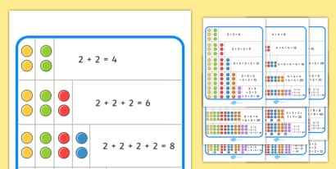  There are some games to consolidate our learning on active learn and TopMarks Hit the Button is also excellent.  Active Learn  https://www.activelearnprimary.co.uk  Hit the Button - Quick fire maths practise for 6-11 year olds  Children have been given a copy of their usernames and passwords already. | PATHS: Feelings  We have been using PATHS to try to keep us calm when we feel angry or upset.  Ask your child to explain what they have ben learning during our PATHS lessons.

