Active Literacy  LI: To use spelling strategies to help spell tricky words.  Choose 1-2 of your spelling words to practise each night. You may wish to use an activity such as Rainbow Writing or Pyramid Writing.  Word lists are at the bottom of this page. Please make sure to only practise words from your current list(s). | Primary 6/7  Weekly Homework Tasks  Week beginning  17.01.22 | Personal Reading  Try to spend 15-20 minutes  each night reading your  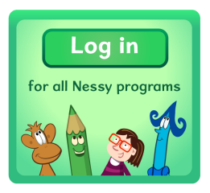  Library book.  Nessy  Try to use Nessy at least 2-3 times per week.
French  We have been learning..  - numbers up to 39;  - the days of the week;  - the months of the year.  Here are some interactive activities for you to play at home:  Numbers 1-12  Numbers 13-20  Days & Months | Multiplication & Division  Practise your times tables every night:  - A deck of cards  - Quick fire questions  - Topmarks: Hit the Button  - Topmarks: Daily 10  - Topmarks: Demolition Division  **Sumdog is also accessible at all times to improve numeracy skills. | Numeracy  Multiples, Factors & Primes.  - I can explain what a multiple is and can create a series of multiples of a number.  - I can use my knowledge of table facts to decide if a number is a multiple of a given number.  - I can compare multiples of different tables and find common multiples.  Task: Active Learn- ‘Reel It In’.
Christmas
Easter
season
birthday
centre
circle
square
triangle
rectangle
different
satisfied
juice
stopped
heard
their
almost
autumn
winter
spring
summer
happened
beautiful
frightened
teacher
difficult
little
Scotland
England
Ireland
Wales

absence
accommodation
ache
acquire
actually
advertise
again
aisle
alcohol
alliteration

although
analyse
analysis
announcing
answer
anxious
argument
assessment
atmosphere
audience

