Personal Reading  Try to spend 10-15 minutes every night reading your Library book.  Nessy  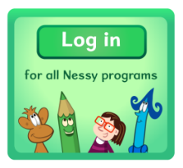  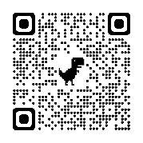  Login to Nessy 2-3 times per week using the QR code or follow the link.  https://learn.nessy.com/account/login#/accountLogin | Primary 5  Weekly Homework Tasks  Week beginning  17.1.22  *Please refer to HW 10.1.22 for Topic work |  | Health and Wellbeing  In PATHS this week we are looking at our feelings dictionary.  The feelings we are focusing on are the ones related to SHANARRI.  https://www.gov.scot/policies/girfec/wellbeing-indicators-shanarri/  Safe, Ambitious, Responsible, Reassured, Included  We will continue to add to our feelings dictionary.
Numeracy  Complete pages 3 and 4 of your Maths Activity Booklet  Can you teach someone at home how to use the removal subtraction strategy that we are working on in Number Talks? Remember this strategy is good for when the number you are subtracting has a higher unit digit.  Try these:  73-9= 94-29= 141-86=  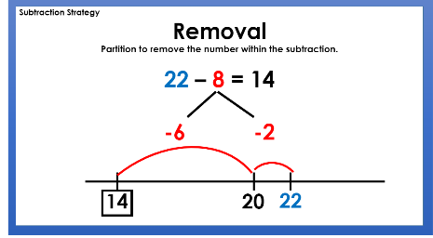  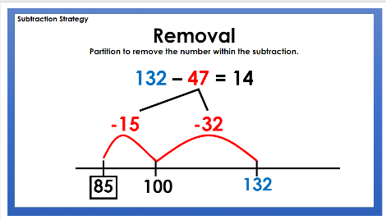  As always think about how we could challenge ourselves… |  | Active Literacy  This week we are focusing on the phoneme ‘oe’.  Can you add words to the phoneme chart and practise spelling the words?  o_e oa ow oe  alone soak throw toes | Multiplication & Division  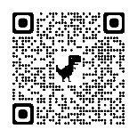  Access Topmarks using the QR code or follow the link to practise multiplication and division facts each night.  https://www.topmarks.co.uk/Search.aspx?q=times%20table%20games  *Don’t forget you can access Sumdog at home for practising times tables too.

