Primary 3 10.01.2022
Here is a preview of the work we will be covering this week in class. Our new phoneme is “ea” as in great.
Tricky spelling words:  white  why  also  turn  great | Phoneme:  “ea”  break  steak  great  breakfast  Please copy the words twice and pick an activity of your choice as well to practise spelling and using the words. | Numeracy: Number  We are learning different methods to calculate times tables.  This week we will focus on the 2 times table. We will be  Counting 0n and back in 2s  Using number lines  Making and using arrays to help us calculate times tables answers and matching these to the array.  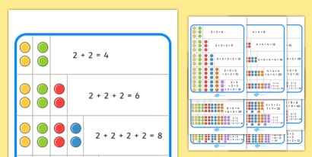  There are some games to consolidate our learning on active learn and TopMarks Hit the Button is also excellent.  Active Learn  https://www.activelearnprimary.co.uk  Hit the Button - Quick fire maths practise for 6-11 year olds  Children have been given a copy of their usernames and passwords already. | PATHS: Feelings  We have been using PATHS to try to keep us calm when we feel angry or upset.  Ask your child to explain what they have ben learning during our PATHS lessons.

