Primary 2 week beginning 22.11.2021
Spelling words:  round  found  wish  men | Phoneme:  ou  as in round  Try out studyladder! | Ways to make the number:  35 and 36
Money:
I can identify all coins up to 20p.
I can use coins to at least 20p to pay for items.
https://www.topmarks.co.uk/money/coins-game
Paths  “Calm or relaxed” | 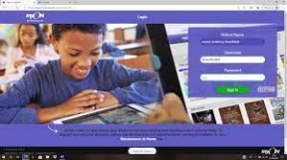  Literacy  Reading : Log on and choose a book !  https://www.myon.co.uk/login/  This month we will be focusing on the Scots language!  Check the school bags for the P2 Scots poem “The Snawman”.  We will be learning to recite this as part of our Scots focus.
Just thought you would like to know about some of the work we will be covering this week in class. It would be really helpful if you could go over spelling words, our phoneme and some number facts.

