Week beginning: 10.1.22 Primary 2
Please try and log in to some of the online learning resources on the Password Passport. Let me know if there are any issues with logins. Thank you 😊
Literacy | Numeracy | Health and Wellbeing
Phonics  This week we will be learning about the phoneme ‘ow’ as in cow.  How many words can you think of that have the ow sound?  https://www.youtube.com/watch?v=9Ph6nnHrVwY  Log on to Study ladder for some ow phonics activities.  Study Ladder  Spelling  How  Where  Now  Too  Have a go at some activities from the spelling menu:  Spelling Menu P2A.pdf  Reading  The children have chosen a book from our class library please spend some time reading this together. This is to encourage the children to read for enjoyment and may be more difficult than the reading books we have at school. They will be able to choose a new one when this book comes back to the class.  Click on the link to find some Blooms Questions to support reading at home:  Blooms questions.pdf  You can apply these questions to any fiction story. They are similar to the ones we use in class and build on our remembering, understanding, applying and evaluation skills.  We have also been doing our reading books and active literacy activities in class. | We will be learning all about money.  - What do we need money for?  - Can you have a look at some coins at home and try putting them in order from the smallest value of coin to the largest value of coin. Sometimes this can be tricky as 5p is a small coin but is worth more than 2p which is a bigger coin in size.  How many ways can you show the number 20?  How many calculations can you think of to make the number 20?  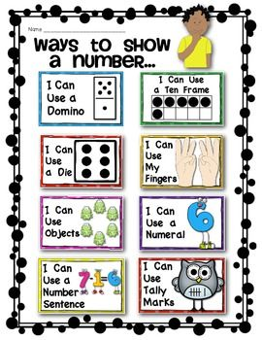 | PATHS  We will be learning about sharing and caring through PATHS this week.  Why is it important that we share?  Think of time when someone did not share something with you. How did that make you feel?

