Health and Wellbeing  In 2022 we are focusing on the positives!  It is important to start each day with a positive thought as this thought can stay with us for the rest of the day. Focussing on the positives can make us feel happier and calmer.  Can you add to our list of positive affirmations?  Share these with others, helping to make their day a little brighter too.  Here is one from Miss McColl … I am unique! | Primary 5  Weekly Homework Tasks  Week beginning  10.1.22 | Personal Reading  Try to spend 10-15 minutes every night reading your Library book.  Nessy  Login to Nessy 2-3 times per week using the QR code or follow the link.  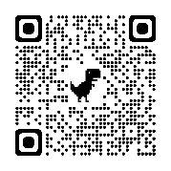  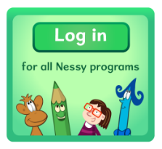  https://learn.nessy.com/account/login#/accountLogin
Topic  *You will have 2 weeks to complete this.  This week we will start our new Scotland topic.  Your task:  - Research the life of Robert Burns using digital technologies and share what you learn creatively.  - Search for images online to enhance your research and include them in your work.  You may want to:  - Create a poster  - Make a PPT  - Write a report  - Design a collage/model  - Make a timeline/storyboard/comic strip  - Give a presentation & record  - Perform a puppet show  - Write a diary entry  - Compose a rap/song  - Compose a text message dialogue  - Create a fact file  Work can be emailed to me at:  eamegan.mccoll@glow.sch.uk | Multiplication & Division  Access Topmarks using the QR code or follow the link to practise multiplication and division facts each night.  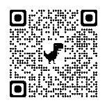  https://www.topmarks.co.uk/Search.aspx?q=times%20table%20games | Numeracy  - Complete pages 1 and 2 of your Maths Activity Booklet  - Continue to work your way through current allocations on Active Learn

