Active Literacy  This week we will be focusing on spelling rules:  - Soft c (-ce, -ci, -cy)  - Soft g (-ge, -gi, -gy)  Below are some of the example we came up with together as a class.  dance centre race cell  cinema circuit pencil  recycle numeracy  geography gymnastics gel  gentle ginger generous  Try to think of more words that follow this spelling rule and then practise the spellings. | Reading  Try to spend 10-15 minutes every night reading your Library book.  Alternatively check out MYON and choose yourself a book.  Nessy  Login to Nessy 2-3 times per week using the QR code.  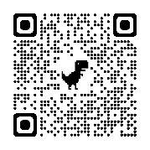  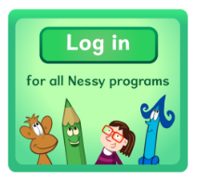  Health and Wellbeing  Our kindness advent calendar:  10th – Ask to leave some food out for the birds.  11th – Play a game with someone you live with.  12th – Help out with a chore in your house. | 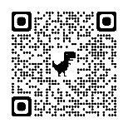  Numeracy  Access Topmarks using the QR code above to practise multiplication and division facts each night.  We have been learning to multiply whole numbers by at least 2 digits using a variety of strategies.  - Place Value  Example: 512 x 5  Step 1. Partition the numbers 500+10+2  Step 2. Multiply each by 5  500 x 5 = 2500 10 x 5 = 50 2 x 5 = 10  Step 3. Add the totals:  2500 + 50 + 10 = 2560  - Area Model  Example: 38 x 4  Step 1. Partition the numbers: 30 and 8  Step 2. Place the numbers in your grid and multiply:  x 30 8  4 30x4=120 8x4=32  Step 3. Add the totals: 120 + 32 = 132  - Written formal method  Have a go at these using your desired strategy or try and create your own questions for extra challenge:  21x3, 53x4, 34x5 517x5, 235x7, 741x8 1568x3, 2847x6, 3936x4  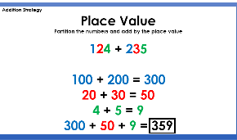  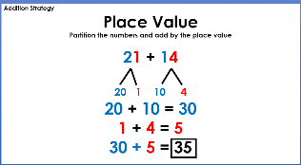  Number Talks  Strategy of the Week:

