Health & Wellbeing  Buddy Bench Design Competition  We have two new buddy benches in the playground. The buddy benches are in the playground so that anyone who is feeling lonely or has no one to play with has a place to go. If you are sitting on the buddy bench others can go over to you, say hi and ask if you want to play.  You were given the template for this last week- All entries must be in by Wednesday 8th December. | Primary 6/7  Weekly Homework Tasks  Week beginning  6.12.21 | Personal Reading  Try to spend 15-20 minutes  each night reading your  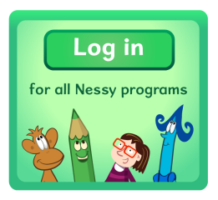  Library book.  Nessy  Try to use Nessy at least 2-3 times per week.
Literacy  Reading Progress – Assigned to you on TEAMS  How to access the assignment:  - Login to GLOW  - On your Launchpad select TEAMS and then ‘ Mauchline P6/7’  - Then select ASSIGNMENTS.  - Record yourself reading the passage. Video is optional. Please take your time and speak clear. | Multiplication & Division  Practise your times tables every night:  - A deck of cards  - Quick fire questions  - Topmarks: Hit the Button  - Topmarks: Daily 10  - Topmarks: Demolition Division | Numeracy  We are learning to use the order of operations in calculations.  Brackets, Orders, Division  Multiplication, Addition, Subtraction  Solve the calculations below using the correct order of operations:  - 36 – 2 x 7  - 5 x 28 ÷ 7  - 16 + 20 ÷ 5 – 12  - 36 ÷ 9 x (3 + 8)  - 7 x 3 – 16 ÷ 4 + (9-3)

