First Level – P. E. Home Learning Activities Grid
Each of these activities help to develop different physical skills and type of fitness.
Kinaesthetic Awareness – Can you take 3 pictures of yourself, showing the tallest shape you can, the smallest shape you can and the widest shape you can? | Stamina – Can you do 30 star jumps without stopping?  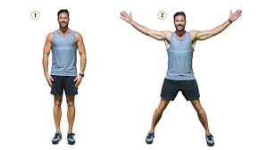 | Coordination & Fluency – Can you perform hop scotch. Landing on 1 foot – 2 feet, 1 foot - 2 feet - 1 foot - 2 feet?  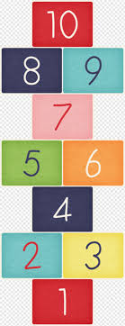
Core Stability & Strength – Can you hold a Plank position for 20 seconds?  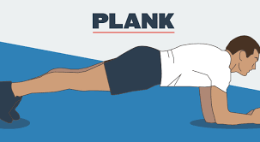  Can you hold the plank on 1 elbow and one foot (keep your legs and belly off the ground)? | Balance & Control – Can you balance on one foot on a cushion for 5 seconds?  Try the other leg – which one are you better with? | Speed – Can you run to a spot, do 10 star jumps and run back faster than an adult at home? 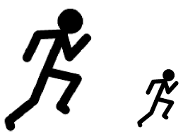
Rhythm & Timing – Can you jump, jump clap - jump, jump clap at the same time as the music from Queen – We will rock you. Can you now try it with no music? | Flexibility – Can you sit on the floor with your legs wide apart, how low can you get your chest to the floor? | Coordination & Fluency – Can you throw a ball/small cuddly onto a paper plate from a distance?  