Early Level – P. E. Home Learning Activities Grid
Each of these activities help to develop different physical skills and type of fitness.
Kinaesthetic Awareness – Can you run around with a sheet of paper on your tummy and keep it there with no hands? 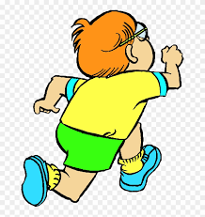 | Gross/ Fine Motor Skills – Can you jump off something low and land on 2 feet? (Remember to bend your knees as you land.) | Stamina – Can you run on the spot for 1 minute without stopping?  Feel what has happened to your heartbeat when you stop.
Rhythm & Timing – Can you jump 5 times, then clap 4 times at the same time as someone else? 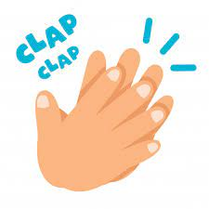 | Speed – Can you run on the spot as slow as you can for the count to 5, then run as fast as you can for the count to 5? | Balance & Control – Can you Balance on 1 Leg for 5 seconds?  Can you do it on the other leg?  Which leg is your best? 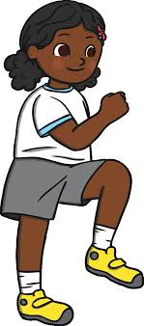
Core Stability & Strength – Can you hold a press-up position for 10 seconds?  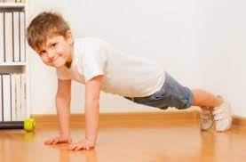 | Coordination & Fluency – Can you throw an object up and catch it? Can you clap before you catch it?  How many claps can you fit in? | Flexibility – Can you touch your toes whilst sitting down with straight legs?  Can you touch your toes whilst standing up?

