Second Level Outdoor Learning Activities Grid
Man-made v Natural Materials  Buildings are often made from a mixture of natural and man-made materials. 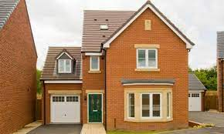  Can you make a list of all the different types of Natural and Man-made materials you can see in your outdoor space? | Outdoor Art  Use things you can find outside to create a work of art. You could use plants, stones, twigs, plant pots, outdoor toys – anything at all, get creative.  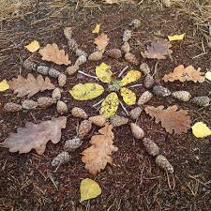 | 5 Senses Hunt  Take a good look, listen, feel, taste, smell around. Can you identify something for each sense? Can you write a descriptive sentence for each sense?  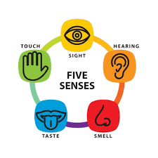
Shape I Spy  Composite Shapes. Many buildings are made from multiple 3D shapes joined together. Can you draw some of the buildings you can see and label the shapes they are made up of? 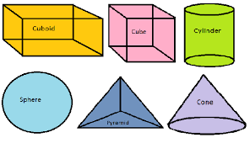 | 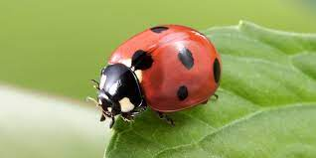  Spot It –Minibeasts  Can you find these minibeasts in your outdoor space? Double click the link. | Make A Den  Grab some blankets/sheets, rope and clothes pegs. Can you make a cool den to fit 2 people, with a roof and 3 sides? What could you do inside your den?  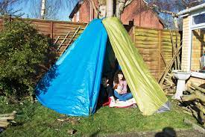
Orienteering  Draw a map of your outside space and plot an orienteering course. Try and orient your map to North and set it as you go round your course.  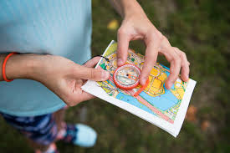 | Traffic Survey  Use tally marks to record the different types of traffic you can see in your street. You can count parked vehicles as well as passing. Use your frequency table to create a bar graph and create 5 questions based on your graph. Remember to label your graph. | Letter Hunt  Write the alphabet and go out for a walk, can you spot every letter? Look at street signs, number plates, shop names, etc.  Example:  A – ArmourVets  B – Ballochmyle Avenue  C – Catrine Road

