First Level Outdoor Learning Activities Grid
Scavenger Hunt  Double click the link to open the activity. There are 3 sheets to choose from. | Outdoor Art  Use things you can find outside to create a work of art. You could use plants, stones, twigs, plant pots, outdoor toys – anything at all, get creative.  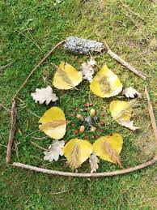 | 5 Senses Hunt  Take a good look, listen, feel, taste, smell around. Can you identify something for each sense? Write them down and draw a picture.  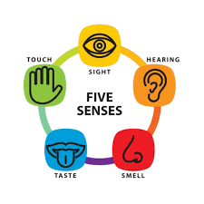
Shape I Spy  How many of these 3D shapes can you spy outside? 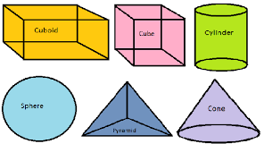  Look carefully at buildings, vehicles and along the street. | 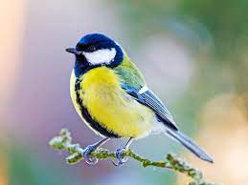  Spot It – Birds and Mammals. Can you find these birds and mammals? Double click the link. | Make A Den  Grab some blankets/sheets and clothes pegs. Can you make a cool den to fit 2 people, with a roof and 2 sides? You could use some rope or chairs too.  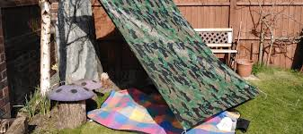
Orienteering  Draw a map of your outside space and plot an orienteering course. You could use an anagram, jumbled book title or some numbers to create a sum as your marker points.  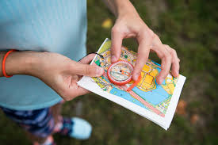 | Traffic Survey  Use tally marks to record the different types of traffic you can see in your street. You can count parked vehicles as well as passing. Use your frequency table to create a bar graph.  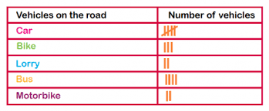 | Letter Hunt  Write Mauchline and go out for a walk, can you spot every letter? Look at street signs, number plates, shop names, etc.  Example:  M – Mary Morrison Drive  A – Armour Vets  U –  C -  H -

