Early Level Outdoor Learning Activities Grid
Colour Scavenger Hunt  Double click the link to open the activity. There are 3 sheets to choose from.  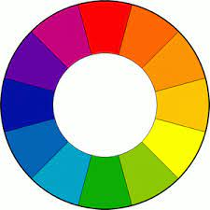 | Make A Splash  Use a sports cap bottle/washing up liquid bottle filled with water to create some outdoor art. Squirt the water on the path/wall to create some artwork. | 5 Senses Hunt  Take a good look, listen, feel, taste, smell around. Can you identify something for each sense?  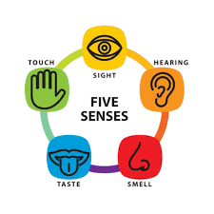
Shape I Spy  How many of these shapes can you spy outside? 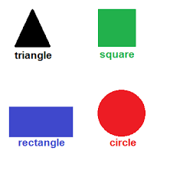  Look carefully at buildings, vehicles and along the street. | 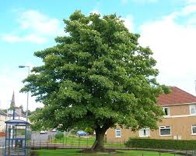  Spot It – Trees and Shrubs. Can you find these plants? Double click the link. | Make A Den  Grab some blankets/sheets and clothes pegs. Can you make a cool den to hide in? You could use some rope or chairs too.  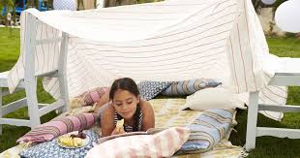
Orienteering  Draw a map of your outside space and plot an orienteering course. Place words or numbers as markers.  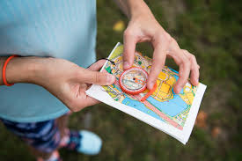 | Traffic Survey  Use tally marks to record the different colours of traffic you can see in your street. You can count parked cars as well as passing.  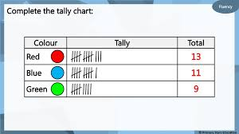 | Letter Hunt  Write your name and go out for a walk, can you spot every letter in your name? Look at street signs, number plates, shop names, etc.  