Home Learning Grids- Second Level (P6 & P7)
Each day, choose 1 literacy and 1 numeracy task and either 1 expressive arts/STEM challenge OR 1 from the separate P.E. challenge grid. If you choose an expressive arts/STEM challenge on day 1, make sure you choose a P.E. challenge on day 2 or vice versa. Parents/Carers please remember that you may need to modify some of the activities to the specific level that your child is currently working at. Send pictures/videos of your completed task to your teacher on TEAMS if you can.

Literacy | Numeracy | Expressive Arts/STEM
Question Master  Create six questions about the book you are currently reading (either personal or class novel). Try to ask different types of questions. If you were a teacher, what questions would you ask your pupils? Can you think of inferential, literal or evaluative questions? | Money  Mum and dad have decided that they will give you extra pocket money for helping out at home! But the most that they will pay you is £5 per week.  Washing, drying and putting away the dishes £1.00  Vacuuming the lounge £0.75  Tidying and polishing the lounge £0.75  Tidying, cleaning and vacuuming your bedroom £2.00  Weeding the garden £1.50  Cleaning the car £2.50  Taking out the rubbish/bin £0.50  •What is the least amount of jobs you will have to do to earn £5?  •What is the most amount of jobs you will have to do to earn £5?  •Which jobs would prefer to do and why? | Vincent Van Gogh  https://www.bbc.co.uk/bitesize/clips/zq3gd2p  Watch the video about the famous artist, Vincent van Gogh. Research some of his paintings. Draw and colour or paint a tree or flowers in his style.
Finish the Story  Slowly, a foot moved, then the trunk, then a loud growl shook the cavern... | Plan a Day Out  Plan a day trip for you and a friend in Scotland. You can choose where you are going to visit. You have to plan transport costs, entrance costs and food and snacks for your outing. You have a budget of £50 for your day. Make sure you don’t go over budget. | Mindfulness Hands Art  Draw around your hands and decorate inside of the hand to show your emotions.  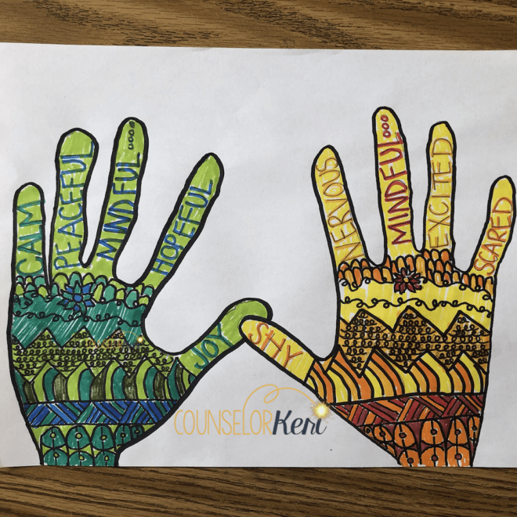
Daily Diary  Keep a daily diary of how you keep yourself busy. This might include how you are feeling, what you have been doing and share ideas with others which might help them keep busy. | Sumdog  Spend 45 minutes on Sumdog- if your teacher has set your class a challenge, complete this first. If not, choose your own games!  https://pages.sumdog.com/ | Bring the Rain Inside  Bring the wet weather indoors by creating a cloud in a jar:  https://www.giftofcuriosity.com/weather-science-how-to-make-a-cloud-in-a-jar/
Job Application Task-  What is your dream job? Write a CV.  Tell us why this is your dream job, why you should get it, list your skills and qualities and why you are suitable for this job.  You can find examples of CVs online to help. | Topmarks Bingo Game  Choose a times table you find tricky. Play Topmarks Bingo- Multiplication & Division for 20 minutes or until you feel more confident with the answers. Could you challenge a family member to play with you? https://www.topmarks.co.uk/  *Challenge- choose another multiplication game to play.* | Natural Art  Take a bag outside and collect as many leaves, twigs and other natural materials. Use your new art supplies to create a picture of your choice.  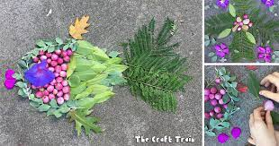
Scrabble Spelling  (Using the common words list on Glow)  In a game of Scrabble, each letter is worth a certain number of points. Write your words and then add the total of the letters. Which of your spelling words has the highest total value? 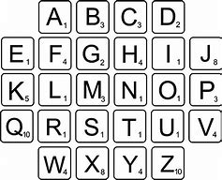 | Number Hangman  Play this game with someone at home. Write down give numbers which all have something in common (e.g. all can be divided by 2, all are square numbers etc.) but don’t tell your opponent what the rule is. For each guess they get wrong, draw part of the hangman. Once they have guessed correctly or run out of guesses, swap over! | Continue the doodle.  Get someone at home to draw a squiggly line on a piece of paper. Try to make the squiggly line into a drawing. It doesn’t need to be real-life objects just use your imagination.
*Remember to complete a minimum of 30 minutes per day using your Accelerated Reader reading book. If you don’t have any books at home or have finished your book, try reading magazines, cookbooks, comics or online books. You can check the book level of books at home using AR Bookfinder: https://www.arbookfind.co.uk/
Oxford Owls have a library of free books: https://www.oxfordowl.co.uk/
For additional activities:
All children have a log in for Sumdog & Education City, sites which develops mental maths and problem solving skills: https://pages.sumdog.com/ https://www.educationcity.com/ (ask your child’s teacher if they don’t know their log in)
Oxford Owls have a library of free books: https://www.oxfordowl.co.uk/
Free audiobooks for children: https://www.storynory.com/
Lots of free maths games: https://www.topmarks.co.uk/
Daily lessons in literacy, numeracy and health and wellbeing: https://www.bbc.co.uk/bitesize
Learn, create and play through exploring Scotland’s history and heritage: https://www.historicenvironment.scot/learn/
STEM (Science, Technology, Engineering & Maths) with Mr N: https://www.youtube.com/channel/UCxziq4omrQP-EKSLilOIPhw

Literacy | Numeracy | Expressive Arts
Reading  Choose a book to focus on. Create a new front and back cover for it. Include pictures, authors and illustrators name. Include a blurb of your own. | Money  I have 5 coins in my pocket, how much money might I have?  There are of course a variety of different solutions. Here are some of the things you might need to consider when solving this problem:  ➢ How will you make sure you don't repeat any totals?  ➢ How will you make sure you find all the different ways?  ➢ What are the maximum and minimum amounts I might have?  Try this game after working out the problem above.  https://natwest.mymoneysense.com/students/students-5-8/coin-cruncher/ | Drawing  Go onto Art Hub for Kids on YouTube and learn how to draw an animal or your favourite character step by step.  https://www.youtube.com/user/ArtforKidsHub  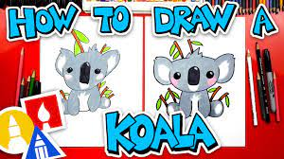
Journalism  Choose a news event you are interested in, past or present, and compose a news article that shares the news with the public. For example - Messi Leaves Barcelona, Bake Off Winner Crowned, Lockdown for Britain. | Times Tables  Log onto your Sumdog account and find the challenge to practice your skills. I will update and monitor challenges every couple of days.  Top Marks is a super resource to help with your mental math skills.  Practice your times tables, especially the 6, 7, 8 and 9. | Junk Modelling  Create a junk model using any junk that you can find around the house. For an extra challenge, can your model balance a book on top of it? Send pictures to our team.
Reading for Pleasure – Own Choice  Aim to read a story of your own choice for at least 20 minutes per day. You could read alone, listen to an audiobook or read with someone at home – it all counts!  Here are ways to listen to stories for free.  Check Accelerated Reader to see if your book has a quiz. (Login details needed) | Countdown  Add your family members birth date and age together.  e.g. date -14/8/1991 age-28 (14 + 8 + 1991 + 28 = 2,041)  Who has the highest total?  Can you create this number: 237 using these numbers 50 6 4 5 1 9  You can add, subtract, multiply or divide the numbers, and only use each number once?  Play countdown on Topmarks.  https://www.topmarks.co.uk/Flash.aspx?f=countdowntimerv3 | Science  Invisible Ink: Write 3 different short messages on paper using milk, lemon juice and vinegar. Leave to dry. Heat up the paper with a hair dryer and see if the message appears.
Writing  https://www.pobble365.com/anunexpected-adventure/  Use the Story Starter to write a story inspired by the picture. The activities on the page will help you to plan your writing. You can use the arrows to select a different picture to write about, if you would like. | Mental Maths – Daily 10  Complete Daily 10 Mental Maths Challenge every day. You can choose the difficulty of the questions and how long you have to answer each question. https://www.topmarks.co.uk/mathsgames/daily10 Mild: No time limit  Spicy: 15 seconds  Hot: Less than 7 seconds | Paper Aeroplane  Design and make a paper aeroplane. Record how far it travels. Try altering your design to make it go even further.
Scots Language Broons comic  Look at the Oor Wullie website below; maybe your parents or grandparents remember reading the Broons or Our Wullie when they were younger. Identify and translate some of the Scots language or add in Scots words you already know. Then have a go at creating your own Broons or Oor Wullie comic. Take a picture of your comic and send it to your teacher.  https://digital.nls.uk/oor-wullie/meet-oor-wullie/scots-language/ | Design a Board Game  Design a board game that tests the players’ knowledge of fractions, percentages and decimals (make sure you know all of the answers). | Food Poisoning  Using the link below watch the presentation on food poisoning, then download and complete the food poisoning worksheet.  https://www.foodafactoflife.org.uk/11-14-years/cooking/hygiene-and-safety/#SS#SS
*Remember to complete a minimum of 30 minutes per day using your Accelerated Reader reading book. If you don’t have any books at home or have finished your book, try reading magazines, cookbooks, comics or online books. You can check the book level of books at home using AR Bookfinder: https://www.arbookfind.co.uk/
Oxford Owls have a library of free books: https://www.oxfordowl.co.uk/
For additional activities:
All children have a log in for Sumdog & Education City, sites which develops mental maths and problem solving skills: https://pages.sumdog.com/ https://www.educationcity.com/ (ask your child’s teacher if they don’t know their log in)
Oxford Owls have a library of free books: https://www.oxfordowl.co.uk/
Free audiobooks for children: https://www.storynory.com/
Lots of free maths games: https://www.topmarks.co.uk/
Daily lessons in literacy, numeracy and health and wellbeing: https://www.bbc.co.uk/bitesize
Learn, create and play through exploring Scotland’s history and heritage: https://www.historicenvironment.scot/learn/
STEM (Science, Technology, Engineering & Maths) with Mr N: https://www.youtube.com/channel/UCxziq4omrQP-EKSLilOIPhw

