Active Literacy  Spelling Rules:  - Soft ‘c’ before e, I or y  - Soft ‘g’ before e, I, or y  Choose 3-4 words with the soft c sound to practise. Choose from the words below or find more of your own. Repeat for soft g.  Examples: Census, centimetre, cygnet, circle, centre, exercise, silence, reference,  Gymnastics, gymnasium, generous, gentle, giraffe, gigantic | Primary 6/7  Weekly Homework Tasks  Week beginning  25.10.21 | Personal Reading  Try to spend 15-20 minutes  each night reading your  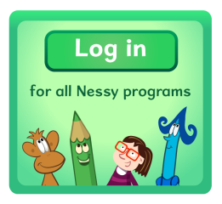  Library book.  Nessy  Try to use Nessy at least 2-3 times per week.
Numeracy: Number of the Week  Choose 1 of the numbers below and then answer the following questions.  - 24 2. 48 3. 72  - Add 39  - Subtract 13  - Multiply by 10 and then by 100  - Divide by 10  - Find all its factors (numbers that multiply together to make your chosen number) | Multiplication & Division  Practise your times tables every night:  - A deck of cards  - Quick fire questions  - Topmarks: Hit the Button  - Topmarks: Daily 10  - Topmarks: Demolition Division | Numeracy  Multiplying and Dividing by 10, 100 & 1000.  Multiply by 10= move 1 place  Multiply by 100= move 2 places  Multiply by 1000= move 3 places  Divide by 10= move 1 place  Divide by 100= move 2 places  Divide by 1000= move 3 places  Task: Active Learn: ‘Smack the Shack’

