Primary 2 week beginning 25.10.2021
Spelling words:  yellow  grow  food  again | Phoneme:  ow  as in snow  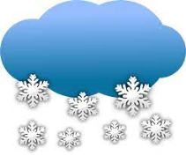  Try out studyladder! | 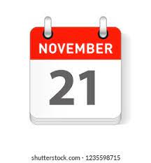  Ways to make the number:  21 and 22  Check out Topmarks  https://www.topmarks.co.uk/addition/robot-addition
 |  | Time: o’clock and half past on analogue and digital clocks http://www.scootle.edu.au/ec/viewing/L9643/index.html
PATHS  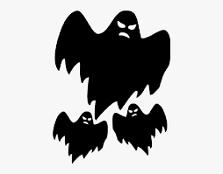  “Scared or Afraid”  Have a chat about these feelings and how we can deal with them if that’s how we feel. | Literacy  Reading : Log on and choose a book !  https://www.myon.co.uk/login/
Just thought you would like to know about some of the work we will be covering this week in class. It would be really helpful if you could go over spelling words, our phoneme and some number facts.

