Week beginning: 25.10.21 Primary 2
Please try and log in to some of the online learning resources on the Password Passport. Let me know if there are any issues with logins. Thank you 😊
Literacy | Numeracy | Health and Wellbeing
Phonics  This week we will be learning about the phoneme ‘ow’ (as in snow)  How many words can you think of that have the ow sound?  https://www.youtube.com/watch?v=9JE8rQLfLCA  Log on to Study ladder for some ow phonics activities. You do not need to complete all of the activities you can choose which ones to do.  Study Ladder  Spelling  Yellow  Grow  Again  Food  Reading  The children have chosen a book from our class library please spend some time reading this together. They will be able to choose a new one when this book comes back to the class.  We have also been doing our reading books in class, | We have been learning about place value and partitioning (splitting) a number into tens and ones eg 12 is 1 ten and 2 ones.  Play this game on TopMarks  https://www.topmarks.co.uk/learning-to-count/place-value-basketball  How many ways can you show the number 13?  How many calculations can you think of to make the number 13?  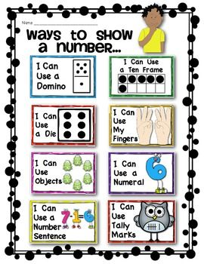 | We are learning all about Autumn. Take some time to do something you enjoy doing at autumn time e.g an autumn walk, collecting items such as conkers or making art some work.  Have fun  