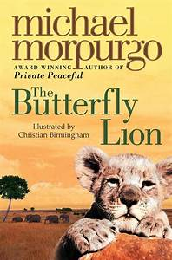
Learning so far…
Literacy:
We have been working on The Butterfly Lion by Michael Morpurgo. We have been learning and applying a range of strategies that we can use to help us have a better understanding when we are reading.
- I can idenitfy the main ideas of a text by discussing the characters, the setting and the plot.
- I can respond to a range of questions, including literal and inferential questions, to demonstrate an understanding of texts.
- I can find and use clues within a text.
- I can create a mental image in my head of the text to develop my understanding.
Main Ideas Strategy
Inference Strategy
Visualising Strategy
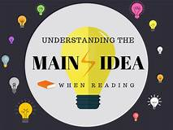
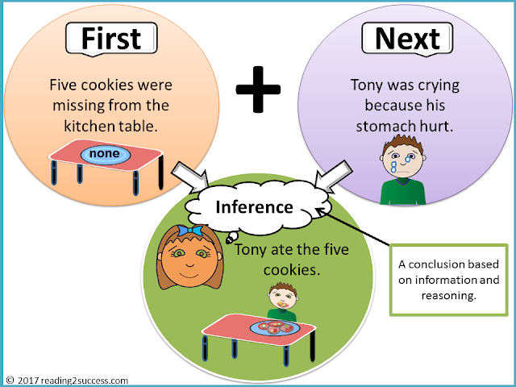

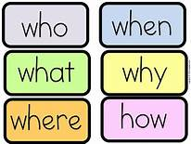

We have been working on the phoneme ‘ae’ and its different representations.
Some words just need the letter ‘a’ to make the sound, e.g., alien, basic
We use a split phoneme ‘a-e’, by adding on the e at the end the sound changes, e.g., bake, trade, escape
We can use ‘ai’, e.g., train, complain
We can use ‘ay’, e.g., away, delay
We can use ‘ey’, e.g., they, obey
We can use ‘ea’, e.g., break, steak
We can use ‘aigh’, e.g., straight
We can use ‘eigh’, e.g, eight, sleigh

Parents/Carers: What can you do to help?
- Encourage your child to read as much as possible (15 minutes each night)
- Encourage your child to practise the focus phoneme (this will change every 4 weeks)
- Encourage your child to practise their tricky word list using activities from the ‘spelling menu’.
Elkonin Boxes
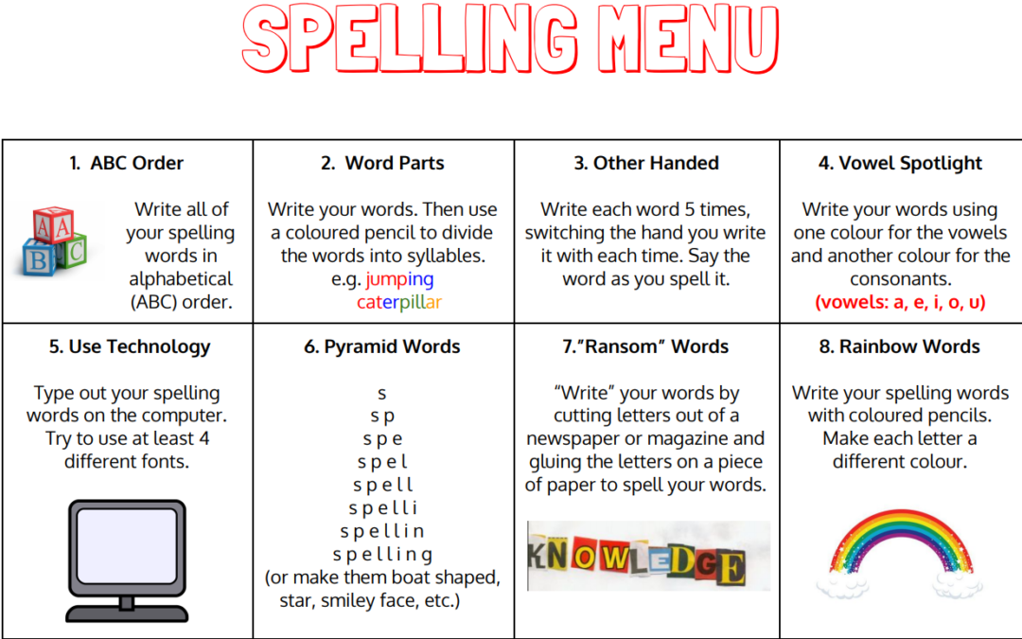
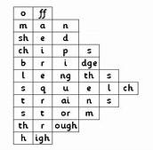
Diacritical Marking
- For single sound
- For joined phoneme (sound)
For split phoneme

