Learning so far…
Numeracy:
- To use my knowledge of place value to count, read, write, partition and order numbers.
  - I can count on and back from any number
  - I can talk about the digits which make up a number and can work out what each digit represents
  - I can put a number into a place-value frame with the digits in the correct position.
  - When I see a number written in digits, I can read it out correctly by working out the value of each digit in its position knowing zero is a placeholder
  - When I hear a number read out I can work out how to write the number in digits
  - I can use my knowledge of place value to partition a number
  - I can compare and order numbers
Parents/Carers - What can you do to help?
- Encourage your child to talk about digits and what digits represents in numbers, for example, in 6351 the value of the ‘6’ is 6000/6 thousand, the value of the ‘3’ is 300/3 hundred, the value of the ‘5’ is 50/fifty and the ‘1’ is 1/one.
- Encourage your child to read and write numbers in digits as well as in words including numbers with 0 as a place value holder, for example, 5001 or 2020.
- Practice partitioning numbers, for example, 5702 = 5 Thousands 7 Hundreds, 0 Tens and 2 Units OR 5000+700+0+2
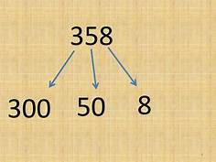
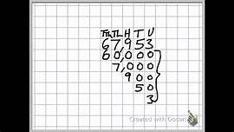

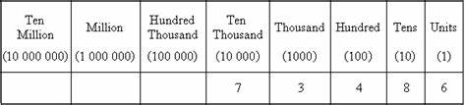

- To recall my number bonds quickly and accurately and can use multiples of 10 and 100 to create new facts.
  - I can recall addition and subtraction bonds to 20, for example 1+19, 2+18, 3+17, 4+16 etc.
  - I can answer questions which use a wide vocabulary, e.g., How many more/less is …?, What is the difference between…?, What is the sum of…?
  - I can explain what doubles are and can recall double facts
  - I can use my knowledge of how to multiply and divide by 10 to multiply and divide by 100
  - I can use my knowledge of number bonds and multiply by 10 and 100 to create new addition and subtraction facts, e.g.,
5+4=9 so 50+40=90 and 500+400=900 and 13-9=4 so 130-90=40 and 1300-900=400
Parents/Carers – What can you do to help?
- Encourage your child to multiply and divide numbers by 10 and 100
- Practise addition and subtraction calculations with your child using multiples of 10 and 100
Tasks:
- Quick grids: Ask children to draw some 3×3 grids. In the top left they draw a + sign. In the other two spaces in the top row and in the left column they write 2- or 3-digit multiples of 10 (or alternatively 3- or 4-digit multiples of 100). Finally, they fill in the remaining four spaces with the totals, e.g. add the 50 to 30 and 140 and add the 170 to 30 and 140 to fill in the totals.
+ | 50 | 170
80 | 130 | 250
140 | 190 | 310

- Write a guide: Ask children to write a short guide to help younger children to understand how to find totals and differences of multiples of 10 and 100 using facts already known, e.g. how to work out 150 – 80, 700 + 1600 or 2500 – 1800.

