Week beginning: 18.10.21 Primary 2
Please try and log in to some of the online learning resources on the Password Passport. Let me know if there are any issues with logins. Thank you 😊
Literacy | Numeracy | Health and Wellbeing
Phonics  This week we will be learning about the phoneme ‘ea’  How many words can you think of that have the ea sound?  https://www.youtube.com/watch?v=Yc36_Imtiig  Log on to Study ladder for some ea phonics activities. You do not need to complete all of the activities you can choose which ones to do.  Study Ladder  Spelling  each  year  ask  eat  Reading  Reading for enjoyment: Try logging in to myON and choose a book to read or read your favourite reading book at home.  Can you tell someone at home (summarise) what your reading book in school is all about? | Log in to SumDog and choose some activities to do.  https://www.sumdog.com/sc/  How many ways can you show the number 12?  How many calculations can you think of to make the number 12?  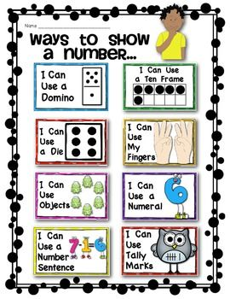 | We are learning all about Autumn. Take some time to do something you enjoy doing at autumn time e.g an autumn walk, collecting items such as conkers or making art some work.  Have fun  