Primary 3 27.9.2021
Here is a preview of the work we will be covering this week in class. Please could go over the new phoneme (wa), tricky spelling words and continue to revise number bonds?
Tricky spelling words:  second  fifteen  five  fourteen | Phoneme: “wa”  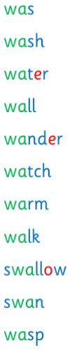 | Numeracy: Place Value  What is place value?  Place value is the value of each digit in a number. For example, in '123', the place value of '1' is 100, '2' is 20 and '3' is 3.  Click on the link to play a game to help reinforce learning:  Place Value Basketball  MATHS WEEK SCOTLAND- pick and choose!  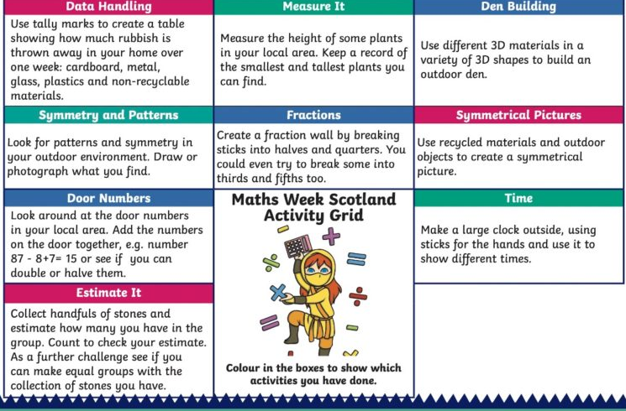 | PATHS: Feelings  We have been using PATHS to introduce lessons on emotions. We have been talking about the fact that feelings are on the inside but can show on the outside.

