Primary 2 week beginning 4.10.2021
Spelling words:  day  away  always  today | Phoneme:  ay  Try out studyladder! | 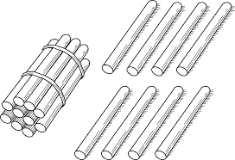  Ways to make the number:  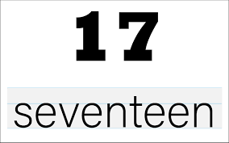  17 and 18  Check out https://www.topmarks.co.uk/maths-games/robot-more-or-less
PATHS  “Compliments.”  Can you give someone at home a compliment? | Literacy  Reading : Log on and choose a book !  https://www.myon.co.uk/login/
Just though you would like to know about some of the work we will be covering this week in class. It would be really helpful if you could go over spelling words, our phoneme and some number facts.

