Week beginning: 4.10.21 Primary 2
Please try and log in to some of the online learning resources on the Password Passport. Let me know if there are any issues with log ins. Thank you 😊
Literacy | Numeracy | Health and Wellbeing
Phonics  This week we will be learning about the phoneme ‘ay’  How many words can you think of that have the ay sound?  https://www.youtube.com/watch?v=eoy1JXYPn6w  Log on to Study ladder for some ay phonics activities.  Study Ladder  Spelling  Day  Away  Always  Today  Reading  Reading for enjoyment: Try logging in to myON and choose a book to read or read your favourite reading book at home.  This week we will be starting our reading books.  Can you tell someone at home (summarise) what your reading book is all about? | Log in to Education City for games that work on adding and subtracting within 10.  https://www.educationcity.com/  How many ways can you show the number 11?  How many calculations can you think of to make the number 11?  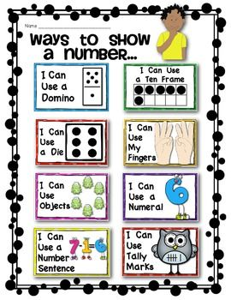 | What is a compliment?  Can you give someone at home a compliment?

