Primary 2 week beginning 27.9.2021
Spelling words:  said  her  could  before | Phoneme:  ph  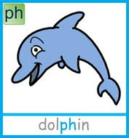  Try out studyladder! | Ways to make the number:  15 and 16  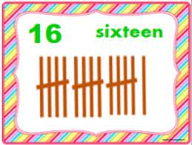  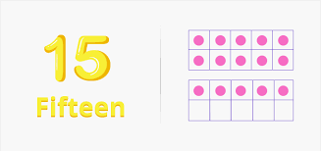
PATHS  “Compliments.” | Literacy  Reading : Log on and choose a book !  https://www.myon.co.uk/login/
Just though you would like to know about some of the work we will be covering this week in class. It would be really helpful if you could go over spelling words, our phoneme and some number facts.

