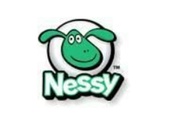
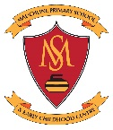
August 2021
Parent/Carer Information
Nessy Reading and Spelling
Your child has been enrolled in Nessy Reading and Spelling, an online, game-based programme that allows children to enhance their reading and spelling skills.
Once again this year, as part of our literacy focus, we are able to continue to give all children from P3 - 7 access to this individually tailored programme.
Nessy can be used at home if your child has access to a computer or tablet. The programme will only work through Google Chrome, Safari or Firefox browsers.
To log in, please follow the instructions below:
1) Visit the Nessy website at http://play.nessy.com/login/
2) Enter the "Secret Word”, at Mauchline PS & ECC the word is relievedarch (no spaces between the two words).
3) Your child should then enter in their first name.
4) The first time your child logs in they will take part in a Reading Challenge and a Spelling Challenge. This will then allow the programme to target specific skills to support your child’s development in reading and spelling.
5) Once your child has completed both challenges they should select the arrow beside ‘My Targets’ (next to the monkey) and play one or more of the selected games.
6) Have fun and develop reading and spelling skills at the same time!
If you have any trouble accessing Nessy, or you wish to withdraw your child from the programme, please contact Mrs Cross: susan.cross1@eastayrshire.org.uk

