Home Learning Grids- First Level (P3, P4 & P5)
Each day, choose 1 literacy and 1 numeracy task and either 1 expressive arts/STEM challenge OR 1 from the separate P.E. challenge grid. If you choose an expressive arts/STEM challenge on day 1, make sure you choose a P.E. challenge on day 2 or vice versa. Parents/Carers please remember that you may need to modify some of the activities to suit the specific level that your child is currently working at. Send pictures/videos of your completed task to your teacher on TEAMS if you can.
Week 1
Literacy | Numeracy | Expressive Arts/STEM
Design a Starbucks Smoothie-  Starbucks want you to design a new smoothie for their Autumn/Winter collection. Write the recipe-  - List the ingredients  - Method- how do you  make it?  - Draw a picture of  what it will look  like. | Topmarks Bingo Game-  Choose a times table you find tricky. Play Topmarks Bingo- Multiplication & Division for 20 minutes or until you feel more confident with the answers. Could you challenge a family member to play with you?  https://www.topmarks.co.uk/  *Challenge- choose another multiplication game to play.* | Family Movie Night-  Plan a family movie night. Design a poster to advertise the movie. Add the date, time and location of the movie. Display it somewhere your family will see it, i.e. on the fridge.  *Optional- prepare the movie area and some snacks for family members.*
Job Application Task-  What is your dream job? Create a CV.  Tell us why this is your dream  job, why you should get it,  list your skills and qualities  and why you are suitable for  this job. | Sumdog-  Spend 30 minutes on Sumdog- if your teacher has set your class a challenge, complete this first. If not, choose your own games!  https://pages.sumdog.com/ | Arty Food Task-  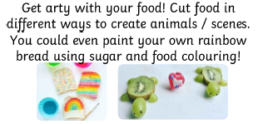
Literacy | Numeracy | Expressive Arts/STEM
Question Master  Create 5 questions about the book you are currently reading (either personal or class novel). Start each question with why, what, where, when or how. | Estimation Activity-  - Estimate how tall each person in your house is in cm.  - Estimate how long it takes to do 30 star jumps in seconds.  - Check both answers using a measuring tape and timer if you have them- how many cms/seconds were you away from the real answer?  *Challenge- convert answers to metres and centimetres/minutes and seconds.* | Spaghetti Bridge STEM-
Isolation Interview-  Interview someone you know- they could live with you or you could phone them. Questions could include:  - What have you had to change about your life in the last few months?  - Do you have any new hobbies?  - What do you miss most?  - Have you learned any important life lessons?  *Challenge- think of your own additional questions to ask.* | Money Chilli Challenge-  Start with the green chilli challenges then try the orange ones.  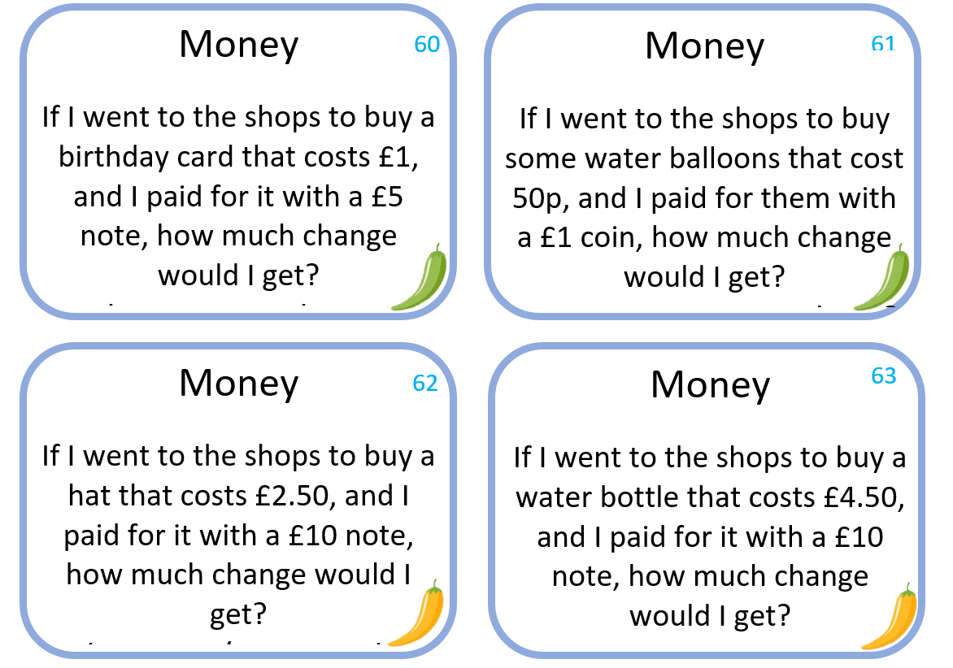 | Word Art  Go to https://wordart.com/ and create a word art picture filled with compliments for someone that means a lot to you.  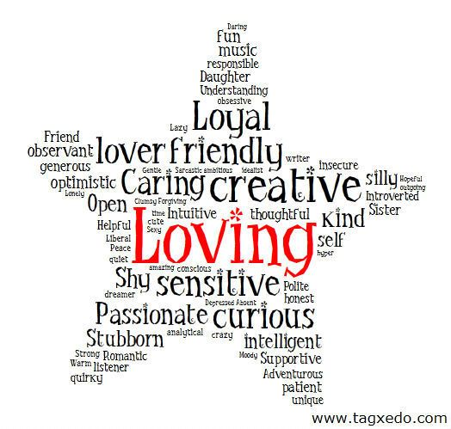
Literacy | Numeracy | Expressive Arts/STEM
You’ve Got a Friend in Me-  Write a postcard to your best friend. What do you want to tell them? What questions would you like to ask them?  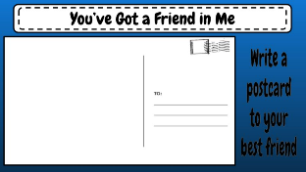 | Rounding Activity-  Go as far as you can in this challenge.  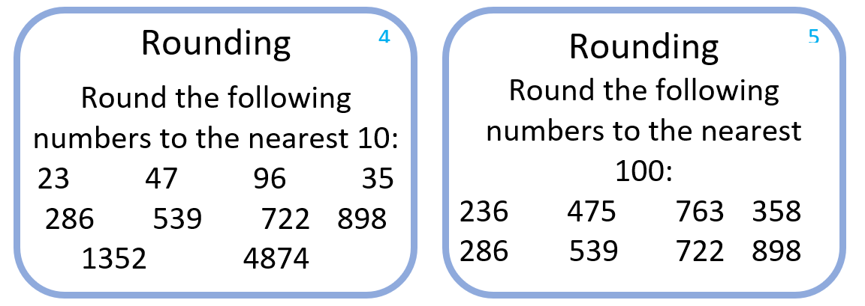 | Freezing Liquids Activity-  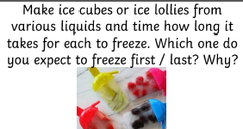
*Remember to complete a minimum of 30 minutes per day of personal reading using your Accelerated Reader book. If you don’t have any books at home, try reading magazines, cookbooks, comics or online books. You can check the Book Level of your book using AR Bookfinder: https://www.arbookfind.co.uk/default.aspx
For additional activities:
All children have a log in for Sumdog & Education City, sites which develops mental maths and problem solving skills: https://pages.sumdog.com/ https://www.educationcity.com/ (ask your child’s teacher if they don’t know their log in)
Oxford Owls have a library of free books: https://www.oxfordowl.co.uk/
Free audiobooks for children: https://www.storynory.com/
Lots of free maths games: https://www.topmarks.co.uk/
Daily lessons in literacy, numeracy and health and wellbeing: https://www.bbc.co.uk/bitesize
Learn, create and play through exploring Scotland’s history and heritage: https://www.historicenvironment.scot/learn/
STEM (Science, Technology, Engineering & Maths) with Mr N: https://www.youtube.com/channel/UCxziq4omrQP-EKSLilOIPhw
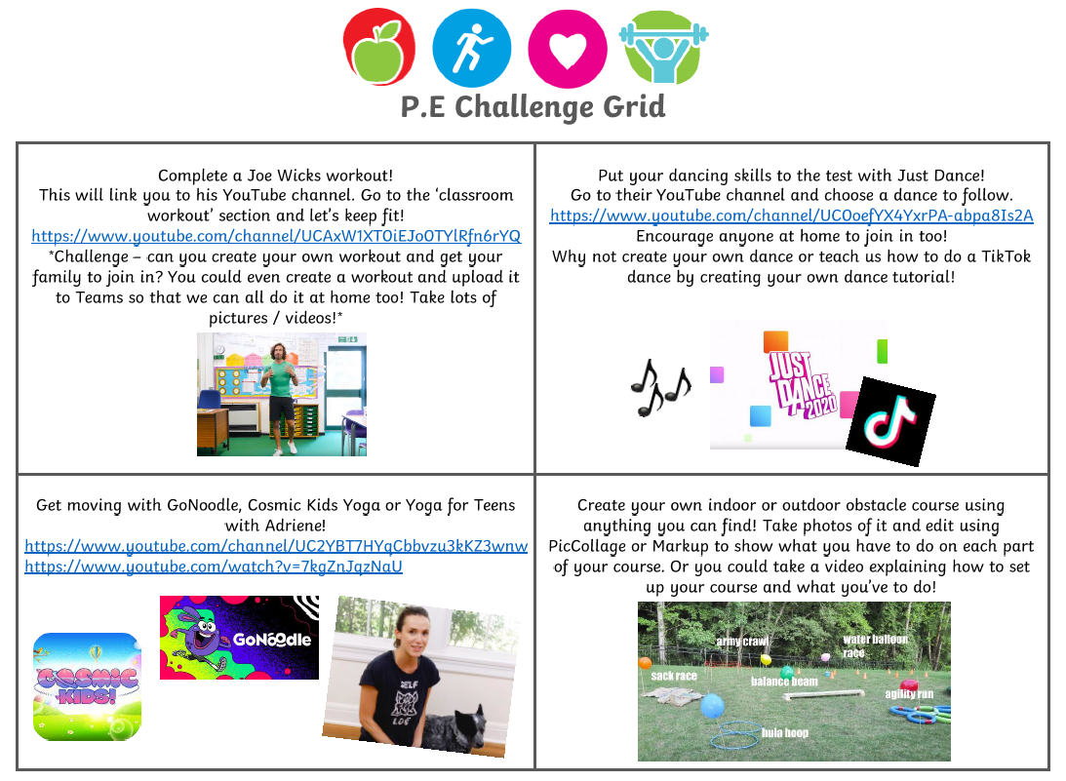
Week 2
Literacy | Numeracy | Expressive Arts
Poetry Task-  Listen to a poem on:  https://childrens.poetryarchive.org/  Three discussion points:  - What did you like/dislike about the poem?  - Any connections you can make to your own life?  - Puzzles- anything that confused you?  *Challenge- record yourself reciting the poem. Have a go at writing your own poem with the same title but use your own words!* | Education City-  Spend 45 minutes on Education City- if your teacher has set your class a challenge on My City, complete this first. If not, choose your own games!  https://educationcity.com/ | Kitchen Roll Art-  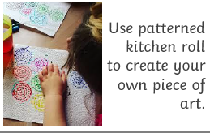
Research Project: Favourite Animal-  Choose an animal that you love and want to find out more about. Create a fact sheet (handwritten or typed on Word)  - Describe this animal  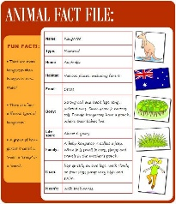  - What do they eat?  - What is their habitat like?  - What is their lifespan?  - Fun facts about this animal  *Challenge- film a David Attenborough-style nature documentary, telling your viewers all about this animal.* | Counting in 2s, 5s, 10s & 100s-  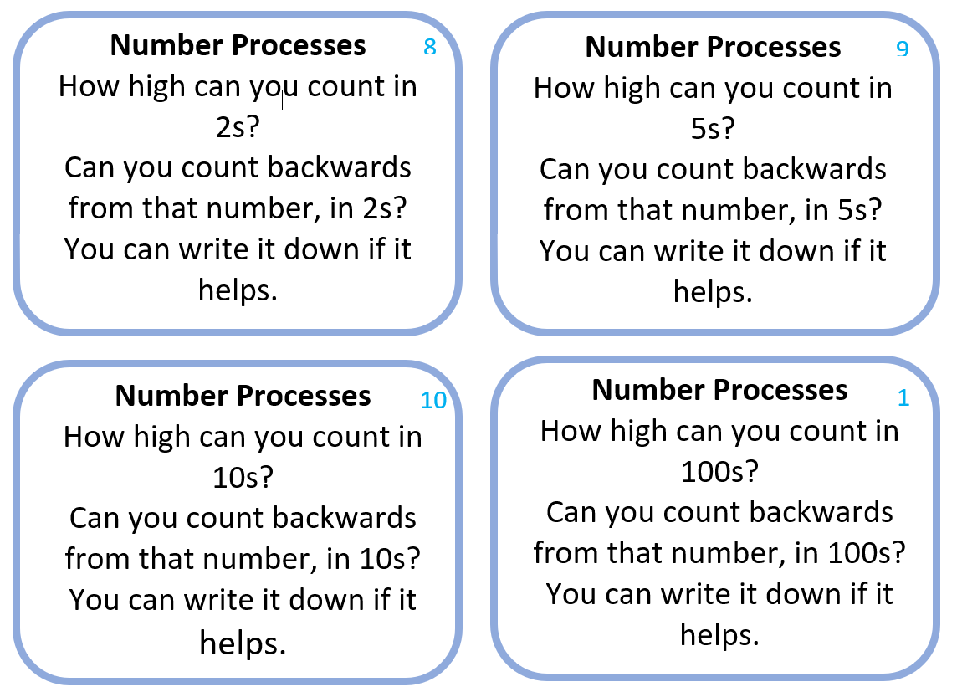 | Blanket Fort-  Design and create your own blanket fort. Take a picture and share it on TEAMS.  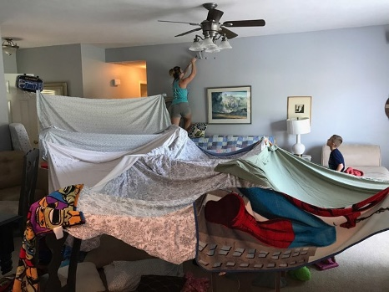
Literacy | Numeracy | Expressive Arts/STEM
Design a New Toy-  - List the materials your toy will be made of, e.g. wood, plastic, etc.  - Who is the toy for? E.g. babies, age 7-10 year olds, etc.  - Describe how you would play with the toy.  Draw your design with labels and details on a piece of paper. | Topmarks-  Play Hit the Button Division Facts (divide by 1, 2 & 3)  https://www.topmarks.co.uk/maths-games/hit-the-button  *Challenge- try dividing by 4 & 5.* | Cereal Box STEM Challenge-
Newspaper Challenge-  Using a newspaper, magazine or a book find words that you don’t know the meaning of. Write them down and use a dictionary (online dictionary is fine) to find a definition for them. | Seasons Activity-  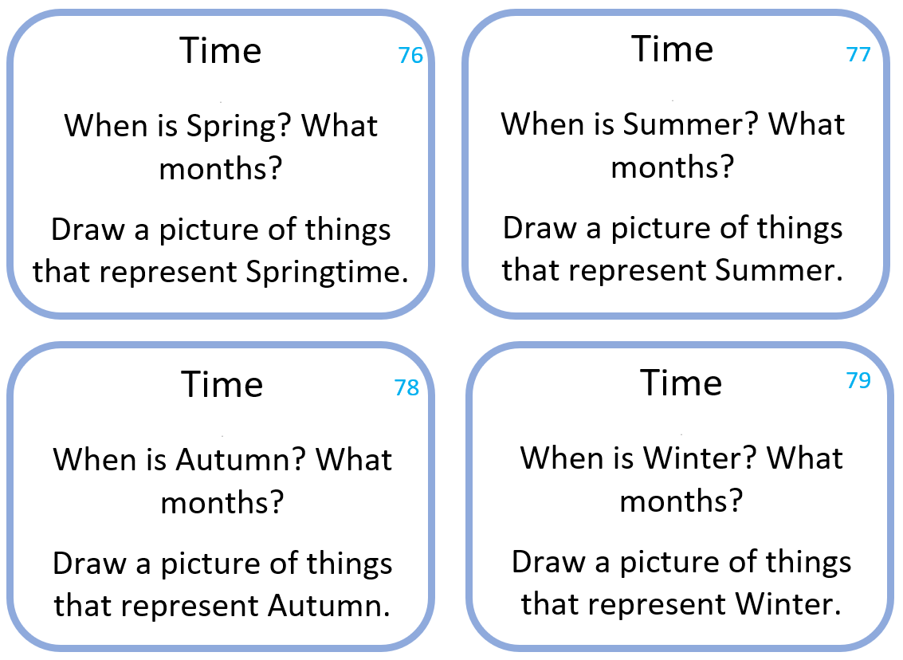 | Origami Activity-  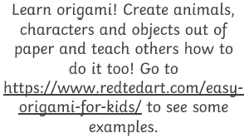  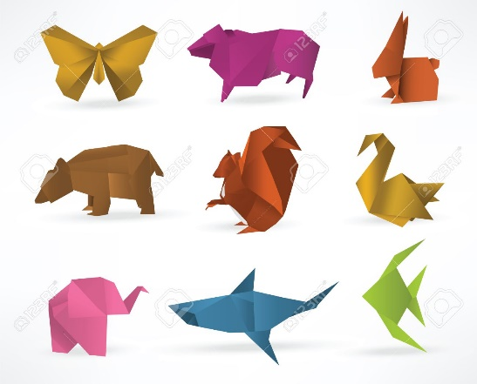
Literacy | Numeracy | Expressive Arts/STEM
ABC Order-  Write the words you used in your newspaper challenge out in alphabetical order. Then write them in reverse alphabetical order.  Word Search-  Create your own word searches using your words. Or use this link to get your computer to do it for you.  http://puzzlemaker.discoveryeducation.com/ | Number Processes Chilli Challenge-  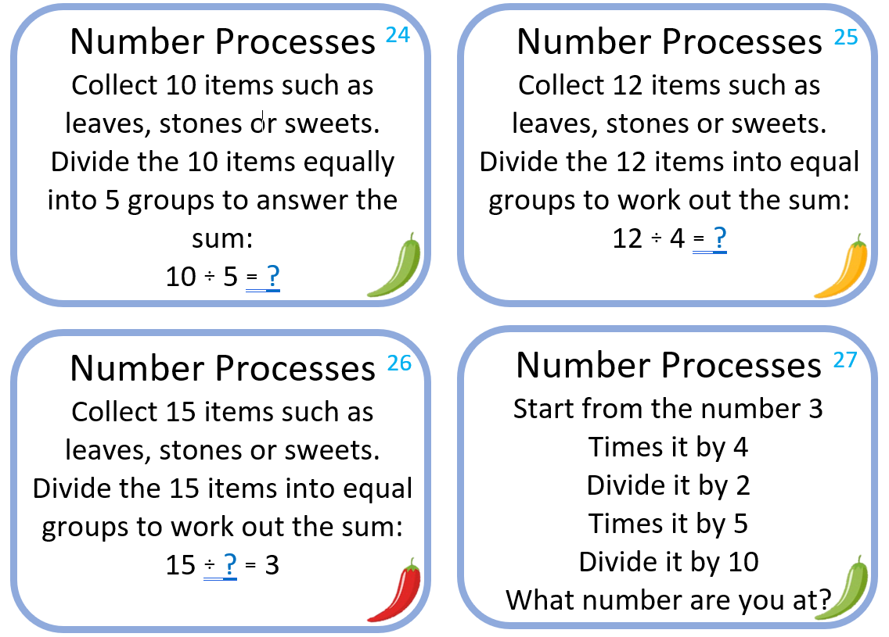 | Coding Challenge-  Go to https://code.org/learn and choose a coding activity to complete. My personal favourite is the Minecraft Hour of Need one.  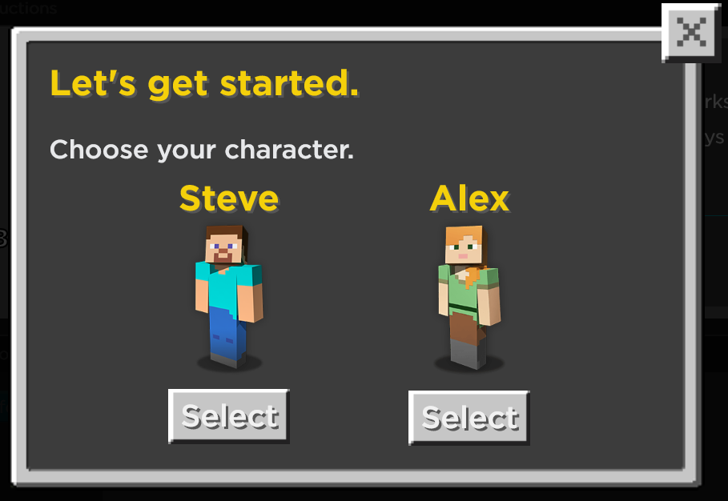
*Remember to complete a minimum of 30 minutes per day of personal reading using your Accelerated Reader book. If you don’t have any books at home, try reading magazines, cookbooks, comics or online books.
For additional activities:
All children have a log in for Sumdog & Education City, sites which develops mental maths and problem solving skills: https://pages.sumdog.com/ https://www.educationcity.com/ (ask your child’s teacher if they don’t know their log in)
Oxford Owls have a library of free books: https://www.oxfordowl.co.uk/
Free audiobooks for children: https://www.storynory.com/
Lots of free maths games: https://www.topmarks.co.uk/
Daily lessons in literacy, numeracy and health and wellbeing: https://www.bbc.co.uk/bitesize
Learn, create and play through exploring Scotland’s history and heritage: https://www.historicenvironment.scot/learn/
STEM (Science, Technology, Engineering & Maths) with Mr N: https://www.youtube.com/channel/UCxziq4omrQP-EKSLilOIPhw
