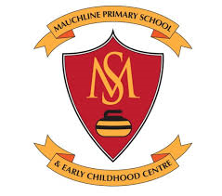
Home Learning Grids- Early Level (P1 & P2)
Each day, choose 1 literacy and 1 numeracy task and either 1 expressive arts/STEM challenge OR 1 from the separate P.E. challenge grid. If you choose an expressive arts/STEM challenge on day 1, make sure you choose a P.E. challenge on day 2 or vice versa. Parents/Carers please remember that you may need to modify some of the activities to suit the specific level that your child is currently working at.
Send pictures/videos of your completed task to your teacher on TEAMS if you can.
Week 1
Literacy | Numeracy | Expressive Arts/STEM
Phonics- Learn to Read- Rhyming Words-  Watch the Alphablocks video and encourage your child to say out loud the letters (phonemes)/ words they recognise. https://www.youtube.com/watch?v=Os9P7wsDZa0  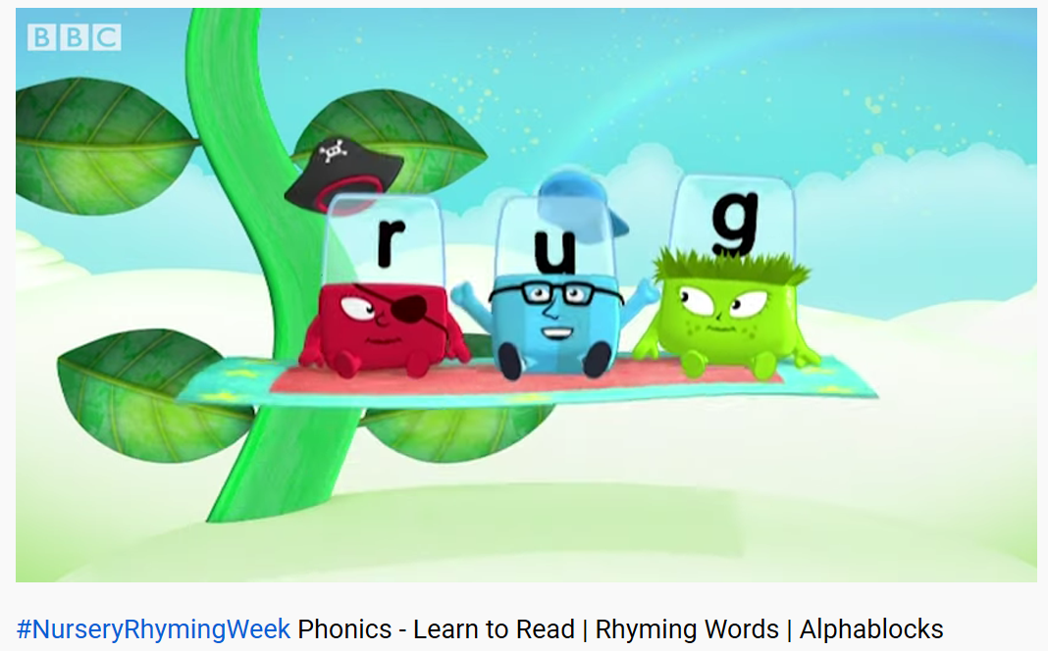 | Topmarks Number Bonds Game-  Play Topmarks Number Bonds Up to 10 games for 20 minutes or until you feel more confident with the answers. If you find this easy, move on to Number Bonds up to 20 games.  https://www.topmarks.co.uk/maths-games/hit-the-button  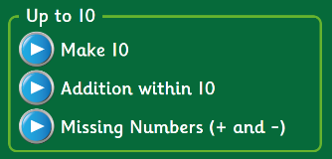  *Challenge- try playing Number Bonds Up to 100 games.* | My Favourite Things-  Draw a picture of your favourite things about school.  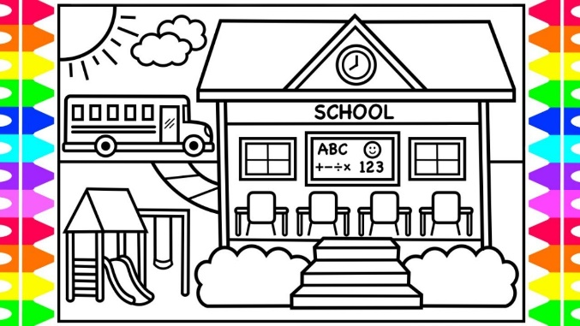
Story Book Challenge- Read a short story or ask an adult to read one to you.  - Choose 1 character. Would you like him/her to be your friend? Why?  - What was your favourite part of the story? Explain why.  - Anything you didn’t like? Why?  *Challenge- ask someone to help you make a video of yourself answering one or all the above questions. | Sorting Objects-  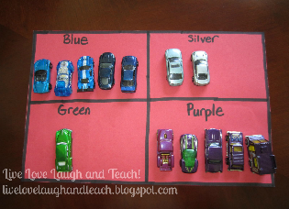  Find some objects from around your house or from the garden and sort them into different groups. How many ways can you sort them? E.g. toy cars - sort them by size, colour or make.  Take a photo and send it to  your teacher! | Arty Food Task-  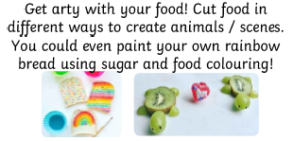  Ask a parent/carer to help you with this task.
Literacy | Numeracy | Expressive Arts/STEM
Colour by Christina Rossetti-  There are 3 videos to watch:  - Listen to the story  - Read key words from the story  - Share enjoyment of the story  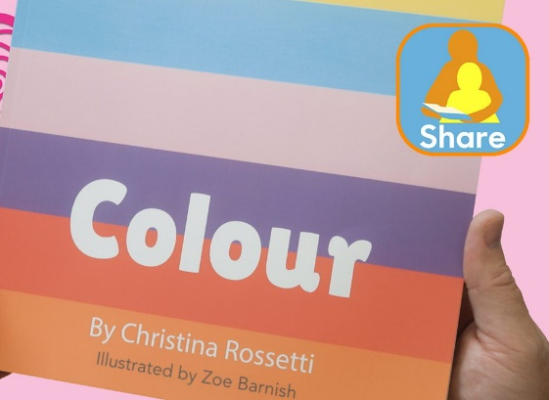  https://www.bbc.co.uk/bitesize/topics/zvyc7nb/articles/zjyfnrd | The Spider’s Web-  Write numbers 1-20 randomly on a page and circle each number. Start at 1 and join in order up to 20. If you find this easy, try numbers 1-50 and if you really want to challenge yourself, 1-100!  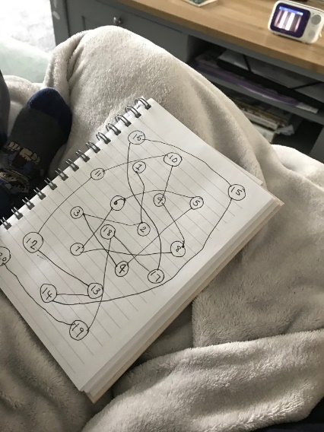 | Salt Dough-  Make the salt dough recipe below. You could:  - Make prints with leaves, stones, etc.  - Print with toys, e.g. Lego, dinosaurs  - Make your name  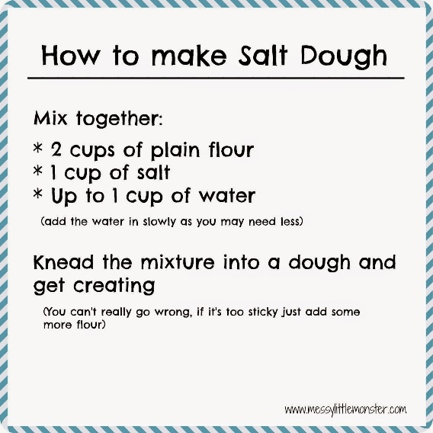
Spelling Activity-  Choose 5 words from your reading book that you think are ‘Wow Words’.  - Air write your words in the air  - Cut out letters from a magazine and stick together to make the words  - Rainbow write your words  - Draw a picture to match each word  *Challenge- write a sentence for each word (or say the sentence and ask an adult to write it for you). | Topmarks Helicopter Rescue Game-  Play Find a Number and Count On & Back 1-10 &1-20. If you find this easy, play 1-30.  https://www.topmarks.co.uk/learning-to-count/helicopter-rescue  *Challenge- try 1-50 and 1-100!* | Shape Art  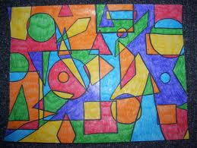  Try and find as many different shaped items around the house. Draw round them on a piece of paper and colour to create your own ‘shape art’.
Literacy | Numeracy | Expressive Arts/STEM
Fine Motor Skills-  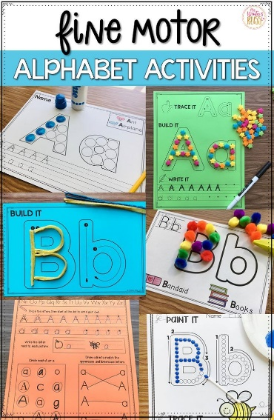  Practise making patterns, letters and numbers in sand, rice, shaving foam or with buttons and playdough. Anything you have in the house! | Shop Imaginary Play Activity-  Find 5 toys, write 5 amounts on post its or pieces of paper, e.g. 5p, 8p, etc. ‘Play shops’- use a calculator as a till register and loose change. Children can be the customer or the shop worker and they need to find the right amount to pay for the items or work out change.  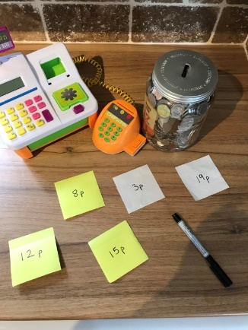  *Challenge- try larger amounts and buy more than 1 item. | Freezing Liquids Activity-  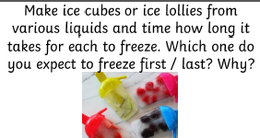
For additional activities:
All children have a log in for Sumdog & Education City, sites which develop mental maths and problem solving skills: https://pages.sumdog.com/ https://www.educationcity.com/ (ask your child’s teacher if they don’t know their log in)
Oxford Owls have a library of free books: https://www.oxfordowl.co.uk/
Free audiobooks for children: https://www.storynory.com/
Lots of free maths games: https://www.topmarks.co.uk/
Daily lessons in literacy, numeracy and health and wellbeing: https://www.bbc.co.uk/bitesize
Learn, create and play through exploring Scotland’s history and heritage: https://www.historicenvironment.scot/learn/
STEM (Science, Technology, Engineering & Maths) with Mr N: https://www.youtube.com/channel/UCxziq4omrQP-EKSLilOIPhw
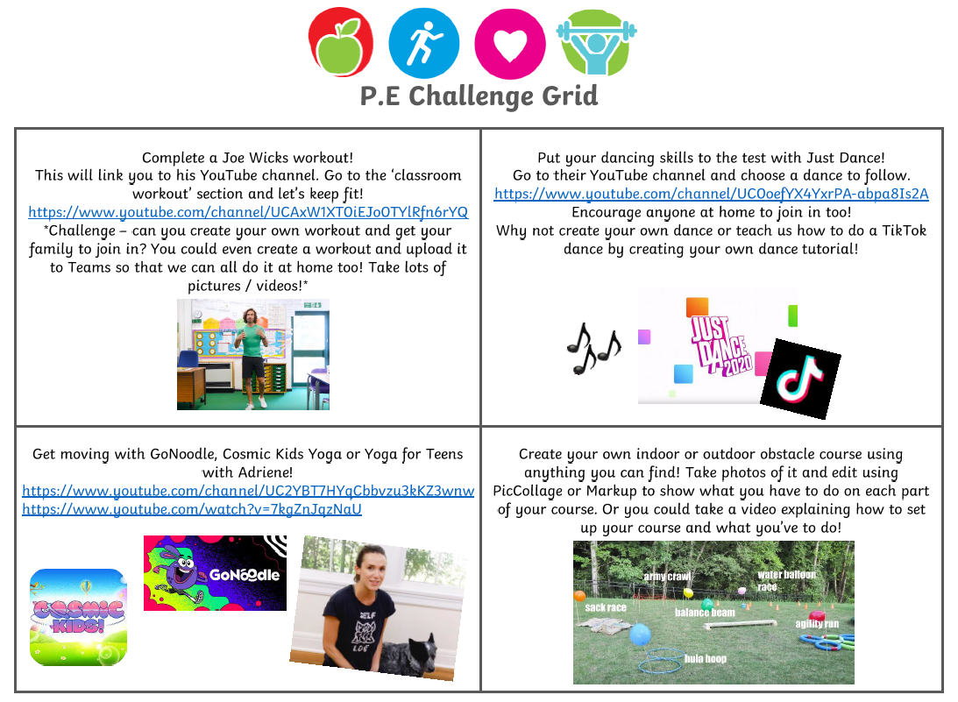
Week 2
Literacy | Numeracy | Expressive Arts
Aliens Love Underpants-  There are 3 videos to watch:  - Listen to the story  - Read key words from the story  - Share enjoyment of the story  https://www.bbc.co.uk/bitesize/topics/ zvyc7nb/articles/zmgbvk7 | Tick Tock-  How many times can you do these things in just one minute? (use a phone timer)  - bounce a ball  - hop of one foot  - run around your garden  - write your name  - do star jumps  Write your scores down and try to beat them! | Kitchen Roll Art-  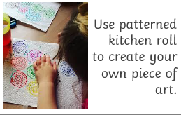
Research Project: Favourite Animal-  Choose an animal that you love and want to find out more about.  - What does this animal look like?  - What do they eat?  - Where do they live?  - Can you find out fun facts about this animal? (Youtube videos are great for this!) | Numberjacks-  Learn to count with Numberjacks:  https://www.youtube.com/watch?v=4aC6D4VcmaA  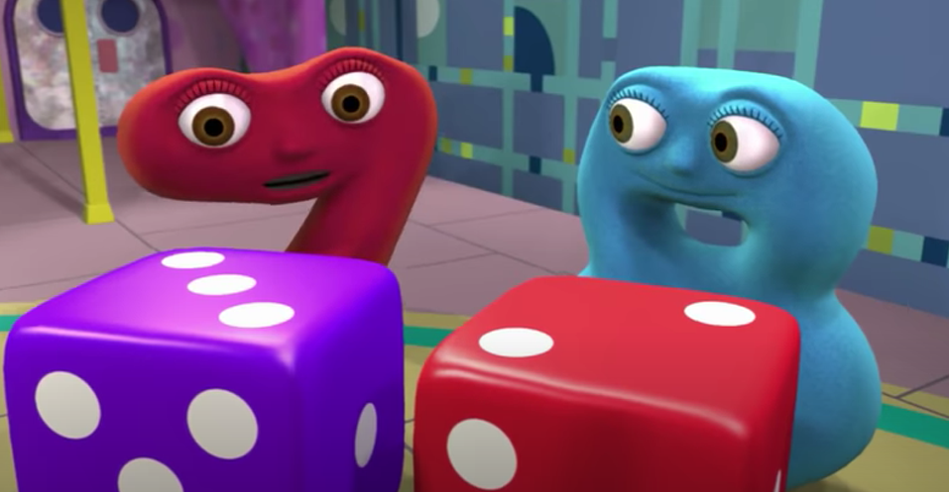  *Challenge- write down the numbers that you spot in the Numberjacks clip. At the end, count which numbers you’ve written down the most. | Blanket Fort-  Design and create your own blanket fort. Take a picture and share it on Seesaw.  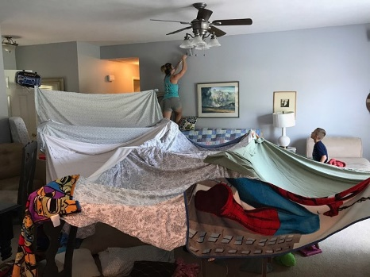
Literacy | Numeracy | Expressive Arts/STEM
Safety in School Poster-  Design a poster that we can use at school to show children how to stay safe:  - Wash your hands  - Sneeze into elbows  What other things do we need to remember? | Topmarks Coconut Odd or Even Game  Play the odd or even games 1-20. If you find this easy, try 1-50.  https://www.topmarks.co.uk/learning-to-count/coconut-odd-or-even  *Challenge- try up to 100 games! | Build Your Own Castle Features-  Build your own arch, battlements, drawbridge or portcullis at home! Use what you have- Lego, blocks, pillows and blankets, or cereal boxes and yoghurt pots. See link below for ideas:  https://www.historicenvironment.scot/media/ 6466/build-your-own-castle-features.pdf  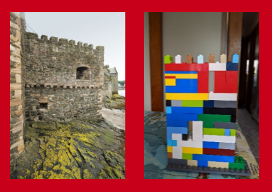
Spelling Activity-  Choose 5 words from your reading book that you think are ‘Wow Words’.  - Air write your words in the air  - Draw a picture and hide your words inside  - Write your words on someone in your houses back and ask them to guess what the word is  - Write the words in all small letters then all capital letters  *Challenge- write a sentence for each word (or say the sentence and ask an adult to write it for you). | Four Pin Bowling  Which pins must be knocked down to score exactly 5?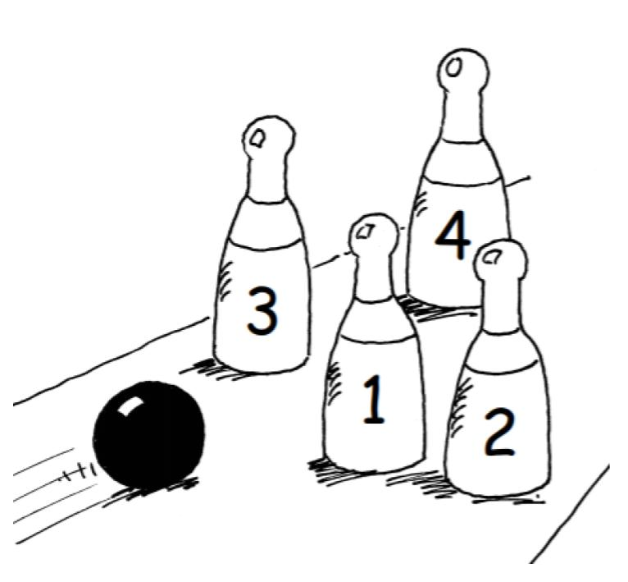  Find 2 different ways:  - to score 5  - to score 6  - to score 7 (Write down your sums and answers.) | Treasure Hunt-  Create a treasure hunt for someone to complete with clues that will lead them round the house/garden to a final destination.  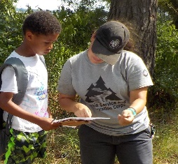
Literacy | Numeracy | Expressive Arts/STEM
Lego Characters Story Writing-  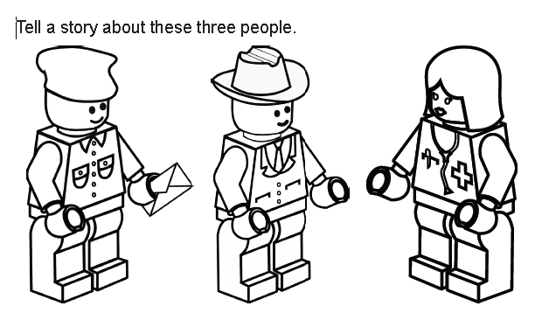  Either tell the story out loud to an adult, film yourself telling the story or write the story down.  - What are the characters names?  - What jobs do you think they do?  - What are they talking about?  - What happens next? | Snowflakes Activity-  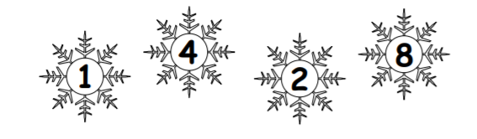  - Pick a pair of numbers and add them together, write all the numbers and answers.  - Keep doing it, how many different ways can you find?  - Now take the numbers away from each other, how many different answers can you get?  *Challenge- choose 4 of your own bigger numbers and repeat the steps above.* | Battery Scavenger Hunt-  Do batteries really power the world? Find as many things around your house as you can that are powered with batteries.  - Take pictures or draw the items you find.  - Sort your toys into categories: ‘battery powered’ and ‘don’t need batteries’  - How do batteries work? Can you find out?  *Remember batteries are not toys and should be left to an adult to handle.*
For additional activities:
All children have a log in for Sumdog & Education City, sites which develops mental maths and problem solving skills: https://pages.sumdog.com/ https://www.educationcity.com/ (ask your child’s teacher if they don’t know their log in)
Oxford Owls have a library of free books: https://www.oxfordowl.co.uk/
Free audiobooks for children: https://www.storynory.com/
Lots of free maths games: https://www.topmarks.co.uk/
Daily lessons in literacy, numeracy and health and wellbeing: https://www.bbc.co.uk/bitesize
Learn, create and play through exploring Scotland’s history and heritage: https://www.historicenvironment.scot/learn/
STEM (Science, Technology, Engineering & Maths) with Mr N: https://www.youtube.com/channel/UCxziq4omrQP-EKSLilOIPhw

