Accessing Microsoft Office 365 through Glow

Some help and advice for the parents/carers of

Mauchline PS & ECC.

Access Glow using the username and password provided for the children last week.
When you log in to Glow, you will see a Launch Pad like this.
Please remember everyone can have a slightly different LaunchPad depending on what APPS you have added or whether you are a teacher/pupil etc.
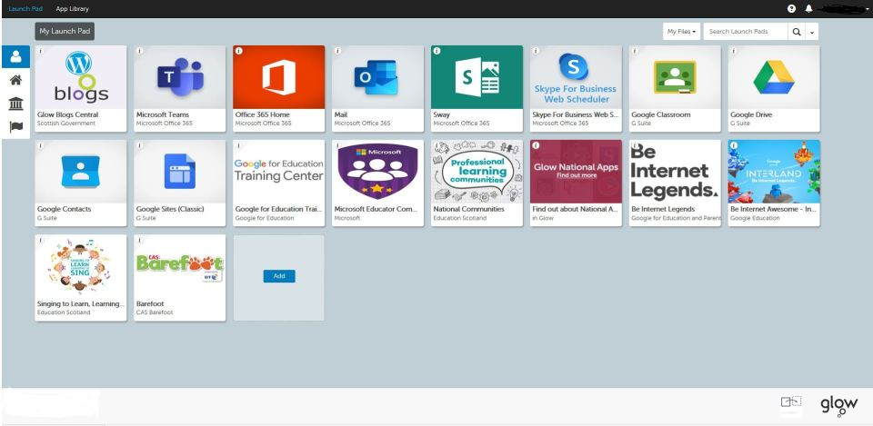

Click on the ‘Office 365 Home’ app (red/orange in colour)

You may reach a sign-in page at some point.
Simply enter the same username and password that you use for accessing the Glow Login page.

You will then see the following page (or something very similar).
This is where you can download multiple copies of ‘Office’ onto your laptop/iPads/tablet etc. (Click the ‘Install Office’ button on the page).
This allows you to have free access to Word (for word-processing documents), Powerpoint (for children to create Powerpoint presentations), Teams (for class-sharing of ideas/work etc) and many more fabulous learning tools.

Hopefully this will help your child access some additional learning tools.

I will try to add more help pages about further uses within Glow.
If you need my help please email me:

easusan.cross1@glow.sch.uk
Here to help! Mrs Cross, Mauchline PS & ECC

