Microsoft Teams Guidance for Parents & Students
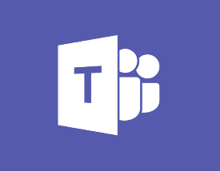
Microsoft Teams for Education brings together students and teachers in an online classroom environment.
What is a TEAM?
A Team is a collection of people who can share conversations, files , tools, assignments all in one place.
Can my child create a TEAM?
No , only Teachers can create Teams.
What is a Channel?
A channel is a discussion in a team dedicated to a department, group , project or topic .
What is the Conversation Tab?
Where all members of the Team can post questions or upload information. (this can be turned off by the teacher if students misuse the Conversation Tab)
The Private Chat function on TEAMS
This is disabled by default for students , it is a useful tool for teachers to discuss assignemts within a Team in private

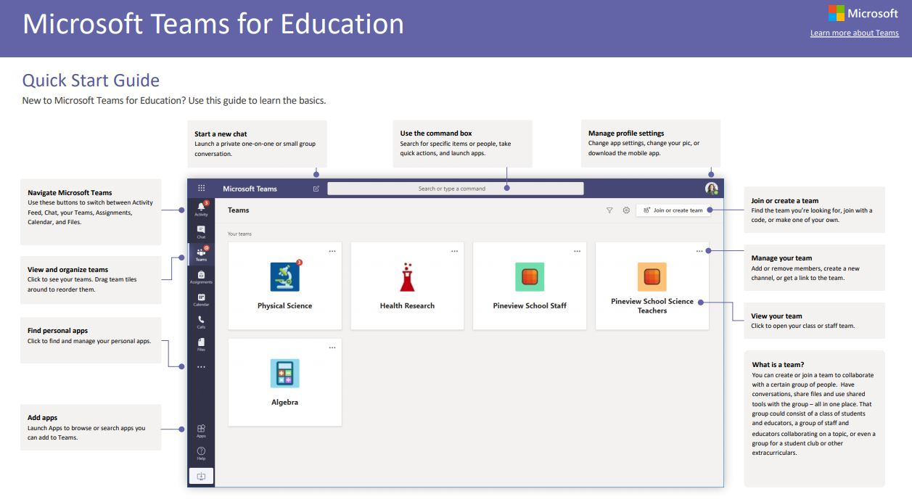
The APP BAR (down the left hand side of the TEAMS APP)
Activity - A notification sign will show if there has been acitivity on your TEAM
Chat - This function is disabled for Students .
Teams - Will show you all the Teams you are a member of.
Assignments - Will show you any assignments you have created or been assigned .

JOIN or CREATE a TEAM
On the top right of your Teams App you will see a box with Join or Create Team

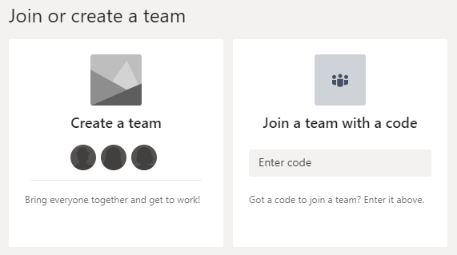

Select this and enter in the CODE supplied to you by your Teacher to Join
Students can chat to there teacher through the Conversation Tab.
Under the Files Tab the Teacher can upload documents , homework and resources for the Students.
The teacher may create seperate tabs for different subjects .

Teams have CHANNELS
Every Team has a Channel , for instance if your teacher wants to create a homework assignment for all the class they will upload the documents under the General Channel.
If the Teacher want different groups within the class to have seperate homework assignments they can create indivuidal Channels under the Team that will be specific to the group that your normally work in.

Lets Get you Started

Log into GLOW - https://glow.rmunify.com/
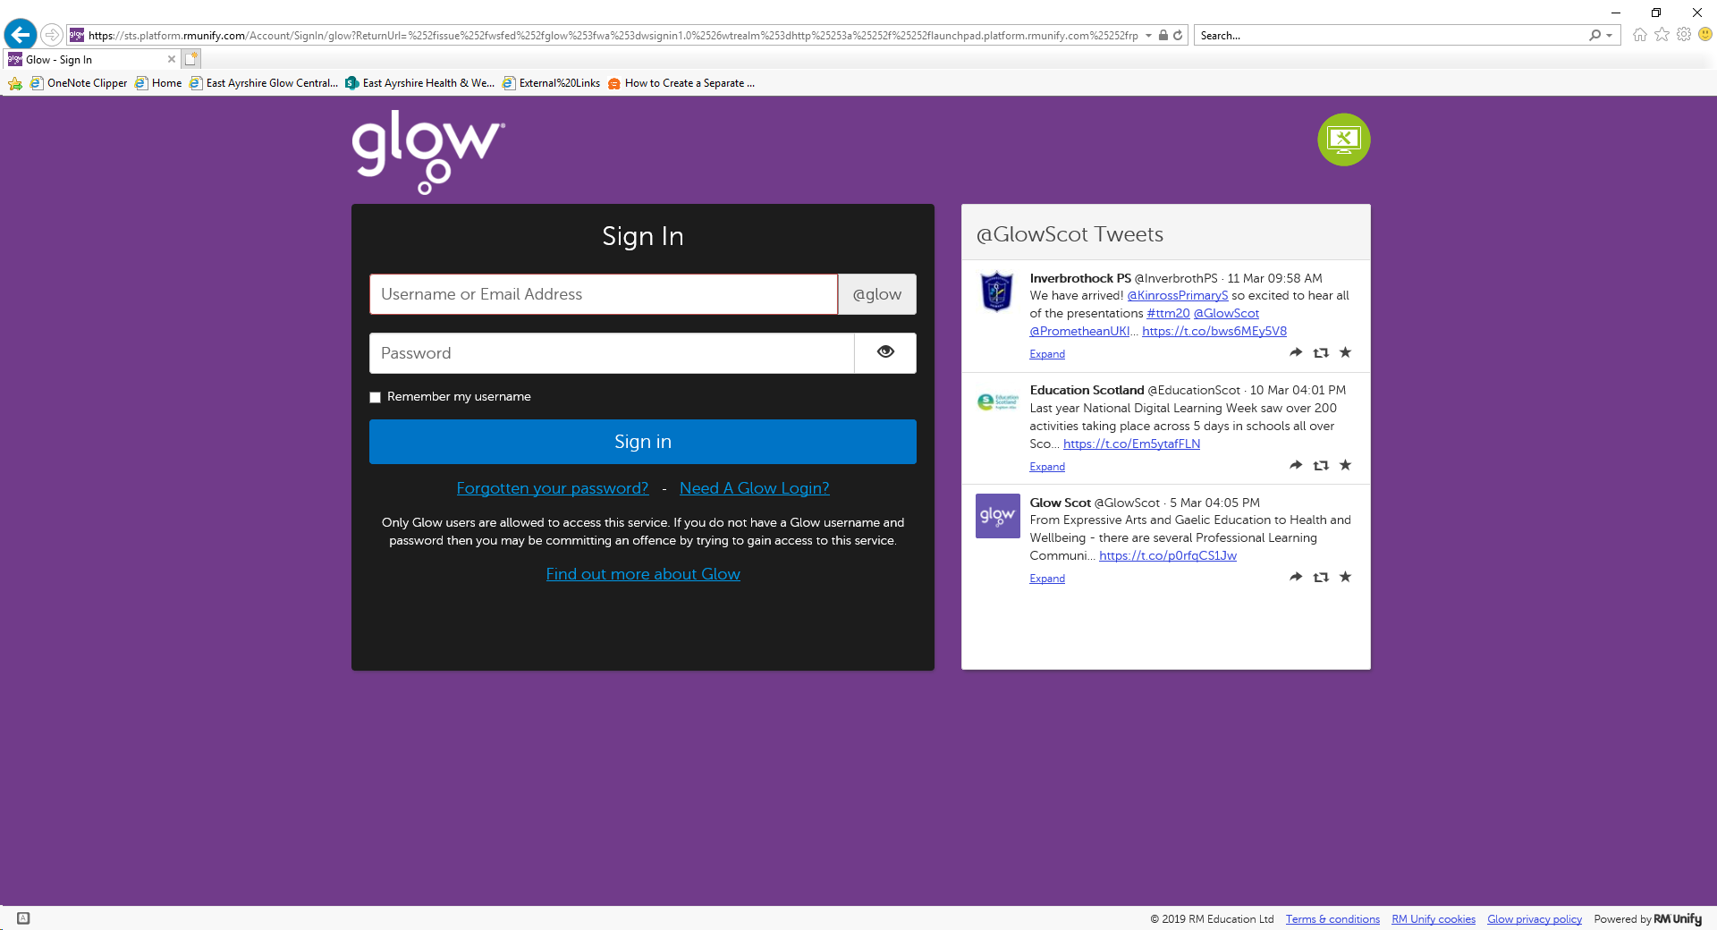
Your child should have details of their GLOW Login.
When you are logged into Glow
You will see there are 4 seperate launch pads

My Launch Pad – Your own Personal Space Add links and apps that you find usefulOnly you see this Launch Pad

Establishment Launch Pad – Each School has
There own launch pad. This can be customised by
The GLOW admins for each school

East Ayrshire Council Launch Pad – Local Authority Polices
Mangement information , Procedures and Guidelines ,
Services & Support

National Launch Pad – Learning Communites and
National Guidelines and Information

Go to the 2nd Tier (Establishment Launch Pad)
Your school may have provided a link here to open up
Microsoft Teams
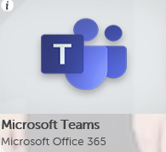

If you see this tile then select to Open up MS TEAMS

If your school has not added the MS TEAMS icon to there Launch Pad . Then you can add the Microsoft Home Tile to your own Launch Pad .
That way you will be able to access all the Microsoft Products available to you quickly each time you login to GLOW .

Go to My Launch PAD

You will see a BLANK Tile with the Word add in it – Select this

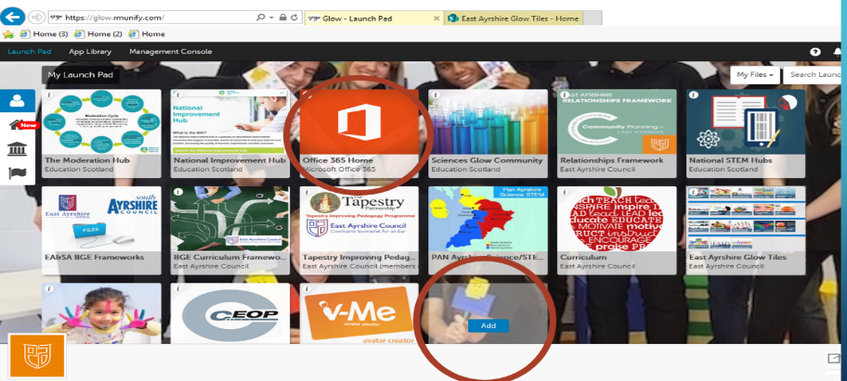

Select App from Library

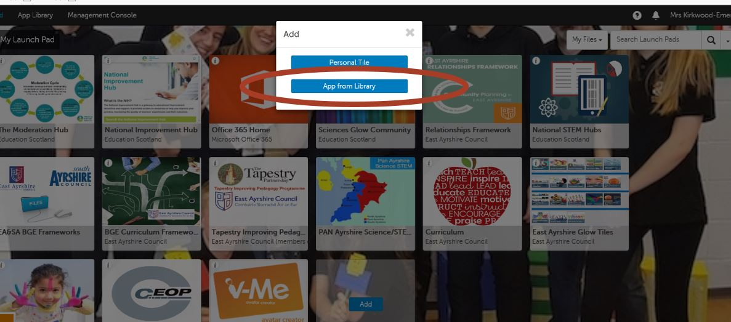

Type in Office 365 into Search Bar

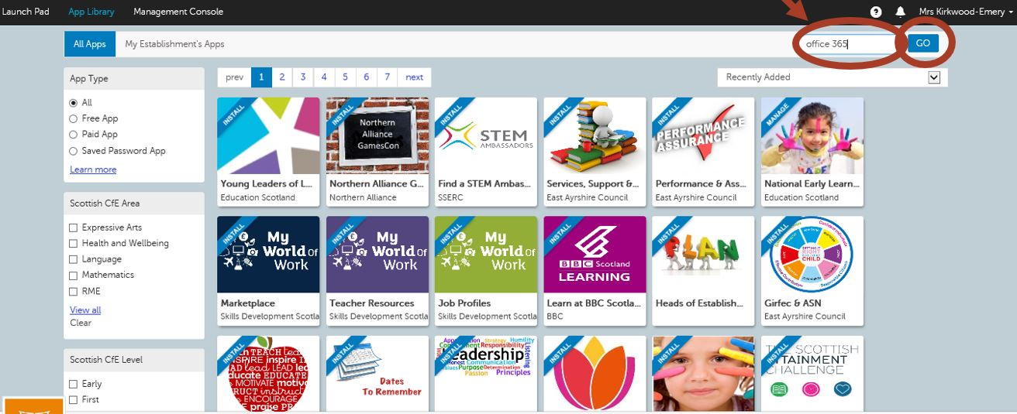

Find the Office 365 Home Tile and Select it

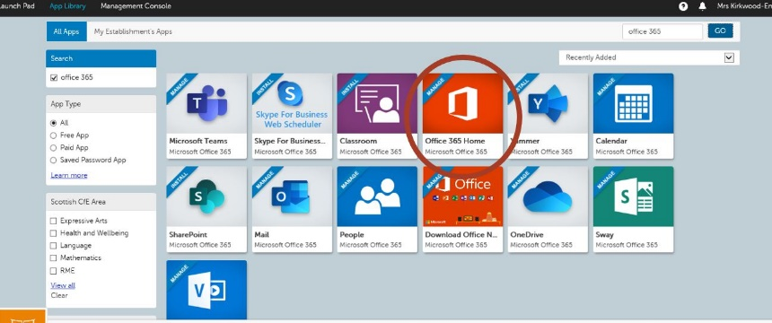

Add to My Launch PAD

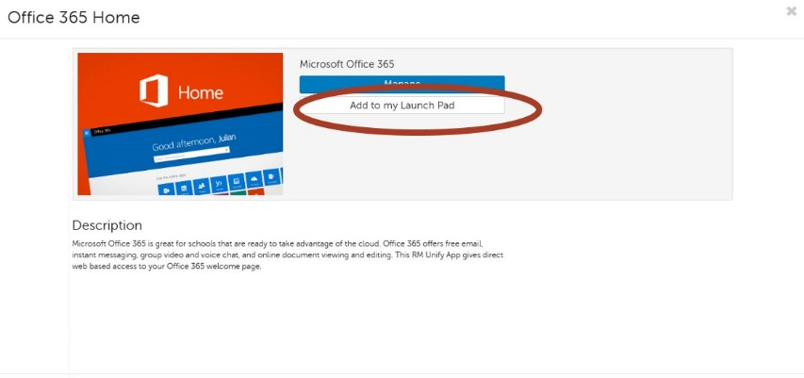

Once you have added the Tile to your launch pad . then close the Window
Now you can open up the Microsoft Home Tile from your launch pad and access TEAMS or any other product from there

