Glow login and Launch Pad

Some help and advice for the parents/carers of Mauchline PS & ECC.

To access Glow using the username and password provided for the children last week, please follow the instructions below.
- Complete a search in your web browser for ‘Glow login’.
- You will see a result that looks like the one below (maybe not exactly like this, but it should have ‘Glow -sign in’ in the search somewhere.

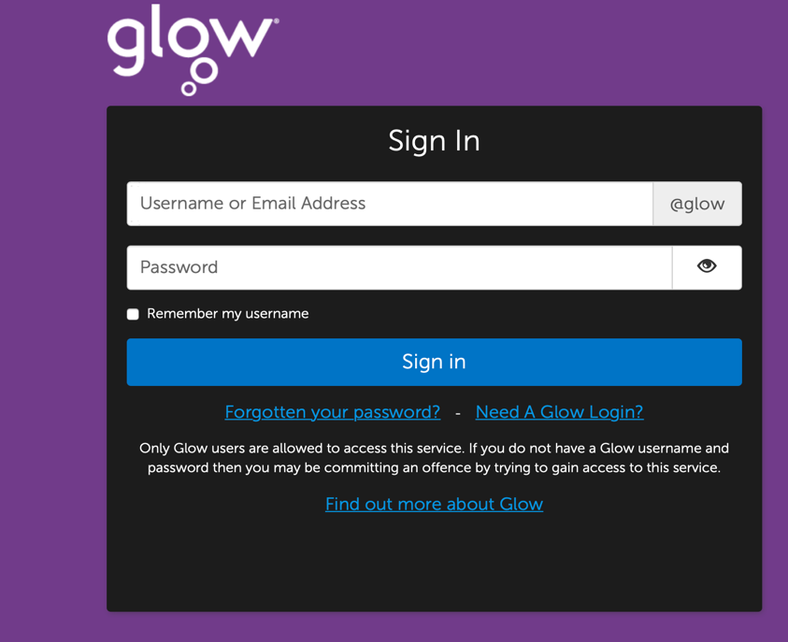
- You should now be at a login page that looks like this:

- Type in the username that your child brought home last week in their ‘Learning at home’ pack.
- The username always starts with a gw followed by a number. Then it is surname, first name and sometimes even a few letters of your child’s middle name if they have one e.g gwsmithtommich (the child’s name may be Tom Michael Smith).
- Then type the password: the password for all children at the moment is
mauchline (no capitals)
- The children can then change their password once they have logged in.
- You will then reach the Launch Pad section. All Launchpads look slightly different as users can add and remove APPS as they feel they require/don’t require them.
- The Glow Launch Pad provided by RM Unify, is made up of a series of web pages that provide:
- access to all Glow services;
- a catalogue of free and paid for resources in an application (app) library;
When you log in to Glow, you will see a Launch Pad like this:
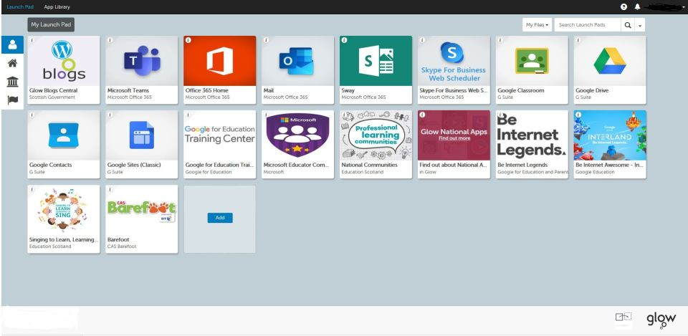
Launch Pads provide links to all Glow services, resources and other, externally hosted content. There are four levels of Launch Pad:
- Personal Launch Pad – this only appears if a user has a Personal Launch Pad configured. This can be customised by each individual user.
- Establishment Launch Pad –the default Launch Pad for each Glow establishment (for example a school). It can be customised by a Glow RM Unify administrator.
- Local authority Launch Pad – a Launch Pad for all schools within local authority control. It is customised by the LA’s Glow RM Unify administrator and only appears if apps have been added to it.
- National Launch Pad (Scotland) – available nationally and configured by an Education Scotland RM Unify administrator.

Click on the ‘blogs’ app:

You will then see the following page (or something very similar).
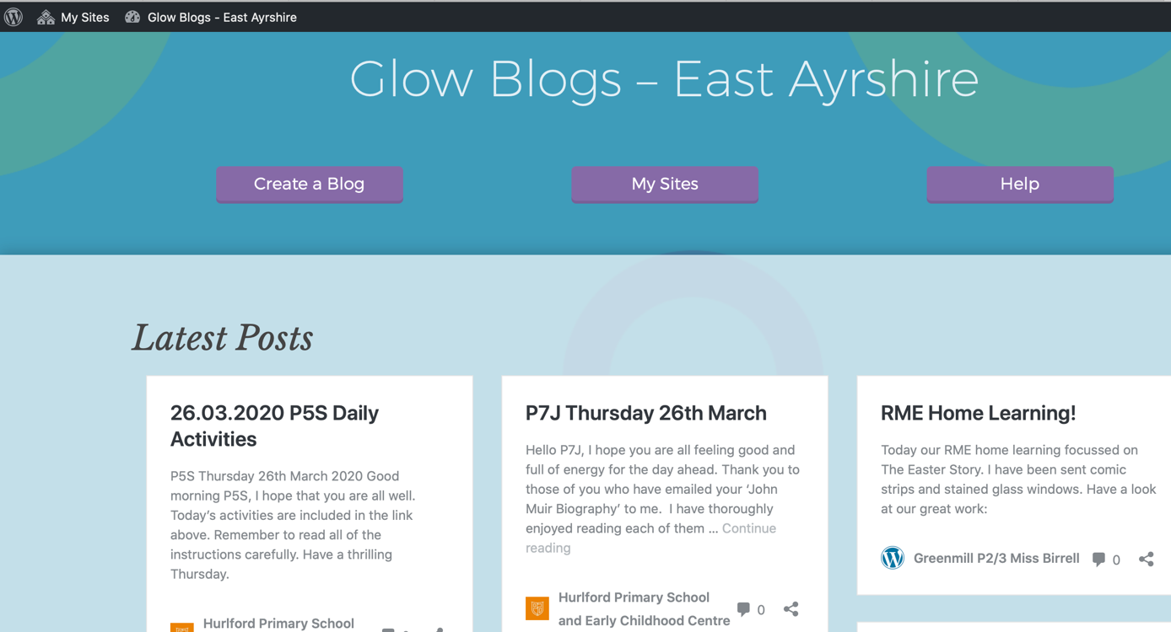
- Look at the top left-hand corner of the page.
- Click on ‘My sites’ and choose ‘Mauchline PS & ECC’.

Hopefully this will help you get on to the Mauchline PS & ECC main blog page.
I will try to add more help pages about further uses within Glow.
If you need my help please email me:

easusan.cross1@glow.sch.uk
Here to help! Mrs Cross, Mauchline PS & ECC

