


Establishment: Mauchline
Primary School & ECC
Establishment
Improvement
Plan
2025-26
East
Ayrshire
Council
Education
Service
School Improvement Plan | Mauchline Primary School and Early Childhood Centre
Head Teacher | Robyn Davidson
Date Submitted | Submitted to Chief Education Officer on : 26th June 2025

School / Centre  Vision and Values | Our School Vision:  Our vision for Mauchline Primary School and Early Childhood Centre is to create a learning community where every child is inspired, supported and motivated to work hard and try to achieve the very best they can, now and in the future.  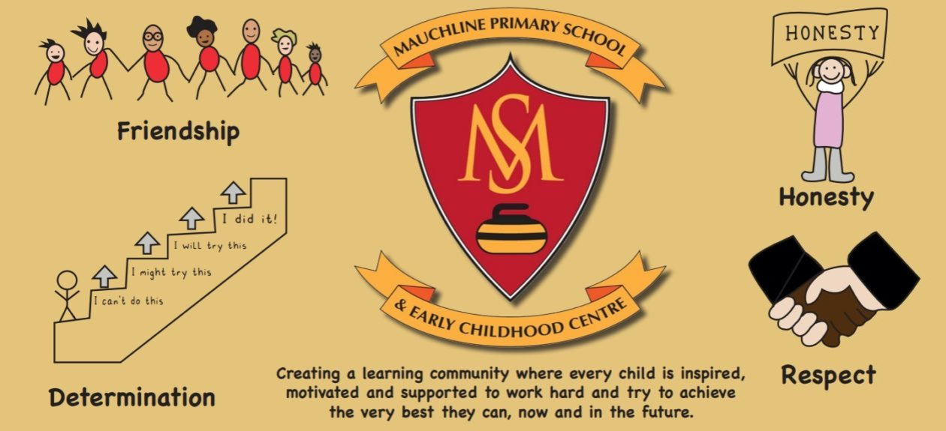  Our Values:  - Respect  - Honesty  - Friendship  - Determination  Our Aims:  - We aspire to provide a safe, welcoming and nurturing learning community where everyone is included and respected.  - We aspire to motivate and inspire our pupils to be ambitious learners who are determined to succeed.  - We aspire to provide a curriculum which is stimulating and designed to promote challenge and enjoyment.

Checklist

In line with the Standards in Scotland’s Schools etc. Act 2000 (amended 2016), the following checklist is designed to assist Heads of establishment with whole school/centre improvement planning that fulfils statutory duties in accordance with the Act. This must be completed prior to submission.

SIP Consultation included the following stakeholders: | Complete |  | Content of plan | Complete
Children and Young People |  |  | Takes account of strategic priorities outlined in the Education Service Improvement Plan. https://www.east-ayrshire.gov.uk/Resources/PDF/E/Education-Service-Improvement-Plan.pdf
Parent Council and Forum |  |  | HGIOS 4 and EYQF are used as the frameworks to inform the content of SIPs. Where appropriate.  https://education.gov.scot/media/v5sh3dqt/frwk2_hgios4.pdf  https://education.gov.scot/inspection-and-review/inspection-frameworks/quality-improvement-framework-for-the-early-learning-and-childcare-sectors/
Teachers, practitioners and ALL school/centre staff |  |  | There is clear focus throughout the plan on measures to reduce of inequalities of outcome as a result of socio-economic disadvantage.  PEF: https://www.gov.scot/publications/pupil-equity-funding-national-operational-guidance-2023/documents/  CEF: https://www.gov.scot/publications/care-experienced-children-young-people-fund-operational-guidance-2023-24/documents/  SEF: https://www.gov.scot/publications/strategic-equity-funding-national-operational-guidance-2023/documents/
Volunteers/ Community partners |  |  | Appropriate cognisance has been made of the links between the plan and the working time agreement for teaching staff.
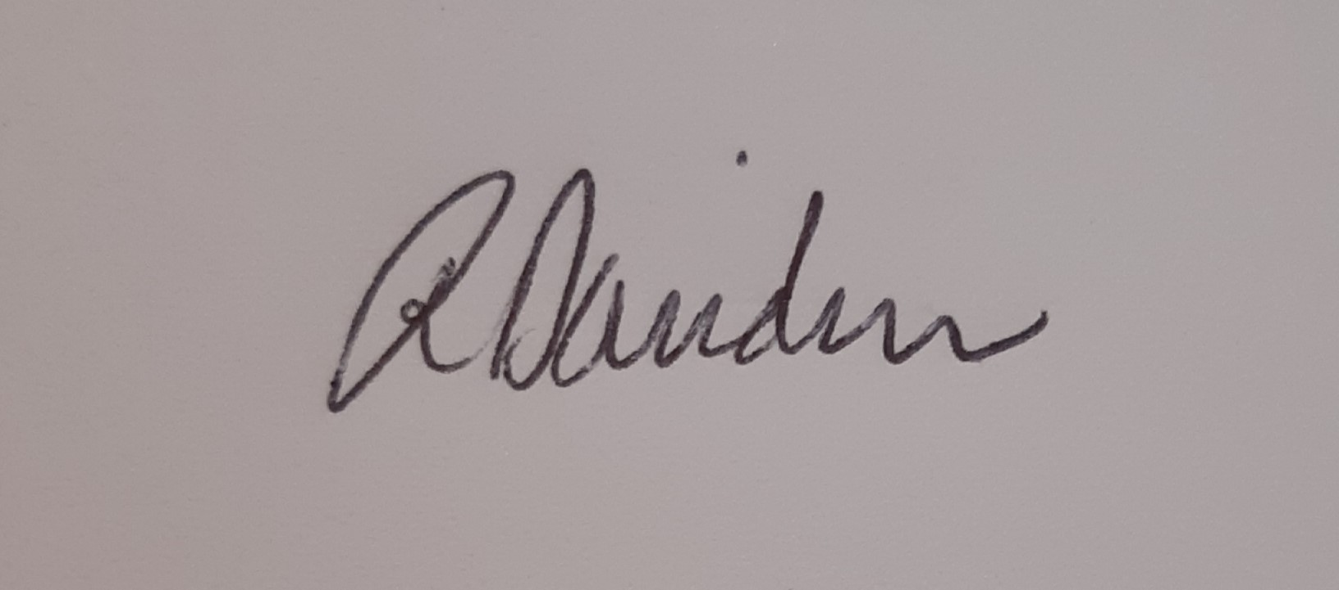  Head Teacher / Head of Centre Signature: |  |  | An accessible summary of the SIP is available and contained in this document and will be provided to parents, children and young people.

Pupil and parental strategic involvement

For session 2025-26, please describe below how children and young people will be involved in decisions relating to the operation of the school/centre | For session 2025-26, please describe below how parents will be involved in decisions relating to the operation of the school/centre
- Through RRSA and PATHS all pupils will be involved in the promotion of wellbeing, participation, relationships and self-esteem. All children will be involved in the creation of class charters.  - Every child from P4-P7 will have the opportunity to be on a school committee/take on a leadership role. At the end of every session, children will undertake an evaluation exercise on the impact/success and areas for improvement.  - Some children will be involved in leading assemblies throughout the school year and sharing their views and ideas on learning with the rest of the school, parents and carers and the wider community.  - A selection of children will be involved in learner conversations throughout the year as part of quality assurance procedures.  - All children will have the opportunity to share their views on aspects of school life through assemblies and surveys. In the ECC this happens through ‘Together Time’, floor books and surveys.  - Pupil Council focus group to be involved in consultation process, decision-making and evaluations. House captains play a role in enhancing the house and school ethos. | - Across the year, parents and carers from every class will have the opportunity to attend “Sharing the Learning” sessions with their children to experience teaching and learning first hand and to learn about how to support children with learning at home. Parents and Carers will be asked to complete an evaluation task to inform improvements or make suggestions for the next “Sharing the Learning” session.  - We will make wider use of survey-type responses to gather parental views, which in turn will influence decision-making within the school.  - Through our very active Parent Council, parents will continue to have a voice in how the school moves forward (in-person and online).  - Class and ECC blogs, and school app will be used to update and inform parents about their child’s class, including newsletters, photos of activities and curricular focus.

Community Plan East Ayrshire  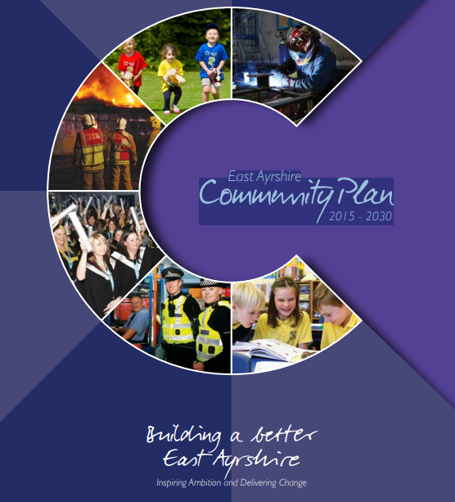  2015 - 2030 | Together, in achieving our Vision, Partners will demonstrate:  Effective leadership  We will provide clear leadership in Community Planning and engage effectively with our employees and communities  Collective ownership  We will take collective ownership for delivering on the Community Plan, the associated Single Outcome Agreement and the Community Plan Delivery Plans, and work hard to improve outcomes for local people and communities  Good governance  We will implement clear operating arrangements to support effective strategic direction, scrutiny and accountability  Democratic accountability  We will measure and report on the impact of our activities to demonstrate how effectively we are improving outcomes for local people and communities, and all partners will be held to account for their contribution.
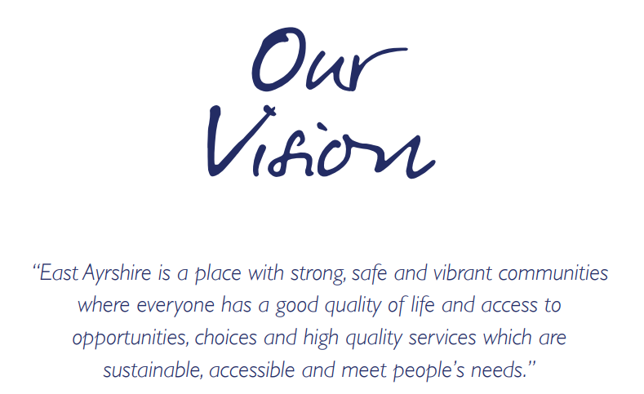  Our Partnership will continue to work to meet the needs of the people who live in our communities. Our guiding principles will be reflected in all that we do and should be evident for all to see. |  | We will:  - Promote lifelong learning.  - Promote equality and tackle inequality;  - Adopt a preventative approach;  - Ensure effective community engagement in the planning and delivery of local services;  - Utilise the strengths and resilience within communities;  - Drive efficiency and performance improvement;

National and Local Priorities
The Scottish Government’s vision for education in Scotland:  - Excellence through raising attainment and improving outcomes  - Achieving equity  Key priorities of the National Improvement Framework:  - Placing the human rights and needs of every child and young person at the centre of education  - Improvement in children and young people’s health and wellbeing  - Closing the attainment gap between the most and least disadvantaged children and young people  - Improvement in skills and sustained, positive  school-leaver destinations for all young people  - Improvement in attainment, particularly in literacy and numeracy | NIF drivers of improvement in the outcomes achieved by children and young people are:  - School and ELC leadership  - Teacher and practitioner professionalism  - Parent/carer involvement and engagement  - Curriculum and assessment  - School and ELC improvement  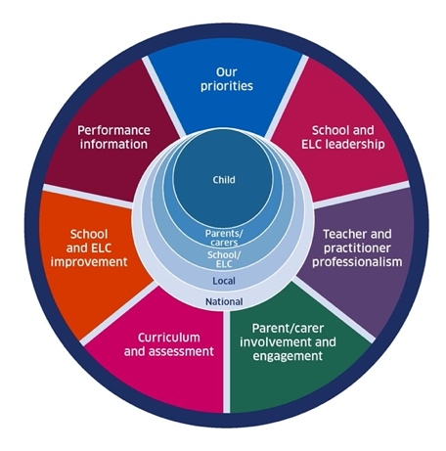  - Performance information | Scottish Attainment Challenge (SAC)  Scottish Attainment Challenge: framework for recovery and accelerating progress  Scottish Attainment Challenge Logic Model – Tackling the Poverty-Related Attainment Gap – Our Theory of Change  SAC organisers:  - Learning and teaching  - Leadership  - Families and communities

East Ayrshire Plans
Key Priorities | Education Service Improvement Plan: | Children’s Services Plan: | Community Learning and Development Plan:
1: Our Leadership | We actively support, promote and enact leadership at all levels. Our young people are supported to be leaders on their learning in our centres, schools and wider life experiences. All staff have ready access to appropriate CLPL and experiences to promote leadership in every classroom and centre. | Priorities for 2023-26:  - Our children and young people feel respected, listened to and influence change  - We are working collaboratively, reducing the impact of social and economic poverty on our children and young people  - Our children and young people feel safe  - Our children and young people have the best start in life  - Our children and young people’s mental health is improving | Outcomes:  - Growth  - Wellbeing  - Fairness  - Sustainability  Action areas  - Youth voice and participation  - Lifelong learning and skills development  - Empowering communities  - Wellbeing and inclusion
2: Teaching and Learning Together | Our young people should experience a teaching, learning and curriculum offer that meets their needs, and those of our local and national context. All staff should be supported to deliver in new and innovative ways by accessing CLPL relevant to their needs and those of our young people.
3: Our Wellbeing and Belonging | We want all of our young people to feel supported by people who know them well, and feel included in all of our schools and centres. Our staff need to be supported in their working with our young people, especially in times of adversity. As a key universal service, it is our vision that all young people attend our establishments on a full-time and regular basis to support them in their development at all stages.
4: Our Attainment, Destinations and Achievements | We want the very best for all of our young people in East Ayrshire. We aim to ensure all young people secure a positive destination through excellent achievement and attainment at all levels.

Our Leadership: Improvement priority:

Learners will continue to have opportunities to contribute to the life of the school and ECC and in decision making; enabling them to develop skills in leadership, problem-solving, and collaboration, and to futher develop their confidence.
Staff will continue to take on leadership and champion roles within the school and ECC, leading to further improvements and providing staff with ownership of developments and change.

Rationale – The recent inspection by Education Scotland highlighted leadership of change in the school as very good and good in the ECC. School staff have led working parties and pupil committees effectively to achieve improved outcomes for children. Senior leaders have highly effective quality assurance procedures in place in the school to monitor and measure progress and impact. This highly effective practice should continue within the school. Within the ECC, staff take on champion roles and are beginning to lead change and improvements through this role, however, this work can be further developed to ensure best practice and high quality learning opportunities in the ECC that meet all children’s needs. Staff also highlighted in a recent survey that some feel they would benefit from further opportunities to lead improvements within the ECC. ECC staff would also benefit from looking outwards at practice with ECCs outwith the education group and possibly in another authority.
NIF key drivers: | School & ELC leadership |  |  | Teacher & practitioner professionalism |  |  |  |  |  | School & ELC improvement
HGIOS4 QIs: | 1.1 |  | 1.3 |  | 1.4 |  |  | 2.3
QF ELC: | 1.3 |  | 3.2 |  | 4.1
ESIP key priorities: | Y Teaching & Learning |  |  |  |  |  |  | N Our Wellbeing |  |  | N Our attainment
Outcomes for our learners |  | Our actions/Approaches/Interventions |  |  |  | PEF | Who |  | Measures |  |  | Review/milestones
Learners will have further opportunities to drive forward improvements in the school and ECC. |  | - Continue to ensure the UNCRC is embedded in our work with young people in policy and practice.  - Utilise ‘How Good is OUR School’ with pupil council and focus groups.  - Continue to include and collaborate with the children to inform and support change, and provide opportunities for pupil voice to drive forward improvement through the use of committees and other leadership roles.  - Provide further leadership opportunities relevant and appropriate to the ECC, looking outward for examples of best practice. |  |  |  |  | Acting PT  HT  HT  Senior Lead ELCP |  | - Gold Accreditation  - Learner Feedback -Surveys with children to gather their views, showing an improvement in ratings in relation to involvement in leading change.  - Self-evaluation will continue to grade the school as very good and the ECC will also be evaluated as very good. |  |  | October 25  August 25 and May 26  May 26
All staff are committed to and involved in leading change which results in improvements for learners. |  | - All staff are involved in the process of change and in evaluating the impact of improvements. This is supported by carefully planned individual and collective career-long professional learning.  - Provide opportunities for collaborative working, such as partnership working with the Robert Burns Academy Education Group and collaboration with school/ECC to share good practice.  - Collaborative working with staff from Lochnorris Auckinlech PS who are also focusing on developing outdoor learning as part of their improvement plan.  - ECC staff continue with champion role and extend their opportunities to lead improvements and training with the whole staff team.  - School staff to continue with staff leadership and work collaboratively to improve outdoor learning. |  |  |  |  | HT  PT  Senior Lead  HT |  | - Quality assurance in the school will focus on high quality learning and teaching using outdoor spaces. Qualitative data will be gathered to review impact of improvement work.  - ECC staff to complete survey again to compare pre and post results in relation to the impact of leadership opportunities.  - New Quality Improvement Framework will be used following its launch in September 25 to support self-evaluation within the ECC. |  |  | Termly  May 26  Termly
Professional learning will lead to high quality learning and teaching. |  | - Staff will have access to high quality CLPL that supports their development to improve experiences and outcomes for children and young people, utilising EAC’s comprehensive professional learning framework (and LOST online resources) to support leadership development; collaborative enquiry; practitioner enquiry; and evidence-based practice and pedagogies, with a focus on outdoor learning.  - ECC staff will share practice in relation to regular use of the local woods and high quality outdoor learning with Primary 1 teachers.  - ECC staff to focus on a consistent and shared pedagogical approach that leads to high-quality and appropriately challenging learning and play opportunities for the learners. EAC team will be delivering training across the session and staff member should attend. Best practice will be observed in other settings. |  |  |  |  | PT  Senior lead and HT  Senior lead |  | - Quality assurance in the school will focus on high quality learning and teaching using outdoor spaces. Qualitative data will be gathered to review impact of improvement work.  - Quality assurance procedures in the ECC will highlight highly-effective practice and demonstrate appropriate support and challenge of all children.  - T&M in the ECC will demonstrate that all children are making good progress, with some making very good progress. This will be evident in data from Learning Journals. |  |  | Termly  Termly  Termly

Teaching and Learning Together: Improvement priority:

Improve the quality and consistency of teaching and learning outdoors across the school.
Improve the quality of learning opportunities for children across the curriculum, ensuring appropriate levels of support and challenge, within the ECC.
Improve the quality and quantity of information shared with parents about their child’s learning and development.

Rationale – Last session, we focused on embedding high quality STEM education across the school and began introducing this into the ECC. This was very successful; staff are confident in their approaches and we achieved the Digital Schools Award for the school and ECC. Outdoor learning was also part of our improvement plan and this is an area working very well within the ECC, however, we made limited improvements in developing a consistent approach across the school. This improvement area will continue into this session.

During our HMIe inspection, the quality of learning in the ECC was graded as good but it was noted that there could be further work to develop the learning environment and to review our pedagogical approach. This work will aim to ensure high quality learning and teaching opportunities across the curriculum and ensure children receive the appropriate levels of support and challenge.

Data gathered from the recent inspection through parent/carer surveys highlighted that only 29% strongly agree that, ‘I receive helpful, regular feedback about how my child is learning and developing’, with 16% either disagreeing or strongly disagreeing. Additionally, when parents rated the statement, ‘The school gives me advice on how to support my child’s learning at home’ only 35% strongly agreed, with 16% either disagreeing or strongly disagreeing. How we share information about a child’s learning and development has been adapting each year and this will be reviewed this session.

NIF key drivers: | Curriculum & assessment |  |  | Parent/carer involvement & engagement |  |  |  |  |  | School & ELC improvement
HGIOS4 QIs: | 2.3 |  | 2.2 |  | 2.5 |  |  | 3.2 |  |  | 3.3
QF ELC: | 4.1 |  | 3.2 |  | 2.1 |  |  | 2.2 |  |  | 1.3 |  |  | 1.4
ESIP key priorities: | N Our Leadership |  |  |  |  |  |  | N Our Wellbeing |  |  |  | N Our attainment
Outcomes for our learners |  | Our actions/Approaches/Interventions |  |  |  | PEF | Who |  | Measures |  |  |  | Review/milestones
Learners will experience high quality learning and teaching in all areas of the curriculum within the ECC and make very good progress. |  | - Develop a shared understanding of standards and pedagogical approaches with the ECC.  - Develop a Curriculum rationale for the ECC.  - Increased collaborative professionalism opportunities for staff across EAC and beyond.  - Creation of the ‘Excellent learning experience’ in collaboration with all stakeholders and looking at examples from other establishments. This will be used to support quality assurance procedures.  - ECC staff will access high-quality CLPL to further improve practice.  - Embed consistent approaches to tracking and monitoring in the ECC, including more robust use of tracking data. |  |  |  |  | Senior Lead & HT |  | - QA observation records  - Tracking and monitoring data – demonstrating all children making good progress, with some making very good progress.  - Staff CLPL records and discussion records form Facetime reviews and supervision meetings.  - Excellent lesson embedded in practice and share with all stakeholders. |  |  |  | Termly  Termly  Biannually  March 26
Parents and carers are involved in supporting and understanding their child’s learning and development, enabling them to provide the best support at home. |  | - Review how we provide feedback to parents about their child’s progress, including school/class blogs and homework.  - Senior classes will pilot the introduction of new Learner Profiles to track skills the children are developing as a result of their achievements.  - ECC and Primary 1 will continue to utilise the Learning Journals. |  |  |  |  | DHT |  | - Parent/carer surveys  - Parent/carer focus group  - Pupil surveys  - Pupil focus group |  |  |  | October and May
School learners will experience consistent and high-quality outdoor learning experiences. |  | - Work in collaboration with teaching staff at Lochnorris PS to develop and share best practice in relation to outdoor learning opportunities.  - Access CLPL from online LOST resources.  - Develop an outdoor learning position paper for our establishment to ensure a consistent approach.  - Leaven scale used to assess and measure engagement.  - Quality assurance procedures to focus on outdoor learning.  - Further progress our excellent practice in developing digital literacy skills to include this is aspects of outdoor learning.  - Review our curriculum model and rationale to update outdoor learning. |  |  |  | ✓ | PT |  | - Pre and post survey to gather confidence levels and learners’ views – increase in post surveys.  - Increased engagement evident using Leavens scale.  - QA procedures focus on outdoor learning and include evidence of high-quality outdoor lessons being observed in all classes.  - Pupil voice surveys and learning conversations |  |  |  | September and May  Termly
School learners will understand what they are learning and why, and they will experience high levels of challenge and pace in lessons. |  | - School lead with participate in EAC’s Leaders of Learning programme, focusing on LIs and SC, self/peer assessment and differentiation to meet learner’s needs.  - Collegiate meetings will be planned for the LoL lead to share information and lead learning with staff.  - Mauchline’s Gold Standard lesson will be used to support quality assurance procedures and reviewed at the end of the session. |  |  |  |  | LoL lead |  | - Learning walks and lesson observations  - Pupil voice surveys and learning conversations  - Review of marked work showing self- and peer-assessment  - Assessment for Learning (AfL) evidence in books and classrooms  - Differentiation/scaffolding of learning evident in planning and delivery  - Lesson observations show all learners engaged and stretched  - Assessment data shows improved attainment and progress over time |  |  |  | September, November, January and May

Our Wellbeing and Belonging: Improvement priority:

Continue with current very good practice in both the school and ECC.
Achieve Gold Rights Respecting Schools Award.

Rationale – We received excellent feedback during our recent HMIe inspection in relation to ensuring children’s wellbeing, inclusion and equality; gaining a rating of ‘very good’ in both the ECC and school. In particular, our relentless focus on ensuring wellbeing and inclusion was highlighted as highly effective practice and shared wider. We will continue to ensure our current policies and procedures align with East Ayrshire’s newly developed Relationships Framework. We have also been working towards the Gold Rights Respecting Schools Award since gaining Silver in 2022 and have continued to ensure children’s rights are core.

NIF key drivers: | School & ELC leadership |  |  | Curriculum & assessment
HGIOS4 QIs: | 1.3 |  | 1.5 |  | 3.1
QF ELC: | 1.1 |  | 4.1
ESIP key priorities: | N Our Leadership |  |  | N Teaching & Learning |  |  |  | N Our attainment
Outcomes for our learners |  | Our actions/Approaches/Interventions |  |  |  | PEF | Who |  | Measures | Review/milestones
Our learners will feel  supported,  respected and  included by staff and other  young people. |  | - Our Anti-Bullying Establishment Statement will be reviewed and updated in consultation with all stakeholders, ensuring it is in line with the new national guidance.  - All staff will complete the respect me online learning module and any other relevant CLPL.  - The respect me anti-bullying self-evaluation toolkit - https://respectme.org.uk/wpcontent/uploads/2021/10/Self_Assessment_Toolkit.pdf will be used to plan appropriate actions and assess progress.  - All stakeholders will be aware of the school processes for tackling bullying.  - Continue work towards achieving Gold Rights Respecting Schools Award and embedding children’s rights in our curriculum and ethos.  - Continue to utilise the GMWP to gather data at individual, class and whole school level, planning appropriate actions where required.  - Educational Psychologist to lead further CLPL for all staff using EAC’s Relationships and Behaviour CLPL Framework for Practice; moving from informed to skilled levels. |  |  |  |  | HT and HWB PT |  | - Reduction in SEEMiS bullying incidents reported to staff or logged on SEEMiS Bullying Module.  - Recent HMIe survey results demonstrated that 92% of children feel safe at school; 6% of children disagreed that the school deals well with any bullying; and 6% of parents also disagreed that the school deals well with bullying. Follow up surveys will show an increase in the number of children who feel safe at school and a reduction in the number of pupils and parents who feel the school does not deal well with bullying.  - GMWP results demonstrate continued improvements or maintain high levels. | Termly  March 26  September 25 and March 26
School attendance will remain at 94% or better. |  | - Undertake review of processes and procedures to support and promote attendance.  - Continue to utilise partner agency support and direct parents/carers to NEST where possible neurodivergence is impacting attendance.  - Continue to utilise the Wellbeing Room to support learners, where appropriate.  - School Positive Relationships Position Paper will be reviewed in line with East Ayrshire’s new Inclusive practice: relationships framework. |  |  |  |  | HT and HWB PT |  | - Monthly attendance monitoring will be used to highlight any reduction or concerns in attendance and supports put in place, where required.  - Updated position paper shared with all stakeholders. | Monthly  December
Care experienced (CE) young people will be supported to reach their full potential by committed, “Promise” aware, skilled staff. |  | - Almost all staff have now completed Promise Award level 1 and 2 Training and have completed the assessment. Ensure all staff have completed this, including any new members of staff.  - Level 3 training to be completed and evidence gathered to demonstrate how we are making a positive difference to CE children in terms of their learning. |  |  |  |  | HT and HWB PT |  | - Records of who has completed the training.  - Facetime reviews and PRD paperwork.  - Evidence complied to apply for the Promise Award in collaboration with Education Scotland.  - Review T&M of CE pupils. | October  November  May  Termly
Children will continue to receive high-quality learning and teaching through the health and wellbeing curriculum. |  | - PLTA HWB guidance and progression frameworks will continue to be utilised effectively in the school to ensure continual ambitious progress, inclusive practice and reliable teacher judgement. |  |  |  |  | HT and HWB PT |  | - Tracking and monitoring meetings with HT to discuss coverage of the curriculum.  - Departmental meetings will review coverage and discuss progression planners. | Termly

Our Attainment, Destinations and Achievements: Improvement priority:

Ensure accurate and robust tracking and monitoring of progress of children in the ECC.

Rationale – Overall school attainment continued to remain high last session. In our recent inspection, the school was graded as very good and current practice was found to be rigorous and robust. The ECC was graded as good and further work is required to have the same, consistently high levels of data analysis and rigorous tracking to ensure children are making very good progress.
NIF key drivers: | Performance information |  |  | School & ELC leadership |  |  |  | Curriculum & assessment
HGIOS4 QIs: | 2.2 |  | 3.2 |  | 1.5
QF ELC: | 1.3 |  | 3.2
ESIP key priorities: | N Our Leadership |  |  | N Teaching & Learning |  |  |  | N Our Wellbeing
Outcomes for our learners |  | Our actions/Approaches/Interventions |  |  |  | PEF | Who |  | Measures | Review/milestones
Children’s progress in the ECC will be very good. |  | - Build capacity of all staff through effective engagement in using tracking and monitoring tools to capture all aspects of children’s progress.  - More robust tracking and monitoring procedures to be introduced in the ECC to best utilise the data from T&M tools.  - Data is analysed to identify individuals who would benefit from targeted support/challenge with communication or numeracy champion.  - Seek support and advice from local authority early years team to further improve use of ECC T&M tools. |  |  |  |  | HT & Senior Lead |  | - Tracking documents will be created to capture and measure progress across the session, demonstrating very good progress for almost all children.  - Record of targeted interventions and impact from champions.  - Targets from personal plans met regularly and tracked in T&M tools. | Termly  Every 4-weeks  Every 4-weeks
Improve outcomes for all learners and reduce inequality, with a focus on closing identified poverty related attainment gap. |  | - PEF funded CA and class teacher hours will be used to provide additional support to the Primary 2 Primary 4 and 6 and 5 cohort for reading and writing.  - Chromebooks to be introduced to some pupils, where appropriate.  - Quality assurance procedures will include a focus on writing jotters to continue to ensure consistently high-quality teaching, learning and assessment. |  |  |  |  | HT |  | - Gap identified with Primary cohort and Primary 5 cohort will reduce. Primary 4 and 6  - Writing jotter audits will show consistent approaches to teaching, learning and assessment of writing, in line with our Gold Standard Lesson and writing position paper. | Termly  October and March
Children’s attainment in reading and writing in Primary 4 will improve. |  | - PEF funded CA and class teacher hours will be used to provide additional support to the Primary 4 cohort.  - ASN Coordinator to provide direct support to those with ASN and plan targeted interventions in collaboration with the teacher.  - Chromebooks to be introduced to some pupils, where appropriate.  - PEF funded online reading support (Nessy) utilised by whole Primary 4 and 5 and asn cohort. |  |  |  |  | DHT |  | - Reading attainment will improve from 64% to at least 70% on track.  - Writing attainment will improve from at least 60% to 70% on track.  - A number of children will be removed from the ASN log due to being on track. | Termly

2024-25 baseline |  |  |  |  |  | 2025-26 targets |  |  |  |  |  | 2025-26 actual
 | Reading | Writing | L&T | Literacy | Numeracy |  | Reading | Writing | L&T | Literacy | Numeracy |  | Reading | Writing | L&T | Literacy | Numeracy
P1 | 90 | 83 | 90 | 88 | 92 | P1 | 85 | 85 | 85 | 85 | 85 | P1
P2 | 88 | 88 | 93 | 86 | 93 | P2 | 90 | 85 | 90 | 88 | 92 | P2
P3 | 64 | 60 | 90 | 60 | 88 | P3 | 88 | 88 | 93 | 88 | 93 | P3
P4 | 90 | 83 | 98 | 81 | 88 | P4 | 70 | 70 | 90 | 70 | 88 | P4
P5 | 85 | 79 | 98 | 79 | 83 | P5 | 90 | 85 | 98 | 85 | 88 | P5
P6 | 73 | 73 | 88 | 66 | 80 | P6 | 85 | 85 | 98 | 85 | 83 | P6
P7 | 76 | 76 | 97 | 70 | 85 | P7 | 75 | 75 | 88 | 75 | 85 | P7

Reading | P1 | P2 | P3 | P4 | P5 | P6 | P7 |  | Writing | P1 | P2 | P3 | P4 | P5 | P6 | P7 |  | L&T | P1 | P2 | P3 | P4 | P5 | P6 | P7 |  | Numeracy | P1 | P2 | P3 | P4 | P5 | P6 | P7
P1 | 90 |  |  |  |  |  |  |  | P1 | 83 |  |  |  |  |  |  |  | P1 | 90 |  |  |  |  |  |  |  | P1 | 92
P2 | 86 | 88 |  |  |  |  |  |  | P2 | 88 | 88 |  |  |  |  |  |  | P2 | 93 | 93 |  |  |  |  |  |  | P2 | 88 | 93
P3 | 83 | 67 | 64 |  |  |  |  |  | P3 | 78 | 62 | 60 |  |  |  |  |  | P3 | 93 | 90 | 90 |  |  |  |  |  | P3 | 90 | 88 | 88
P4 | 88 | 90 | 90 | 90 |  |  |  |  | P4 | 85 | 85 | 85 | 83 |  |  |  |  | P4 | 95 | 95 | 98 | 98 |  |  |  |  | P4 | 85 | 85 | 93 | 88
P5 | 84 | - | 75 | 88 | 85 |  |  |  | P5 | 76 | - | 73 | 81 | 79 |  |  |  | P5 | 90 | - | 96 | 98 | 98 |  |  |  | P5 | 84 | - | 85 | 85 | 83
P6 | - | - | - | 71 | 71 | 73 |  |  | P6 | - | - | - | 71 | 61 | 73 |  |  | P6 | - | - | - | 83 | 85 | 88 |  |  | P6 | - | - | - | 81 | 78 | 80
P7 | 97 | - | - | 76 | 78 | 70 | 76 |  | P7 | 97 | - | - | 67 | 63 | 58 | 76 |  | P7 | 97 | - | - | 91 | 94 | 97 | 97 |  | P7 | 100 | - | - | 79 | 78 | 79 | 85

Summary of Improvement Plan directly linking to Education Service Improvement Plan

Our Leadership | Teaching and Learning Together
- Learners will have further opportunities to drive forward improvements in the school and ECC, through leadership opportunities and taking part in committees.  - Staff will continue with leadership and champion roles to drive forward improvements.  - Staff will work in collaboration with staff at Lochnorris PS to lead improvements in our approaches to outdoor learning. | - ECC staff will review our pedagogical approaches and contribute to the creation of our Excellent Experience overview and curriculum rationale, to ensure consistently high quality learning experiences for our learners.  - Parents and carers will be involved in supporting and understanding their child’s learning and development, enabling them to provide the best support at home.  - School learners will experience consistent and high-quality learning experiences outdoors.
Our wellbeing and belonging | Our Attainment, Destinations and Achievements
- Care experienced (CE) young people will be supported to reach their full potential by committed, “Promise” aware, skilled staff.  - Our learners will feel supported, respected and included by staff and other young people, through our commitment to children’s rights and we will apply for the Gold Rights Respecting School Award.  - Our anti-bullying establishment statement will be updated and staff will participate in updated training, to reduce any incidents of bullying.  - We will continue to implement our procedures to maintain our high levels of attendance. | - Children’s progress in the ECC will be very good and staff will make effective use of tracking tools and data to track progress and plan support/challenge.  - We will improve outcomes for all learners and reduce inequality, with a focus on closing identified poverty related attainment gap.  - We will focus on improving attainment in reading and writing at identified stages, with the support of PEF funded staff and resources.

