Sun Protection Policy

At Mauchline ECC we acknowledge the importance of sun protection and want staff and children to enjoy the sun safely. Sunburn increases the risk of skin cancer and does not just happen on holiday. Skin can burn even when it is cloudy. The best way to enjoy the sun safely and protect your skin is to use a combination of shade, clothing and sunscreen.
The purpose of this policy is to clearly set out the responsibility of all staff in the matter of sun safety. This policy has been written with consideration given to guidelines issued by Cancer Research UK and the NHS.

Who is responsible?
- It is the overall responsibility of the Senior Management Team (SMT) to ensure that all staff understand their role fully in protecting children from harm when exposed to the sun.

- It is the responsibility of all staff to ensure that this policy is fully implemented at all times.

- It is the overall responsibility of the SMT to ensure that there is written parent/carer consent to apply sunscreen to all children.

- It is the overall responsibility of the SMT to ensure that sunscreen is in date and checked termly.

How will this policy be implemented?

- In the UK the suns UV rays are the strongest between 11am – 3pm from mid-March to October. Staff should encourage children to stay in the shade as much as possible between the hours of 11am and 3pm.

- On warm days, a member of the SMT should check the UV daily forecast and take appropriate action if the UV levels reach 3 or above (see appendix 1).

- Staff should minimise sunscreen use on children under 6 months by keeping them out of direct strong sunlight and dressing them in lightweight sun-protective clothing that breathes and covers their arms and legs.

- Staff must be mindful as the sun moves throughout the day, adapting shaded areas as required.

- Children can wear UV protective sun glasses if they choose, however wraparound sunglasses are best.

- Sun protection must be discussed with all children through appropriate dialogue and activities.

- Staff should model and promote sun safety, helping children to learn and develop good habits.

- Parents/carers must be informed of the importance of sun safety.

- Staff should ensure that children’s clothing covers their shoulders, the more the skin is covered by clothing, the better the protection. Children should wear loose, light coloured clothing to help keep them cool. If children get wet, then they must be dried and changed into dry clothing.

- Parents/carers should be encouraged to provide a wide brimmed hat that covers the child’s face, neck and ears. The ECC should maintain a stock of hats to use if required.

- Children should be encouraged to drink plenty of water and encouraged to drink more than usual in hot weather.

Sunscreen
- Staff should apply sunscreen with at least SPF30 to protect against UVB. Sunscreen should have a UVA rating of 4 or more stars to protect skin. Sunscreen should meet the EU standards by displaying this on the bottle with the letters UVA in a circle.

- For children with specific skin conditions / allergies, parents/carers should supply suitable sunscreen for their child. This must be clearly labelled with the child’s name and D.O.B. This information should be detailed on the centre’s health overview and the child’s personal plan.

- Parents may wish to provide their own sunscreen, again this must be labelled as stated in point 17.

- Expiry dates of sunscreen must be checked prior to use (the letter m and the number on the bottle shows the number of months the sunscreen will last after opening) and a label applied to the bottle stating clearly the opening date.

- A record should be kept for checking expiry dates (see appendix 2).

- Where possible, sunscreen should be available for parents/carers to apply to their child on arrival at the centre.

- If children are exposed to the sun long enough to risk burning, sunscreen should be applied twice: 30 minutes before going out and then reapplied just before going out.

- Sunscreen should be applied to all exposed skin (areas not protected by clothing) such as the face, ears, feet and back of hands.

- Sunscreen should be generously reapplied throughout the day in-line with manufactures’ instructions for example, straight after water play, after sweating or when the sunscreen may have rubbed off. It is recommended that sunscreen is reapplied every 2 hours when the risk of burning is high.

- On warmer days parents should be encouraged to apply sunscreen prior to drop off. This should be discussed with parents/carers at induction and highlighted within the parents/carer handbook.

- When children access outdoor play from the point of entry, it may not be possible for staff to apply sunscreen 30 minutes prior to children going outdoors. If children arrive at the ECC with no first application, staff must apply immediately and then again after welcome time (approximately 30 minutes following arrival).

- Where possible children should be supported and guided to apply their own sunscreen. When staff are applying sunscreen, handwashing must take place between all applications.

Sunburn
- If a child experiences sun burn whilst attending the centre, then staff must sponge the skin with cool water and parents contacted and informed. The child must then stay out of the sun until all signs of redness have gone.

- If a child arrives at the centre with sun burn, then the child must be encouraged to play out of the sun until all signs of redness have gone.

- Staff must encourage parents to seek medical help if a child with sun burn appears unwell or the skin swells badly or blisters.

- If staff are concerned about a child’s wellbeing, then the SMT should be informed immediately and appropriate action taken.

Heatstroke

- Heat exhaustion can lead to heatstroke when the body is unable to cool itself down. Heatstroke is a medical emergency and can be fatal.
Symptoms of heatstroke may include:

- Confusion or lack of co-ordination
- Seizures (fits)
- Loss of consciousness
- High body temperature (a temperature above 40 degrees)
- Red, hot skin that can be sweaty or dry
- Fast heartbeat
- Fast shallow breathing
- Diarrohea

If heatstroke is suspected staff should alert a member of management immediately and emergency services contacted (999). Staff should attempt to cool the child down whilst waiting for medical assistance and the child’s parent/carer should be contacted.

Staff can attempt to cool the child down by:

- Moving them to a cool place
- Removing unnecessary clothing like a jacket or socks
- Encourage the child to drink cool water
- Cool their skin by spraying or sponging them with cool water and then fanning them.

If a child loses consciousness or has a seizure, staff must seek urgent medical help immediately by calling 999. The staff member dealing with the seizure should also:
  - Alert other staff to the situation (first aider to support asap).
  - Note the time the seizure starts and ends.
  - Protect the child’s head with their hands or something soft. Staff must not move the child or try and hold them in place.
  - Remove any dangerous objects that are nearby.
  - After the seizure ends, put the child in the recovery position and make sure there is nothing in their mouth or throat that might affect their breathing.
  - Staff should also follow advice given be the tele handler from NHS.
  - Parents/carers should be contacted as soon as it is safe to do so.

This Sun Protection policy is based on;
- Cancer Research UK – Sun Protection Policy Guidelines for Nurseries and Pre-schools.
Accessed at https://cancerresearchuk.org

- NHS
Accessed at Sunscreen and sun safety - NHS (www.nhs.uk)

- Health & Social Care Standards, 2017, 3.20 I am protected from harm by people who have a clear understanding of their responsibilities.
Accessed at: www.newcarestandards.scot

Policy created: July 2022
Policy last reviewed: 18 July 2025

Appendix 1

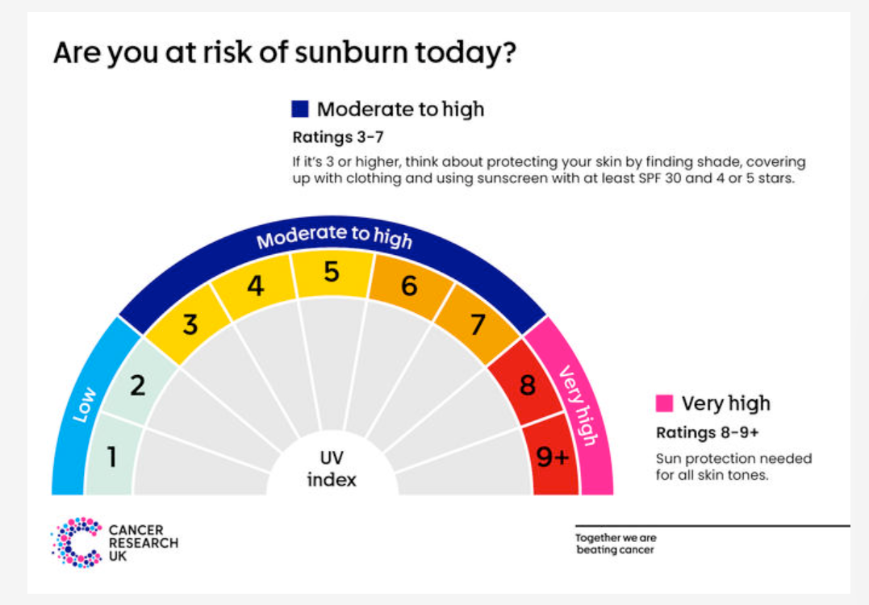

When UV Levels reach 3 or above, sunscreen and sun hats are required and shade encouraged. When UV levels reach 5 or above, limit time outdoors and/or provide shade and remember that UV can penetrate cloud cover. When levels reach 8 or above, avoid children playing outside during the midday hours. Ensure when children are outdoors, all safety precautions are followed (sunscreen, hats, appropriate clothing, easy access to drinking water, shaded areas etc).

Appendix 2
Sunscreen Expiry Checklist
(Label to be applied to bottle on opening, clearly stating date opened)

Sunscreen (name/ brand) | Opened on (date) | Expiry( check letter M and number on bottle) | Checked by member of staff (signature) | Date checked

