(a) (i)
Statistical software output:

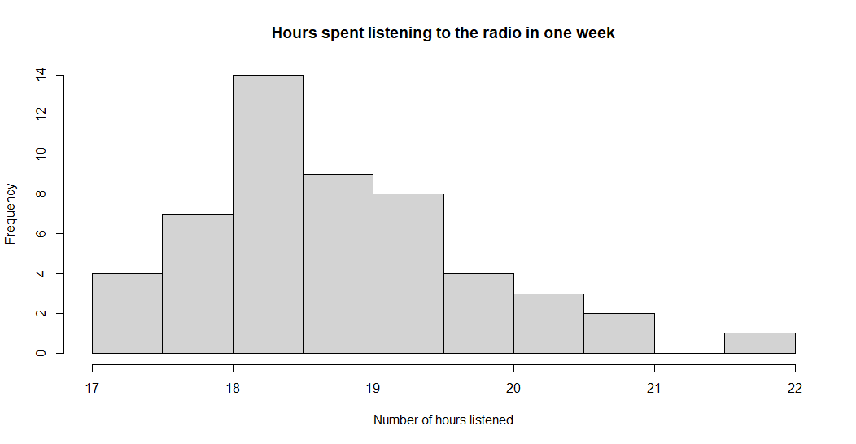

(ii)
Answer:

The data is skewed, with a right tail.

(iii)
Statistical software output:

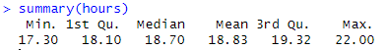

Answer:

Measure of location is 18.7 hours.

(b)
Answer:
The data was self-gathered by listeners, and does not include a random sample.

