(a) (i)
Statistical software output:

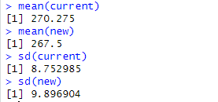
Answer:

 | Measure of location  (metres) | Measure of spread  (metres)
Current golf ball | 270.275 | 8.752985
New golf ball | 267.5 | 9.896904
.

(ii)
Answer:

On average, the current golf balls travelled further distance than the new golf balls (270.275m > 267.5m).

The distance travelled by the new golf ball are more varied than those travelled by the current golf ball (9.896904m > 8.752985m).

(b)
Answer:

Null hypothesis:

There is no difference in the mean distances travelled by the current and the new golf balls.

Alternative hypothesis:

There is a difference in the mean distances travelled by the current and the new golf balls.

(c) (i)
Answer:

Two-sample t-test.

(ii)
Statistical software output:

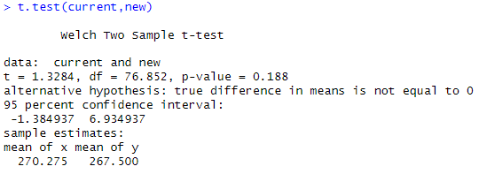

Answer:

p-value = 0.188

(iii)
Answer:

Since the p-value is greater than 0.05, we fail to reject the null hypothesis, and there is insufficient evidence to suggest there is not a significant difference in the mean distances travelled by the current golf ball and the new golf ball.

