(a)
Statistical software output:

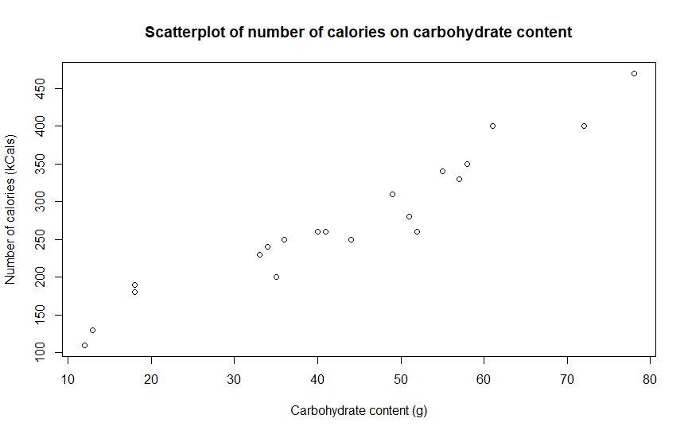

(b) (i)
Statistical software output:

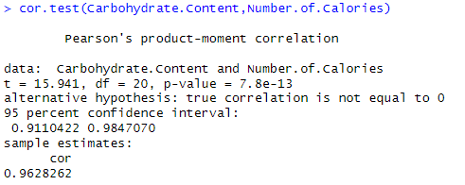
Answer:

Correlation coefficient = 0.9628262

(b) (ii)
Answer:

As the correlation coefficient is very close to 1, then there is a strong positive linear relationship between carbohydrate content and number of calories.

As the carbohydrate content increases, so too does the number of calories.

(c) (i)
Statistical software output:

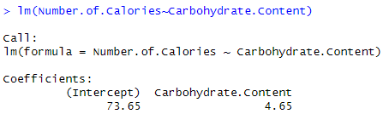

Answer:

Number of calories (kCals) = 4.65 x Carbohydrate content (g) + 73.65

(ii)
Answer:

The number of calories increases by 4.65 kCals for every additional gram of carbohydrate.

The number of calories in a coffee with zero carbohydrate content will be 73.65 kCals.

(d)
Answer:

Number of calories ≈ 348 kCals.

