(a) (i)
Statistical software output:
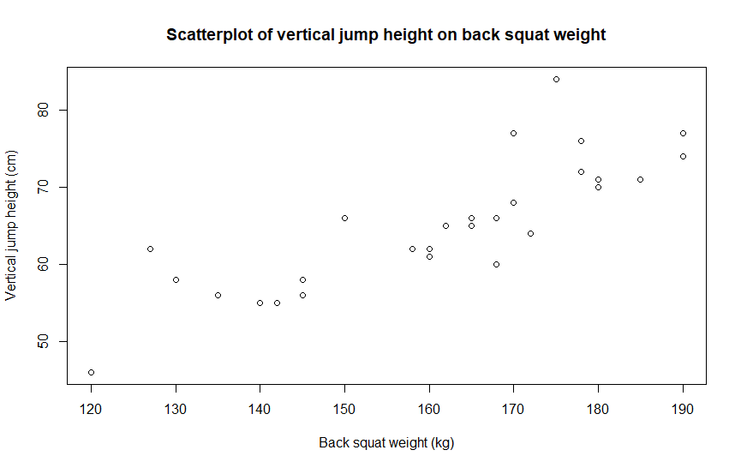

(ii)
Answer:

There is an approximate positive linear relationship between vertical jump height and back squat weight. As back squat weight increases, the vertical jump height also increases.

(b) (i)
Statistical software output:

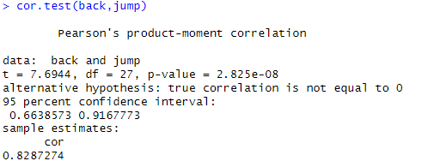

Answer:

Correlation coefficient value = 0.8287274

(b) (ii)
Statistical software output:

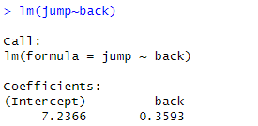

Answer:

Vertical jump height (cm) = 0.3593 x Back squat weight (kg) + 7.2366

(c)
Statistical software output:

Answer:

For a trainee squatting 165kg, their vertical jump height is approximately 66.5cm. The true value is likely to be between 56.7 and 76.3cm.

(d)
Answer:

The statistical analysis does not support the advice from the coach (that increasing back squat weight will increase their vertical jump height) since correlation is not causation.

