Mental Maths 5.5.21  1. What day is after Wednesday? ___________  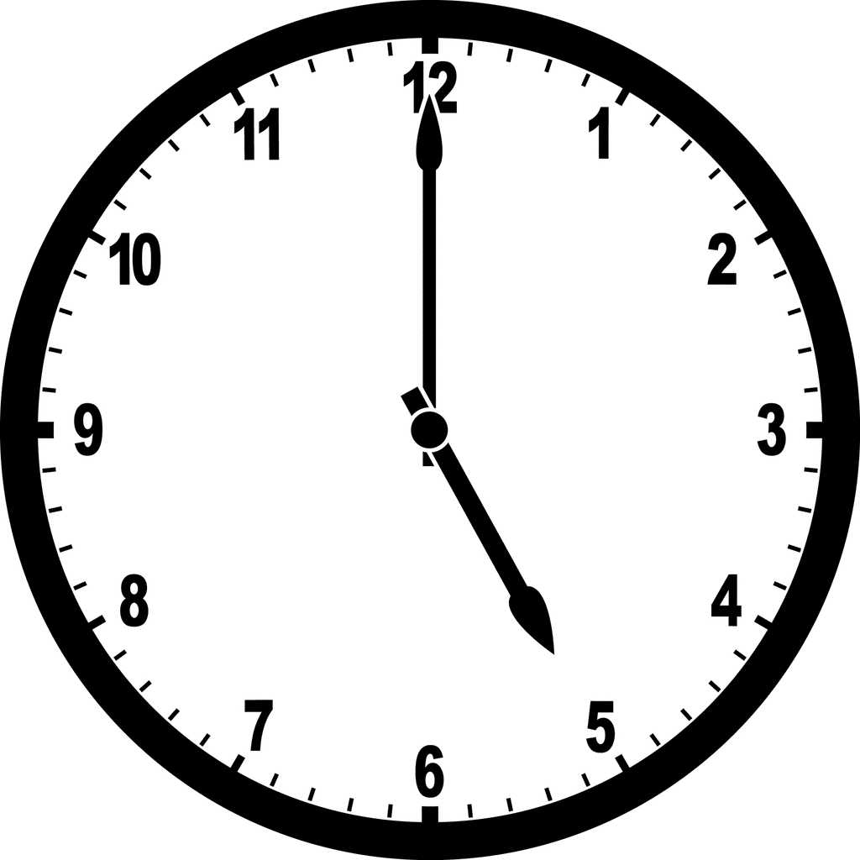  2. What time is showing on the clock?  _______________________  3. Finish the patterns  65, 60, 55, 50, ___, ___,  14, 24, 34, ___, ___, ___,  4. Circle the odd numbers  56 37 19 78 11 223 65  5. Name this 2D shape___________  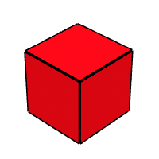  6.Name this 3D shape  ________________  7. Write this number in words 89 ____________________ | 8. Write this number in digits  Ninety-one  _________  9. Write the numbers before and after _____ 399_____  10. Put these numbers in order from lowest to highest  345, 652, 900, 526  _____ _____ _____ _____  11. 2 less than 65 _____  12. 1 more than 532 _____  13. 70 + 10 =_____  14. 26 + 42 = _____  15. 59 + 3 = _____  16. Double 14 = ______  17. Half of 28 = ______  18. 8 x 2 = _______

