Mental Maths 5.5.21  1. What day is after Wednesday? ___________  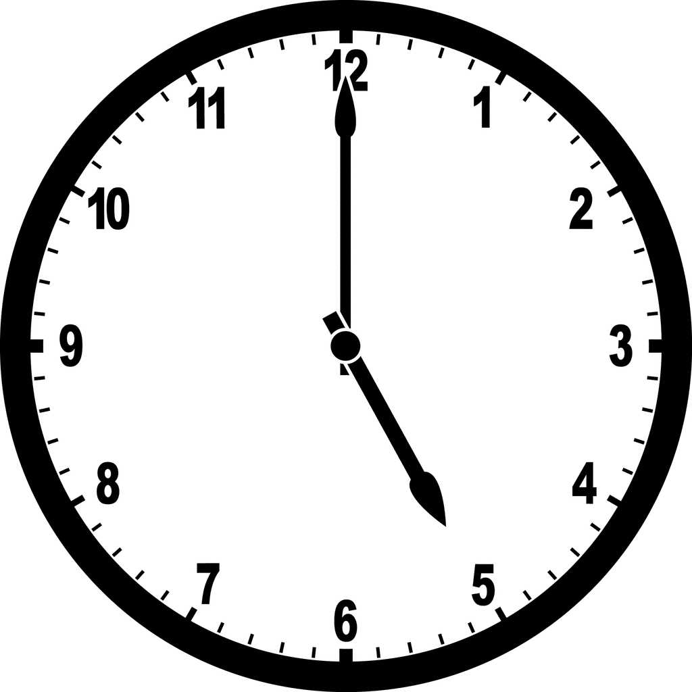  2. What time is showing on the clock?  _______________________  3. Finish the patterns  12, 14, 16, 18, ___, ___, ___  40, 39, 38, 37, ___, ___, ___,  4. Circle the even numbers  12 28 5 13 34 9 70  5. Name this 2D shape___________  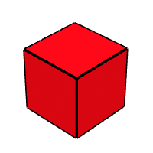  6.Name this 3D shape  ________________ | 7. Write this number in words  14  _________  8. Write the numbers before and after _____ 20 _____  9. Put these numbers in order from lowest to highest  40, 10, 50, 20  _____ _____ _____  10. 2 less than 4 _____  11. 1 more than 23 _____  12. 6 + 4 =_____  13. 23 – 1 = _____  14. 30 + 2 = _____  15. Double 6 = ______  16. Half of 8= ______

