Can you find Scotland on a map?  Can you outline the border of Scotland on a map of the UK? | Do you know why Scotland celebrates Burns Night? Can you talk about some other important Scottish traditions, festivals or events which take place throughout the year. | Can you use strips of paper and weave a tartan design?  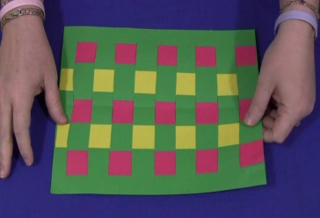 | Listen to Burns’ poems and other Scots poetry. Do you recognise that the language is different from what you are used to hearing? | Here is an example of a good book with Scots language - The  Gruffalo’s Wean.  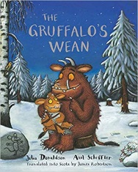 | Can you learn a Scottish poem and recite it to your family? e.g. Fireworks aff the Castle by Matthew Fitt  Mince and tatties by JK Annand
Investigate who the Loch ness monster is? Can you draw it? Make it with your playdough?  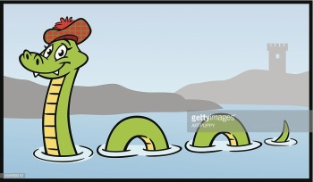 | What can you find out about the Saltire flag? Can you draw it? Make one? 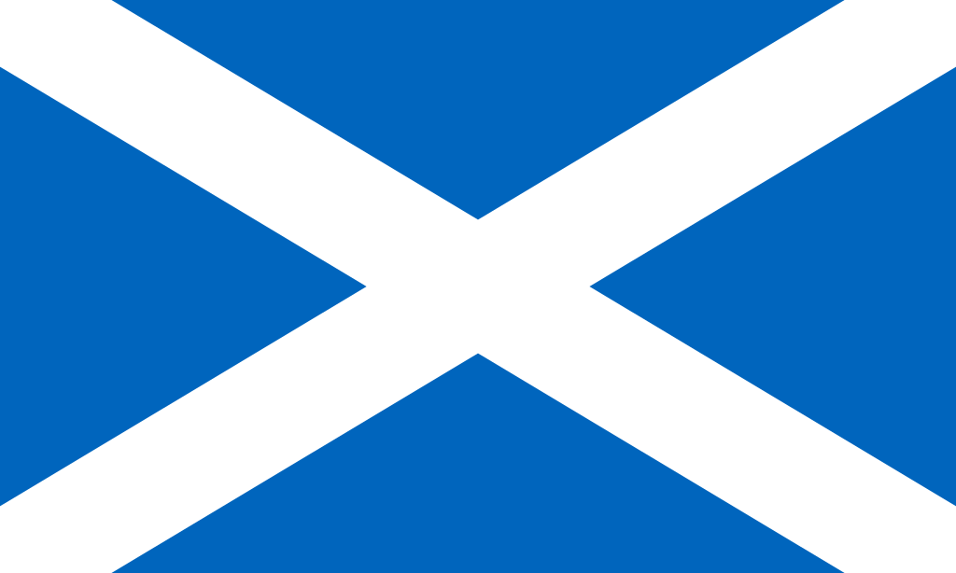 | Can you find a clip of a Scottish Country dance? You could learn it and perform it to your family. | If you could invent something, what would it be? Can you draw it and label it?  John Logie Baird, a Scot born in 1888 invented the televion! | Can you create your own piece of work inspired by Charles Rennie Mackintosh’s style of art.  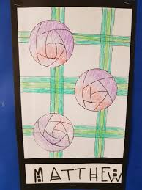 | Name all 7 of the cities in Scotland. Do you know what city is the capital of Scotland?
Can you investigate the invention of the television? | Can you write an acrostic poem?  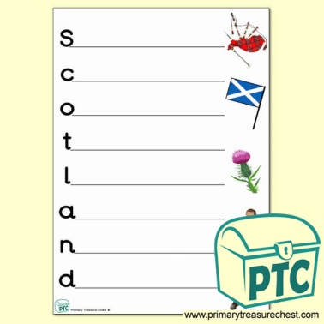 | Find out about the life of a famous Scot. An actor, singer, poet. | Name some traditional Scottish foods. Do you know where some of these foods come from? | Have you tried any Scottish foods? Haggis, shortbread, tablet or dumpling? | Can you create a line drawing of a Scottish landmark, such as a castle or monument?  Below is a picture of Edinburgh Castle.  