We have been learning about adjectives and how they are describing words.
Can you think of adjectives to describe this witch? E.g. The witch has a green and warty nose.
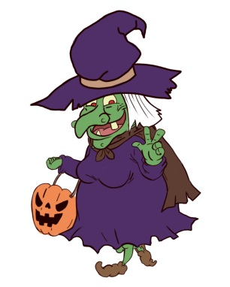

We have been using this description bubble to help us write. It helps us to make our writing really interesting. We write one sentence for each bubble. When we have written a sentence we put a counter over it so we know we have completed it.

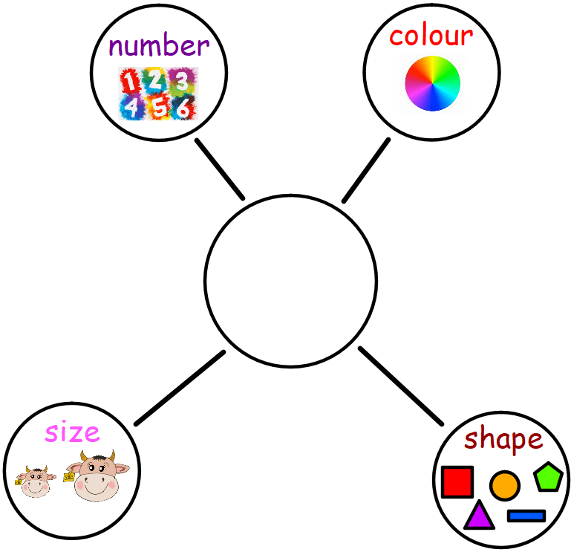

When we write our description sentences we try to vary them by starting them with nouns and pronouns, this helps to keep our writing interesting.
A noun is a naming word e.g. cat, dog, table, car.
A pronoun takes the place of nouns in a sentence. It is a word that functions by itself as a noun phrase, which refers to a person, someone or something e.g. I, he, she.
Here is an example of our writing.
The witch

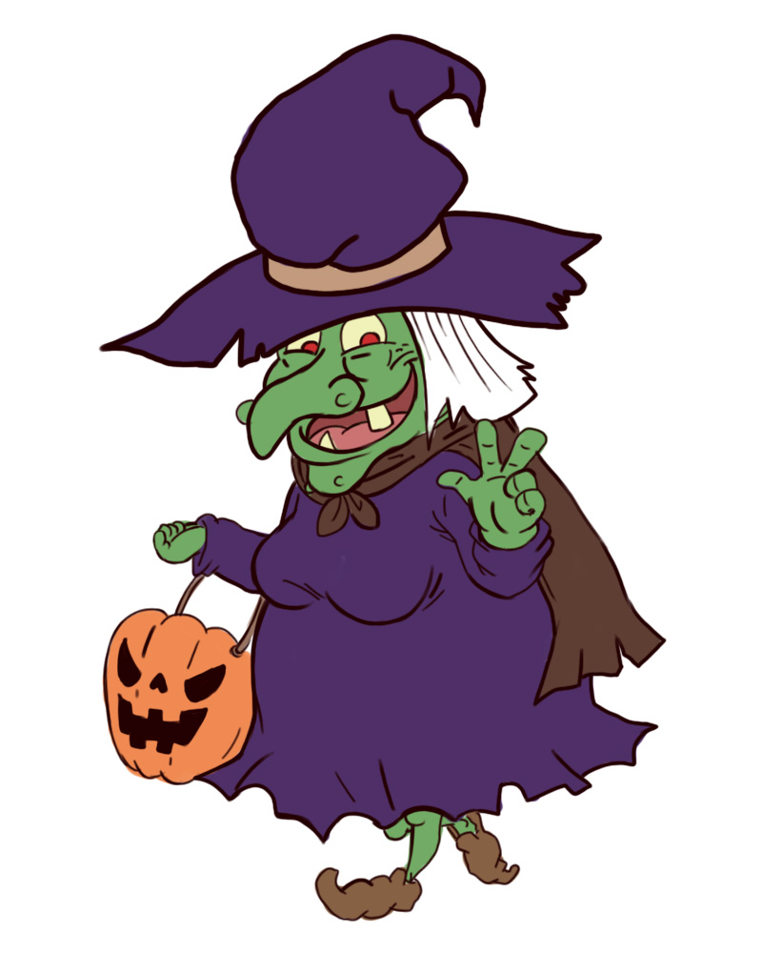

The witch
has one pointy green nose.
She
She
She
noun pronoun pronoun noun
has a purple hat and dress.
She

has small curly brown shoes.
The witch

has a round orange pumpkin bag.

Can you think of your own sentences for the witch or for any other topic? Here is the template if you fancy giving it a go.

_____________________
noun pronoun pronoun noun

