Sustainability – 2 ways to get delicious home-grown tatties!

Method 1: Go to a garden centre or your local Home Hardware shop and buy some “seed potatoes.” You get a choice of different kinds, and they’re pretty well sure to grow in your garden.

So far, so good, but they are a bit dear.

Method 2: And this one’s free! Most families eat potatoes and sure enough, there’s always one or two that get forgotten. Like these ones...

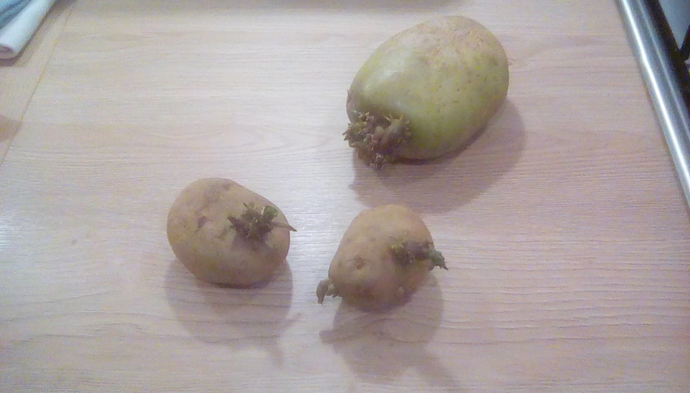

But don’t waste them, don’t throw them out. Instead, put them aside on a piece of paper, or on an old egg box, in a quiet corner of the house for a couple of weeks.

They’ll look pretty awful by then!

I’ll show you how to grow a new crop of potatoes from them in an old plastic bag in the middle of March. No waste here!

Reduce, Re-use, Recycle

That’s the message for today. Mr Clarence.

