Tesco’s adverts say “Every little helps.”

There is a shop in Prestwick that sells milk – but only in recyclable bottles. You take the bottle back, and you get money off your next bottle. No waste!

There’s another one that that only uses paper bags for the food you buy. Like peas and beans, or lentils; and if you want oil or vinegar, you have to bring your own bottle, or buy a reusable one.

They say that:

“If millions of people do just one little thing, then the world will be a better place.”

OK, here’s couple of tiny little things to do. Let’s hope millions of people do them.

Problem: Millions of people try to be “green” or “sustainable” so they buy millions of little plastic plant pots to grow seeds in.

Oops! More plastic waste.

Solution: Make your own little pots to plant seeds in!

How?

Couldn’t be simpler...

Collect cardboard tubes from toilet paper rolls and kitchen towels.

Keep any tiny boxes (face cream, perfume) you find.

Put 4 cuts in the end of the tubes and fold them in, open the tops of the tiny boxes; fill them with compost...
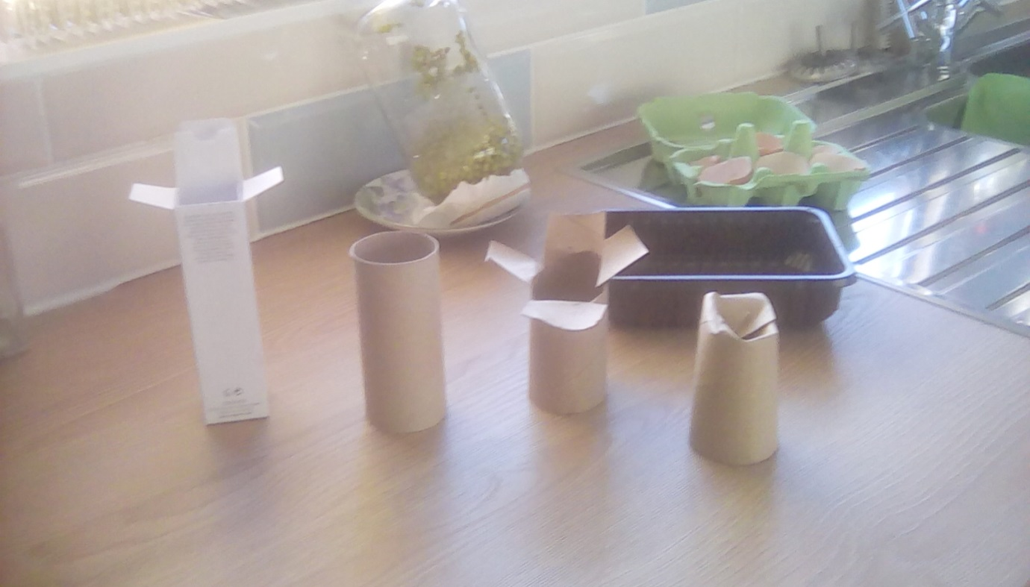

Free plant pots!

Or, if you want to go totally green, save your eggshells (see picture for details!)

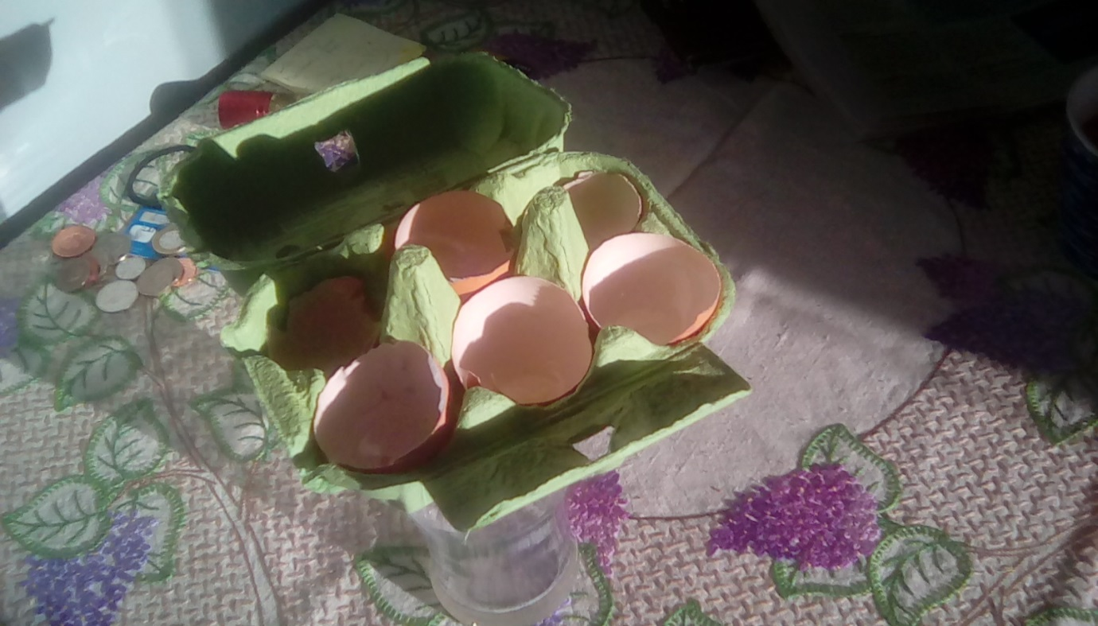
In each little pot, or eggshell, plant a seed.

When it sprouts, plant it, pot and all, (crack the eggshell) in your garden and watch it grow.

It’s easy (and really cheap!) when you know how!

Mr Clarence

