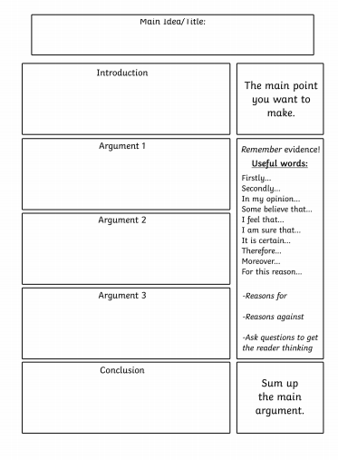
Spending time outdoors improves children’s mental health.

- Create a piece of writing to persuade people that spending time outdoors helps to improve children’s mental health.
- Use this guidance sheet and information on the following website to help:
https://outdoorclassroomday.com/2018/03/19/five-reasons-going-outdoors-improves-childrens-mental-health-and-wellbeing/

Structure
Title: Playing outdoors helps to improve children’s mental health

Paragraph 1- Introduction
- State that you agree with the above statement and list 2-3 reasons to explain why you agree.
- For example: I strongly believe that spending time outdoors helps to improve children’s mental health. I think this because…

Paragraph 2: Explain your first reason (eg. break from schedule)
- Begin with an opening sentence which states your first argument. Remember to start your sentence with a time connective e.g. firstly, my first reason etc.
  - E.g. Firstly, being outdoors gives children a break from their busy schedules.
- Explain your point in more detail by adding more information.
- See first paragraph on the website (link at the top of page).

Paragraph 3: Explain your second reason (increase in vitamin D)
- Opening sentence which states your second argument.
- E.g. Secondly, being outdoors help children to increase their vitamin D intake, which is important for keeping healthy.
- Explain this point in more detail by adding more information.
- See paragraph on the website (link at the top of page).

Paragraph 4: Explain your third reason (relieves stress)
- Opening sentence which states your third argument.
  - E.g. In addition, being in the outdoors can help to relieve children’s stress and anxiety, which ultimately improves their mental health.
- Explain this point in more detail by adding more information.
- See paragraph on the website (link at the top of page).

Paragraph 5: Conclusion
- Write a few sentences to sum up your arguments.
- For example: In conclusion, I believe that spending time outdoors can improve children’s mental health because it gives them a break from busy schedules and helps clear their mind, it increases their vitamin D intake which contributes towards better health and it helps to relieve their levels of stress and anxiety.

Remember to add in persuasive words and phrases throughout. You will find these on your persuasive writing word mat.
Examples of persuasive words and phrases you might use are:
- Surely kids mental health is important!
- There is no doubt that spending time in the fresh air helps to clear children’s heads.
- It’s outrageous that some children are spending so much time indoors!
- I strongly believe children should spend more time outdoors.

