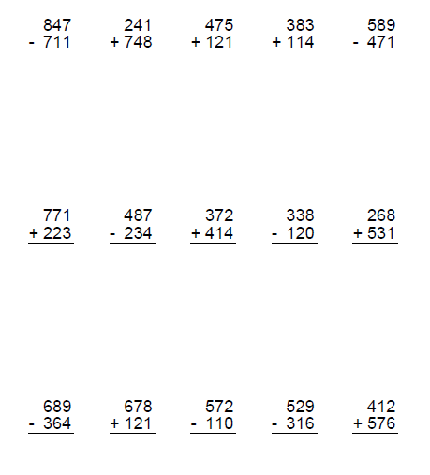**Triangles Homework 30/11/20**