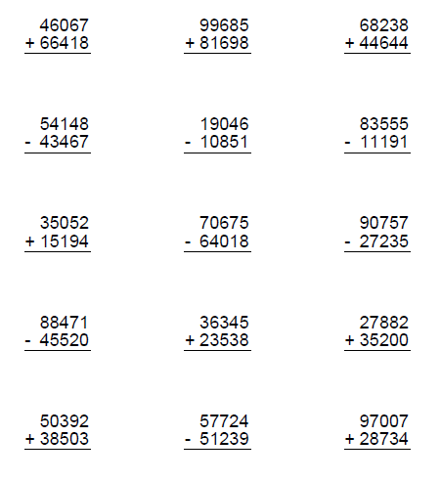
Diamonds Homework 30/11/20

