Read, Spell, Count, Excel!
Primary 1/2

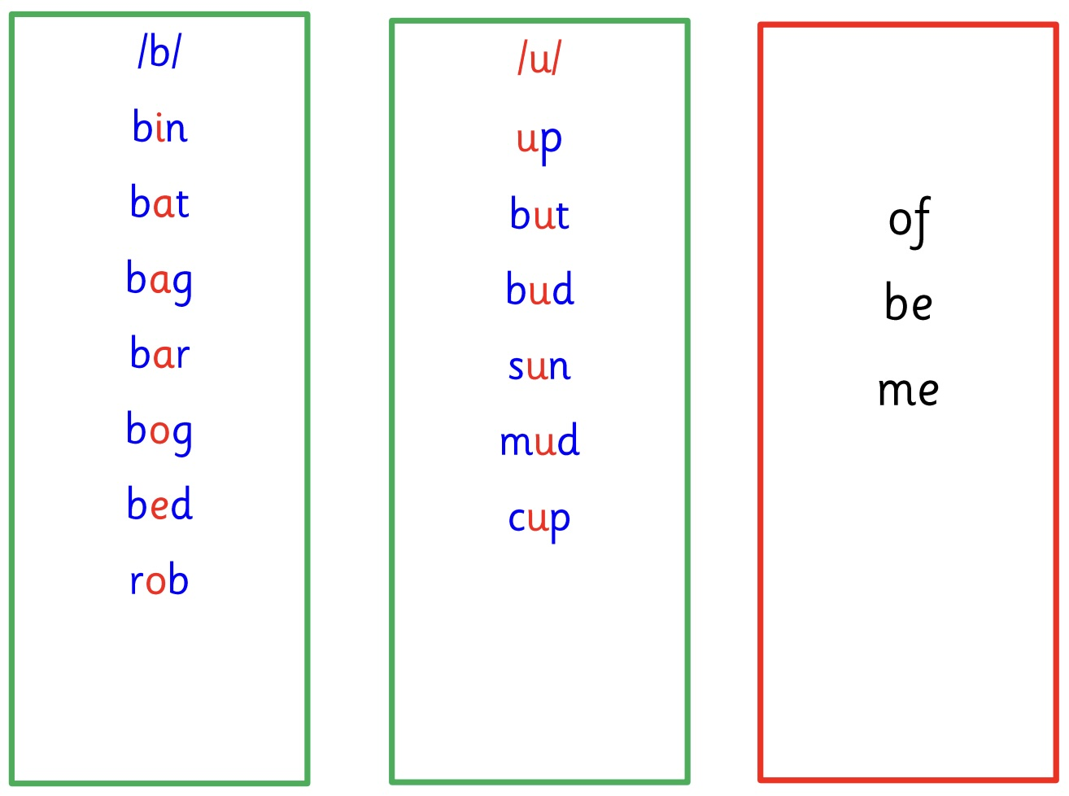
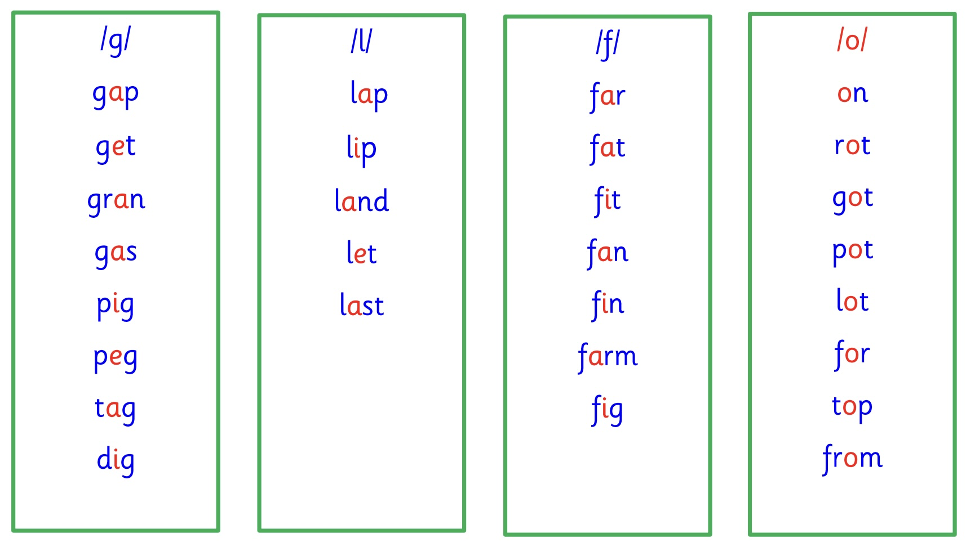
These are the sounds and wordlists the children will be focusing on in the next few weeks. Children could practise reading and spelling these words at home.

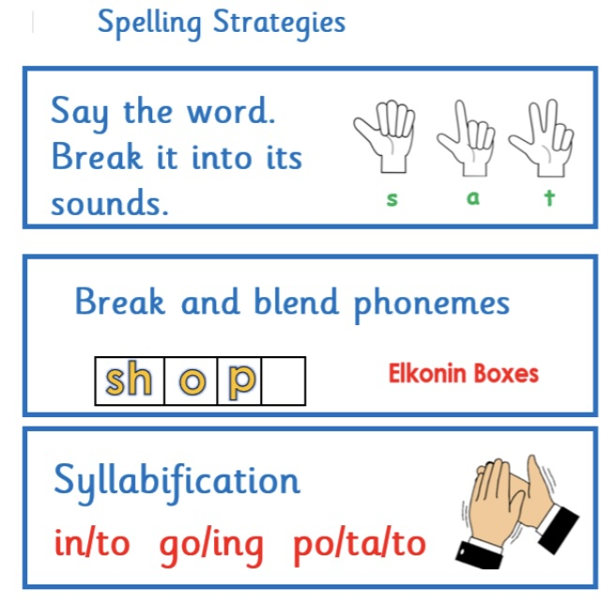
Children will also need lots of practice writing the words independently using their spelling strategies.

They should also recognise High Frequency Words.

In class we use dictated sentences to assess this skill.

Here are the sentences and HFW for
Block 3 sounds.

