
Logan Primary School and ECC
Handbook 2026-27
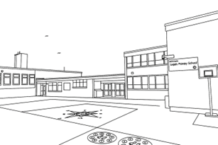
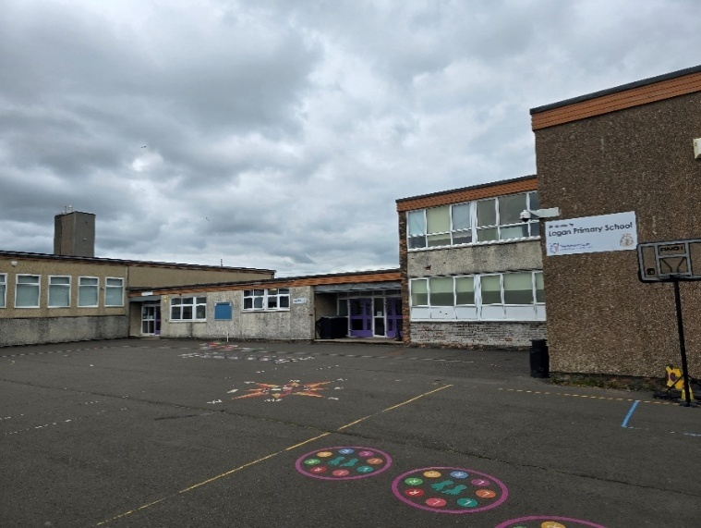

Head Teacher | Mrs Sarah Robson
Address | Logangate Terrace, Logan, Cumnock, Ayrshire
Postcode | KA18 3HD
Telephone Number | (01290) 421916
Email Address | ealogan.ps@eastayrshire.org.uk
Stages of Education | ECC (3 and 4 years)- P7
Current Roll | 114 School/ 23 ECC
Denominational Status | Non-denominational

Section 1
Welcome to our school, situated at the heart of the Logan, Lugar, and Cronberry communities. We are a close-knit, caring school where the wellbeing and success of every child lie at the centre of all we do.
Our dedicated staff team is committed to providing the highest quality learning experiences and supporting each child to achieve their very best. We take great pride in nurturing a love of learning and in creating an environment where every pupil feels valued, respected, and inspired to succeed.
As a school, we value our strong partnerships with families and the wider community. Together, we work to provide opportunities that enrich the lives of our young people and strengthen the close bonds that make our school so special. Parents are invited to be involved in their children’s learning through open afternoons, class assemblies, surveys and events.
We are a welcoming and inclusive community, proud of our shared achievements and always striving for excellence. We look forward to continuing our journey of learning, growth, and success together.
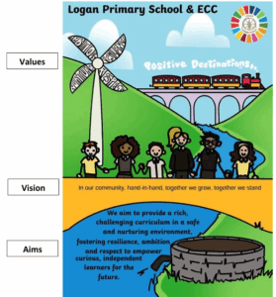
We utilise the Safer Scotland Schools app as our main method of communication, info on which can be obtained from the school office.
Our Vision, Values and Aims
Our Vision- In our community hand-in-hand together we grow, together we stand.
Values- Ambition, Resilience, Respect and Nurture
Aim- We aim to provide a rich, challenging curriculum, in a safe and nurturing environment, fostering resilience, ambition and respect to empower curious, independent learners for the future.

Section 2- Transitions
Supporting Transitions
We place a strong emphasis on supporting children and families at key points of transition to ensure that changes in learning environments are positive and well-planned experiences.
Transition from Home to ECC
We recognise that the transition from home into ECC is an important milestone for children and families, and we aim to make this experience as positive and reassuring as possible.
Prior to starting ECC, children and their families are offered transition visits. These visits allow children to become familiar with the ECC environment, staff, routines and play spaces in a relaxed and supportive way. The visits are carefully planned to help children build confidence, form early relationships and begin to feel secure in their new setting.
Parents and carers are encouraged to attend transition sessions with their child. This provides an opportunity to share important information with staff, ask questions, and establish strong home–ECC partnerships from the outset. Transition visits are flexible and responsive to individual needs, ensuring that children are eased into ECC at a pace that is appropriate for them.
By providing these supportive transition opportunities, we help children settle well, feel safe, and develop a positive start to their learning journey.
Transition from ECC to Primary 1
To support children moving from ECC into Primary 1, we have a structured programme of transition events that takes place during Terms 2 and 3. These opportunities allow children to become familiar with the school environment, routines, and staff, helping to build confidence and reduce anxiety. Parents and carers are also supported through information-sharing opportunities to ensure they feel well prepared for their child starting school.
Transition from Primary 7 to Secondary School
We work closely with our local secondary school, Robert Burns Academy, to support learners moving from Primary 7 into S1. Strong links are maintained with the academy, including close communication with the First Year Head, Mrs Anderson, to ensure continuity of learning and wellbeing.
For children who may experience difficulty with the transition from primary to secondary school, we offer an enhanced transition programme. This may include additional visits to the secondary school, personalised transition activities, and, where appropriate, support for parents and carers. These measures help ensure that individual needs are identified and supported, enabling all pupils to move on with confidence.
Through these planned and supportive approaches, we aim to make every transition a positive and successful experience for our learners.
Contact details for all East Ayrshire primary schools can be found here , our nearest denominational school is St Patrick’s Primary. Our associated secondary school is Robert Burns Academy, details of this school and all other East Ayrshire secondary schools can be found here.
Support for Children and Young People and Parents/Carers
Mrs Robson is our Head Teacher and Mrs Baillie is our Depute Head Teacher. Mr Robertson is the Senior Lead within the ECC. Together, they work closely with staff to ensure that children, young people and families are well supported.
If you have any concerns, worries, additional needs, or would like advice or support, please contact the school office. Staff will arrange an appropriate appointment or ensure that a member of the leadership team returns your call as soon as possible. We encourage open communication and value working in partnership with parents and carers to support the wellbeing and progress of all our learners.
Where additional support needs are identified, we will work closely with families to arrange a Team Around the Child/Family meeting. This ensures that the right supports are in place, delivered by the right people, and that everyone involved is working together to best meet the needs of the child or young person.
Section 3-

School and ECC Hours

Logan Primary provides a term-time service from 9:00am to 3:00pm.
Our ECC also operates full-day sessions from 9:00am to 3:00pm during term time.

Each morning and at break, we offer pupils toast and fruit free of charge. This is available from 8:45am, when playground supervision begins.

Our holidays and in-service days are in-line with those set by East Ayrshire Council and are available to view here.

Attendance and Time-keeping

We encourage all pupils to aim for excellent attendance, as being in school regularly has a significant impact on learning, wellbeing and achievement. When a pupil’s attendance approaches or falls below 90%, we will contact parents and carers to offer support where needed and to ensure they are aware of the dip in attendance. Our aim is always to work in partnership to help improve attendance and remove any potential barriers.

We understand that occasional late-coming can be unavoidable; however, we kindly ask that children arrive on time as much as possible. A prompt start to the day reduces disruption, helps establish positive routines and ensures that pupils do not miss valuable learning opportunities.

Reporting an Absence

All absences must be reported to the school or ECC as soon as possible by contacting the school office on 01290 421916.
It is essential that all contact numbers are kept up to date. If a child does not arrive at school and no absence has been reported, we will contact parents/carers via text and then phone call from 9.15am. If we cannot get in touch with the main contact we will then proceed to contact other listed adults.

The school SEEMIS messaging system holds one main contact and will send attendance notifications to the main contact only. It is not possible to generate the automated message necessary to inform all parents/carers. However should a parent/carer have a significant concern that the main contact is not sharing key information regarding attendance, they should contact the school to discuss possible alternative solutions.

Behaviour and Anti-Bullying

At Logan, we promote positive behaviour through a restorative approach, supporting pupils to build, maintain and repair relationships.
Bullying in any form is not tolerated. We work closely with pupils and parents/carers to address any concerns or negative behaviours promptly and effectively.

Dress Code

We are proud of our school identity and encourage all pupils to wear our black and yellow uniform.
Acceptable items include shorts, skirts, trousers and pinafores. While the school badge is not required, logo t-shirts are available locally for those who wish them.

For P.E., pupils require soft shoes and shorts. As with school uniform, P.E. clothing must be free from team affiliations.

Security and Visitors

The school building is secure, with access permitted only through the main entrance or car park entrance.
Between 9:00am and 3:00pm, all visitors must use the car park entrance to ensure the playground remains secure.
For planned events, the main entrance will be used for visitor access as appropriate.

Homework

Following recent consultation, we have adopted a refreshed approach to homework.
We now use our school blog to share regular updates on class learning and offer suggestions on how parents/carers can support learning at home:
https://blogs.glowscotland.org.uk/ea/loganpsandecc2016/

School Canteen Facilities and ParentPay

All school meals at Logan are prepared on site by our catering team and are currently free for all pupils.
Parents/carers are asked to order lunches using ParentPay, which is also used to make payments for trips and other school activities.

If you require assistance setting up or accessing ParentPay, please contact the school office. Information on school meals, clothing grants, etc, can be found here .

Complaints Handling

At Logan, we aim to acknowledge, investigate and resolve complaints as quickly as possible.
All complaints- whether made verbally or in writing- are taken seriously. Concerns should be directed to the Head Teacher, Depute Head Teacher or Senior ELCP.

This does not replace the right to use East Ayrshire Council’s formal complaints procedure, available here.

Emergency Procedures / Medical Matters

Parents/carers must ensure that contact details and medical information are kept up to date. Medication should have a pharmacy label present with the child’s name, in date and submitted to the school office with the required forms. Logan has two fully trained first aiders who will attend to your child if needed.

For serious concerns or head injuries, parents/carers will be contacted immediately.

For minor issues, first aid will be administered and a note will be sent home.

Data Protection

All information held by Logan Primary School & ECC and East Ayrshire Council is managed in accordance with current legislation, including GDPR.
Consent is sought for data sharing and photographic permissions at the start of term, although parents/carers may amend these permissions at any time.

Parent Council

Whilst all parents are automatically part of the Parent Forum, we also have a Parent Council, which is designed to convey the voices and opinions of the wider parent group and to help the school in various ways.
If you are interested in joining or contributing, please contact the school office- we welcome new members.

Section 4- Curriculum

At Logan Primary, we are committed to delivering a curriculum that is meaningful, engaging and responsive to the needs of our learners. We are currently developing an updated Curriculum Rationale, working in partnership with our school community to ensure that our approach to learning reflects our local context, making learning both relatable and relevant for all children.

We remain fully informed and up to date with the Curriculum Improvement Cycle, ensuring that national guidance is carefully considered and adapted to fit the needs, priorities and strengths of our school. This ensures our curriculum remains dynamic, coherent and aligned with best practice across Scottish education.

A key area of our ongoing development is our focus on Metaskills. We are in the raising-awareness stage, exploring each Metaskill and what it means for learners in everyday classroom experiences. This helps our children develop the essential skills they need for learning, life and future pathways.

We aim to deliver learning that is relevant, inspiring and grounded in current pedagogy. As part of this work, we are developing our Logan Excellent Lesson, a shared vision among staff of what high-quality learning and teaching looks like in our school.

Pupil voice is central to our curriculum and improvement journey. Children play an active role in shaping learning, contributing their views and participating in our quality assurance processes alongside staff.

We also work closely with the schools in our Education Group, sharing practice and developing professional knowledge together. Our learners benefit from this collaboration through learning exchange opportunities, helping them build confidence, broaden their experiences and connect with a wider learning community.

Through these approaches, we strive to create a curriculum that supports every child to achieve their potential and develop a lifelong love of learning.

Further information on our improvement priorities can be found in our Improvement Plan, available here.

Section 5- Achievement and Improvement

Our most recent standards and quality report is available to view here. This contains an overview of our achievements and developments over the past academic year.

Section 6

Assessment

At Logan, we take a holistic approach to assessment, considering each pupil’s strengths, achievements and areas for development. Our aim is to build a complete picture of every child as a learner.

We are currently enhancing our approaches to feedback and ongoing formative assessment, ensuring that children receive clear, meaningful guidance that helps them understand their progress and identify their next steps. This forms an integral part of daily learning and teaching.
To support teacher professional judgement, we also make use of GL assessments and Scottish National Standardised Assessments (SNSA). The information from these assessments helps us to plan effectively and tailor learning to meet the needs of all pupils.

Teachers report Curriculum for Excellence levels three times across the school year using East Ayrshire’s tracking and monitoring system. This ensures we are closely monitoring progress and supporting pupils to achieve. These levels are shared with parents through our annual reporting calendar, which includes parent meetings and written reports.

Reporting

Within Logan ECC, we use online learning journals to provide real-time updates to parents and carers. These journals capture key moments of learning and development throughout the year, helping families stay informed and engaged in their child’s progress.
Across the school, a formal annual report card is issued once per year and is supported by two scheduled parent–teacher meetings. We are always happy to arrange additional appointments for parents or carers who have concerns or wish to discuss their child’s progress at any time.

We are also beginning to introduce My World of Work profiles, which support children in analysing their progress, identifying their strengths and setting personal goals. This helps pupils develop a deeper understanding of themselves as learners and contributes to their growing confidence and independence.

For pupils with additional support needs, meetings are arranged separately and take place at least once per session. Further meetings are scheduled as required to ensure that appropriate supports are in place and reviewed regularly.

Section 7

Helpful contact details and websites

Education & Learning Support
- Parentzone Scotland – official Education Scotland information for parents on curriculum, learning at home, additional support, rights and school involvement: https://education.gov.scot/parentzone/ Education Scotland
- Enquire – Advice for Parents & Carers – Scotland’s advice service on additional support for learning rights and processes: https://enquire.org.uk/parents/ Enquire
- Connect Scotland – resources to help parents be engaged in children’s learning and school life: https://connect.scot/ connect.scot
- Play Scotland (Parents & Families) – practical play ideas and activities for home learning and development: https://www.playscotland.org/parents-families/ playscotland.org
Parenting & Family Support
- Parent Club – trusted advice, tips and support for parenting at every stage: https://www.parentclub.scot/ parentclub.scot
- Parenting Across Scotland – help and information on parenting issues, support and family wellbeing: https://www.parentingacrossscotland.org/ Parenting Across Scotland
- Parent Network Scotland – free courses and family support resources for parents: https://www.parentnetworkscotland.com/ parentnetworkscotland.com
Early Years & Childcare
- Best Start in Life (UK government resource) – advice from pregnancy through early years and school readiness: https://beststartinlife.gov.uk/ Best Start in Life
- Scottish Government Parenting & Early Education Resources – guidance on early learning, care and family support: https://www.gov.scot/policies/early-education-and-care/parenting-resources/ Scottish Government
Online Safety
- ThinkUKnow (Online Safety for Parents & Children)
https://www.thinkuknow.co.uk/
Government-backed advice on helping children stay safe online, with age-specific guidance.
- Internet Matters
https://www.internetmatters.org/
Trusted support for parents on online safety, screen time, social media and devices.
- National Online Safety (Parent Guides)
https://nationalonlinesafety.com/guides
Easy-to-read guides for apps, platforms, games and online risks.
Health & Wellbeing
- NHS Inform (Parents & Carers)
https://www.nhsinform.scot/healthy-living/parents-and-carers
Health advice from early years through childhood.
- Young Scot (Wellbeing & Families)
https://www.young.scot/
Information on mental health, rights and support for families and young people.
- Cool2Talk
https://cool2talk.org/
Safe space where young people can ask anonymous wellbeing questions and receive advice from professionals.
- Place2Be (Mental Health & Emotional Support)
https://www.place2be.org.uk/
Guidance for parents on supporting children’s emotional wellbeing.
Literacy Support
- Scottish Book Trust / Bookbug
https://www.scottishbooktrust.com
Free resources, songs, rhymes and reading activities for early years and primary.
- Oxford Owl (Reading & Free eBooks)
https://www.oxfordowl.co.uk/
Free eBooks and practical tips for reading at home.
- BBC Bitesize Literacy
https://www.bbc.co.uk/bitesize/subjects/zv48q6f
Literacy games and learning activities for Early and First Level learners.

Numeracy Support
- TopMarks Maths Games
https://www.topmarks.co.uk/maths-games
Interactive numeracy games covering Early, First and Second Level.
- NRICH (Cambridge University Maths Challenges)
https://nrich.maths.org/
Problem-solving activities suitable for primary age.
- BBC Bitesize Maths
https://www.bbc.co.uk/bitesize/subjects/zjy2hbk
Videos and practice to support classroom numeracy learning.

Curriculum Support (CfE & Learning at Home)
- Parentzone Scotland (Curriculum for Excellence)
https://education.gov.scot/parentzone/
Official explanation of CfE, assessment, levels and learning pathways.
- Education Scotland – Learning at Home
https://education.gov.scot/parentsandcarers/learning-at-home/
Supports parents in understanding how to help with learning beyond the classroom.
- BBC Bitesize Scotland
https://www.bbc.co.uk/bitesize/scotland
Videos, activities and games tailored to the Scottish curriculum.
- My World of Work (Skills and Profiles)
https://www.myworldofwork.co.uk/
Helps children (and older learners) explore strengths, interests and future goals.

Play, Creativity & Early Years Development
- Play Scotland
https://www.playscotland.org/
Ideas and guidance on play-based learning and child development.
- CBeebies (Educational Games & Stories)
https://www.bbc.co.uk/cbeebies
Safe, age-appropriate videos, songs and interactive learning for young children.
- Hungry Little Minds (Early Language & Play)
https://hungrylittleminds.campaign.gov.uk/
Activity ideas for supporting early language development.

