
Lochnorris Primary
Home Learning Month: October 2025 Class: P7

- Here are your suggested home learning tasks for this month. Your teacher will discuss each one in class.
- Try to do as many of the tasks as you can and ask your teacher if you need help with any of the tasks.
- At the end of the month, your teacher will go over all of your home learning.
Literacy - Reading  Choose a book to read for enjoyment and practise reading with expression.   | Literacy  We are enjoying reading the novel Goodnight Mister Tom. If the book was to be re-published today, could you design a new front cover? | Health & Wellbeing – Food and Health  Create a 1-day menu (breakfast, lunch, dinner and snack) making sure your menu follows the Eatwell Guide.  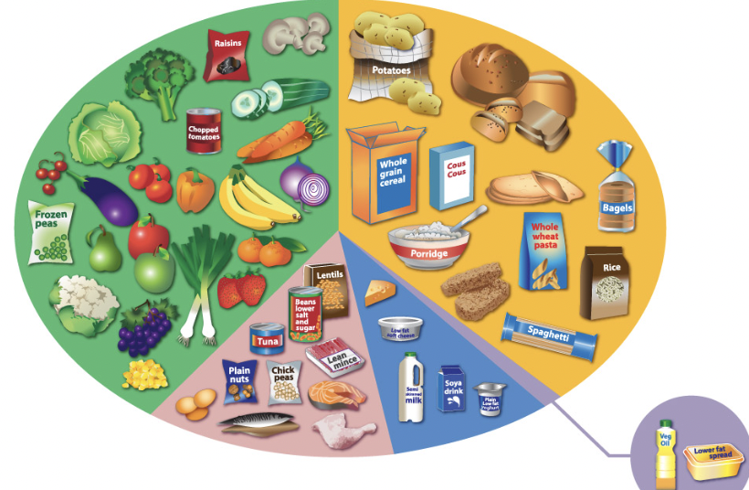
Numeracy  Go to https://mathsbot.com/questionsIWB?id=1&min=5&max=10 and complete the calculations within the 10-minute timer.  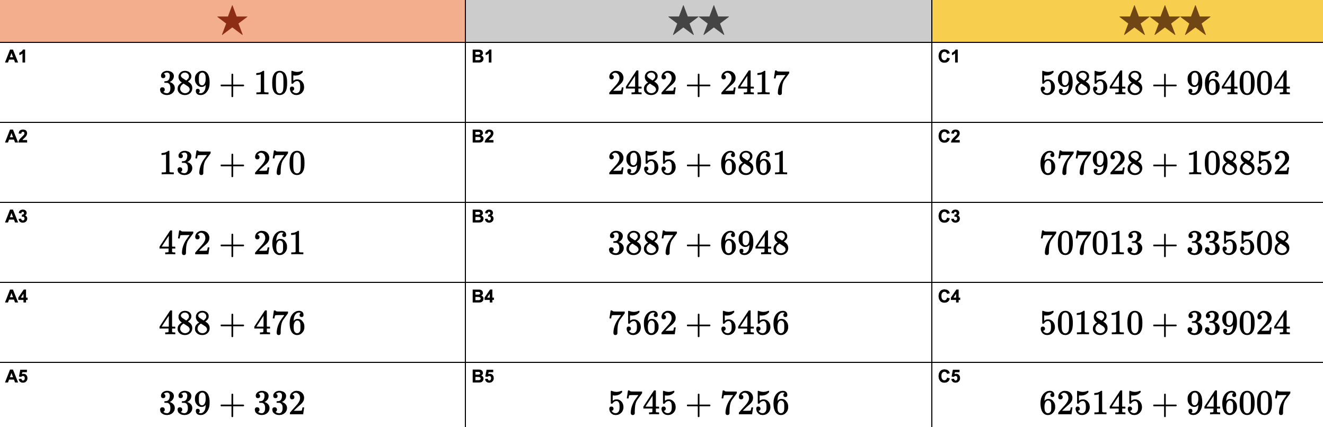 | Numeracy  Use the ‘Hit the Button’ game to practice all your times tables from 1-12. Please try ‘Times Tables’ and ‘Division Facts’. | Languages  Practise greetings in BSL by watching this video and following along:  https://www.youtube.com/watch?v=BGp2Lef7yL0
IDL – WW2  Write 5-10 facts about how life has changed since the 1940’s. | IDL-WW2  Design and test a parachute (using a toy/weight) that would allow an RAF pilot to land safely. You can bring your parachute into school or email a video. | Art and Design  Choose an inanimate object and draw a picture of it, making it look as realistic as you can. Consider your use of line, shape and texture.

