
Home Learning - January P7

Writing – Scots  Its Scots month as we celebrate Burns Night on 25th January.  Research as many Scots words you can, write these down with their definitions.  Now write two paragraphs using Scots only. | Scottish Poetry Performance  Get a head start learning your Scottish poem.  To a mouse  By Robert Burns | New Year – New Me  Every year people make New Year resolutions.  Talk to someone at home about your new year resolutions – what do you plan to work on inside school and outside school?  (Think improving confidence, going to bed earlier, getting fitter)  What are your New Year resolutions and how will you stick to your new goals?
Times Tables  Go onto hit the button and get your highest score on your 7,8 and 9 times tables.  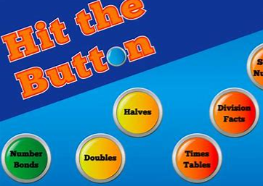  Hit the Button - Quick fire maths practise for 6-11 year olds (topmarks.co.uk) | Scots Art  Create your own tartan outfit that someone could wear on Burns Night.  Think tartan kilt or troosers! | Numeracy  Practise all your tables. Get someone to test you on random tables.  You MUST feel confident with your tables to progress onto our maths learning this term; factors, multiples, fractions and percentages.
Writing - Response  This term we are looking at response type writing. As an introduction,  watch a new film and write four paragraphs covering these points:  - What did you like best about the film?  (characters, plot, music, acting)  - What do you think the film missed and could improve on to make it better?  - How would you change the ending of the film?  - Provide a recommendation for the film. Remember to rate it and provide a target audience. | World of Work  In January, we explore the different jobs people do in everyday life and start to think about our own possible career paths.  Write down 10 jobs you can think of.  Now research the following points:  - What training/qualifications are required for this job  - Typical hours worked  - Annual Salary/ earnings per hour | P.E  This term we are developing our skills at Basketball.  Practise your dribbling and passing with someone at home.  Can you think of any popular basketballers in the world?

